|  |
| --- |
| DIRECTIVES SUR L’UTILISATION DE PROJETS D’APPRENTISSAGE À DISTANCE |
| Ce matériel a été élaboré dans le but de faciliter la transition entre l'apprentissage en salle de classe et l’apprentissage à distance temporaire. Les expériences d'apprentissage correspondent aux résultats d'apprentissage et les outils d’évaluation ont été inclus dans chaque projet. **Remarques :**  * 1. L'enseignant doit envoyer le lien au projet approprié ou envoyer le document lui-même.   2. L'enseignant doit s'assurer que les parents ou les gardiens d’enfants reçoivent les fournitures scolaires requises (bac avec crayons, marqueurs, papier, etc.).   3. L'enseignant rassure les parents, les tuteurs ou les gardiens d'enfants et les élèves, qu’une communication sera maintenue entre la maison et l’école.   4. Les parents, les tuteurs et les gardiens d'enfants peuvent avoir accès à des ressources additionnelles à :      + Mon apprentissage chez moi ([www.edu.gov.mb.ca/m12/monapprentissage/index.html](http://www.edu.gov.mb.ca/m12/monapprentissage/index.html));      + Mon enfant à l’école ([www.edu.gov.mb.ca/m12/monenfant/index.html](http://www.edu.gov.mb.ca/m12/monenfant/index.html)). |

|  |  |
| --- | --- |
| APERÇU DU PROJET | |
| Années d’études : | 5e année, 6e année |
| Matières principales : | Français arts langagiers, *English Language Arts,* mathématiques, sciences de la nature, sciences humaines, éducation physique, arts visuels, arts dramatiques, musique |
| Titre : | RESSOURCES POUR LES PARENTS D’ÉLÈVES D’IMMERSION FRANÇAISE |
| Thème : | Mini-leçons |
| Durée : | 10 jours |
| Matériel : | Un jeu de cartes, papier blanc, papier de construction, marqueurs, crayons de cire ou de bois, bâton de colle |
| Brève description : | Mini-leçons portant sur différentes matières, partagées par la Division scolaire Louis Riel. |

|  |
| --- |
| AnnexeS (Matériel d'appui en format imprimable, lES évaluationS, LES CORRECTIONS) |

|  |  |
| --- | --- |
| Concept original créé par : | Les enseignants de l’École Apprendre-chez-soi de la Division scolaire Louis Riel |

**Trousse d’apprentissage-chez-soi**

**5e et 6e années / Grades 5 & 6**

**Learning from Home Package**

|  |  |
| --- | --- |
| **Matériaux essentiels**  ***Essential Supplies*** | **Un jeu de carte**  ***Deck of Cards*** |
| **Matériaux pratiques *Helpful Materials***  ***In most cases, you can substitute something similar that you have on hand.*** | **Papier blanc, papier de construction, marqueurs, crayons de cire ou de bois, bâton de colle**  ***White copy paper, construction paper, markers, crayons or pencil crayons, a glue stick*** |

**Trousse d’apprentissage-chez-soi :  
*5e et 6e année – Immersion française***

Bien que le niveau restreint (orange) soit en vigueur dans les écoles du Manitoba selon le [Système de riposte à la pandémie de #RELANCE](https://www.gov.mb.ca/covid19/restartmb/prs/index.fr.html)**[MB](https://www.gov.mb.ca/covid19/restartmb/prs/index.fr.html)**, Éducation Manitoba donne aux parents et aux tuteurs des élèves de la maternelle à la 6e année l’option de faire apprendre leurs enfants de chez eux temporairement du4 au 18 janvier 2021. Conforme à cette direction, la Division scolaire Louis-Riel offre aux familles une option temporaire d’apprentissage à distance dont les objectifs sont :

* De continuer d’inciter les enfants à atteindre des résultats d’apprentissage essentiels tout en apprenant de chez eux.
* D’assurer la continuité de l’apprentissage en réponse à des niveaux plus élevés d’absentéisme.
* De veiller à ce que les enfants qui apprennent de chez eux de façon temporaire maintiennent un lien avec leur communauté scolaire.

Les élèves de la maternelle à la 6e année recevront une trousse d’apprentissage élaborée par la division et adaptée par la communauté scolaire de chaque élève. Ils auront un horaire quotidien et un menu de possibilités d’apprentissage axées sur les résultats d’apprentissage essentiels et mettant l’accent sur la littératie et la numératie. On ne s’attend pas à ce que l’élève complète toutes les expériences d’apprentissage proposées. Au contraire, ils feront des choix en fonction de leurs intérêts, de leurs connaissances antérieures, de la disponibilité de matériaux, et leur capacité de les compléter indépendamment ou au moyen du support qui leur est offert.

En plus de la trousse imprimée fournie, les élèves, les parents et les tuteurs auront accès à des ressources d’apprentissage électronique accessibles sur la page d’accueil de la DSL-R. À la fin de la période d’apprentissage temporaire à domicile, les élèves sont invités à partager leur travail avec leur enseignant de classe. Ces derniers accuseront réception des travaux et fourniront de la rétroaction relative à l’apprentissage des élèves en temps opportun.

Les membres du personnel de la communauté scolaire de l’élève seront en contact régulier pendant la période d’apprentissage temporaire à domicile pour assurer que chaque élève comprend les tâches d’apprentissage, répondre aux questions, et favoriser le bien-être.

Les parents et les tuteurs sont encouragés à maintenir un horaire habituel afin de maximiser l’engagement et de tirer parti de l’apprentissage. Voici quelques astuces à considérer :

* garder constante l’heure du coucher, de réveil et des repas ;
* s’habiller et se préparer pour l’école (même s’ils restent chez eux) ;
* respecter les périodes prévues d’apprentissage et de pauses ;
* prévoir de l’activité physique quotidienne ;
* assurer une communication quotidienne avec les amis et la famille.

Désigner un espace d’apprentissage à domicile peut aider les enfants à se concentrer. Si possible, l’espace doit comprendre :

* une atmosphère calme ;
* un bon éclairage ;
* un bureau ou une table à une hauteur confortable pour votre enfant ;
* un panier ou un bac de rangement pour conserver les effets scolaires (papier, stylos, crayons, marqueurs, livres, etc.) ;
* l’accès à un ordinateur/tablette ou à un autre appareil intelligent, si possible.

**Grade 5 and 6 LFH Learning Package (French Immersion)**

At the direction of Manitoba Education, the Louis Riel School Division has planned for students in Kindergarten- Grade 8 to temporarily learn from home from January 4th- January 18th. While the Restricted Level (Orange) is in effect under the Manitoba Pandemic Response System, temporary remote learning options may be provided to Kindergarten to Grade 8 Students who can be supported while learning from home. In doing so our goals are to:

* Continue to engage children in achieving essential learning outcomes while learning from home.
* Address continuity of learning in response to higher levels of absenteeism due to concerns about safety as a result of COVID-19.
* Ensure children who are at home on a temporary basis maintain a connection to their school community while learning from home.

Students in Kindergarten-Grade 6 will receive a learning package developed by the division along with each student’s school community. They will be provided with a daily schedule and a menu of learning opportunities focused on essential learning outcomes and emphasizing literacy and numeracy. It is not expected that students complete all of the proposed learning experiences. Rather, they will make their choices based on interest, prior knowledge, availability of materials, and ability to complete independently or with the support available to them.

In addition to the print package provided, students, parents, and guardians will have access to online invitations to learning. These will be accessible via the LRSD homepage. At the end of the period of temporary learning from home, students are invited to share their work with their classroom teacher. Teachers will acknowledge the learning and provide feedback to students in a timely manner.

Staff members from the student’s school community will be in regular contact during the temporary learning from home period to ensure each student understands the learning tasks and to answer any questions and to nurture well-being.

Parents and guardians are encouraged to establish a learning space for their child and to maintain a regular schedule to maximize engagement and capitalize on learning:

* regular bedtime, wake-up and mealtimes
* getting dressed and ready for school (even though they are at home)
* time for learning
* time for breaks
* daily physical activity
* daily communication with friends and family

Setting up a home learning space to work can help children focus. If possible, the space should include:

* a quiet atmosphere
* good lighting
* a desk or table at a comfortable height for your child
* a storage basket or bin to keep supplies (paper, pens, pencils, markers, books, etc.)
* access to a computer/tablet or other smart device, if possible

**5e et 6e année *–* Plan d’une journée *Grade 5/6 – Daily Schedule***

|  |  |
| --- | --- |
| 9:00 – 9:15 | **Mouvement** ***Movement***  Choisis une activité physique à faire dans la section « Créons » du document afin de bien te préparer à l’apprentissage. *Choose a physical activity from the "Let’s Create” section to prepare yourself for learning.* |
| 9:15 – 10:00 | **Literacy (ELA)** ***Literacy (ELA)***  See Literacy Section for the suggested order of activities and resources provided. Each task includes one or more of the following components:  **Reading** **Writing** **Reflection/Analysis**  **Presentation** **Research** |
| 10:00 – 10:30 | **Littératie (Français)** ***Literacy (FLA)*** Choisis une activité dans la section “Français”. *Choose an activity from the “Français” section.*  Ou lis/écoute un livre sur Tumblebooks ou Digital Library or on Radio-Canada (Audio books and Podcasts for children and families): [Enfants et famille | Première | Radio-Canada Première (radio-canada.ca)](https://ici.radio-canada.ca/premiere/enfants-et-famille) <https://ici.radio-canada.ca/enfants-et-famille> |
| 10:30 – 10:45 | **Récré/Pause/Goûter** ***Recess/Break/Snack*** |
| 10:45 – 11:30 | **Numératie** ***Numeracy*** Choisis une activité de sens du nombre dans la section “Numératie” du document. Chaque tâche porte sur l’un de sujets ci-dessous. *Choose a number sense activity from the "Numératie” section. Tasks address the topics below.*  **Nombres décimaux / *Decimal numbers***  **Calculs de nombres entiers / *Whole Number Calculations***  **Estimation, collecte et représentation de données / *Estimating, Collecting & Representing Data*** |
| 11:30 – 12:30 | **Diner** ***Lunch*** |
| 12:30 – 12:50 | **Temps de choix silencieux** ***Silent Choice Time***  Lire à soi / Dessiner / Faire un casse-tête (puzzle) / Terminer les tâches du matin en littératie et en numératie. *Read to self / Draw / Do a puzzle / Complete assignments from the morning* |
| 12:50 – 2:00 | **Apprentissage par projet** ***Project-Based Learning***  Trouve les activités dans la section Sciences de la nature et Sciences humaines. On invite les élèves à choisir **trois** ou **quatre** activités à compléter pendant la période d’apprentissage à distance. Ce n’est pas nécessaire de compléter toutes les activités. Fais tes choix en fonction de tes intérêts, de tes connaissances antérieures, ou de ce que tu as récemment étudié en classe.  *Locate the activities presented in the Science and Social Studies section. Choose 3 or 4 activities in total to complete during the remote learning period. You don’t need to complete them all. Activities can be selected based on grade level/interests/prior knowledge/topics previously studied.* |
| 2:00 – 2:20 | **Récré/Pause/Goûter** ***Recess/Break/Snack*** |
| 2:20 – 2:50  2:50 – 3:15 | **Créons** (Art/musique/danse/théâtre) ***Let’s Create*** Choisis deux activités dans les sections ci-dessous et divise ton temps comme tu le voudras. *Choose two activities from the sections below and divide your time as you would like.*  **Éd. phys. Travail rigoureux Mouvement & Drame Mouvement & Musique Arts visuels**  ***Phys. Ed. Heavy Muscle Work Movement & Drama Movement & Music Art*** |
| 3:15 – 3:30 | **Réflexion** ***Reflection***  Réfléchis sur ton apprentissage en choisissant quelques activités dans la section « Réflexion ».  *Reflect on your learning by choosing a few of the activities in the “Reflection” section.* |

**Grade 5 and 6 *–* Literacy (ELA)**

This literacy unit includes:

* An overview of activities for the remote learning period
* Example and procedure: Found Poem
* Example and procedure: Parallel Poem
* Name Story Activity Page
* Link: [Cube Creator (readwritethink.org)](http://www.readwritethink.org/files/resources/interactives/cube_creator/)
* Planning Template and Printable Cube: Bio Cube
* Mystery story: Bus Ride
* Planning Template and Printable Cube: Mystery Cube
* Planning Template and Printable Cube: Story Cube
* Reading Comprehension: Compare and Contrast Paragraph Examples
* Venn Diagram for Compare and Contract Paragraphs
* Paragraph writing templates – Hamburger and Basic
* Compare and Contrast Paragraph Checklist

**Literacy: ELA**

**OVERVIEW**

Students will use, as literacy resources, their recent classroom novel study, short stories, biographies, etc., or will use the literature provided. The following lessons include poetry creation, a review of story elements and paragraph comprehension, analysis and writing.

Day 1 : Found Poems

* Students learn about Found Poems. Samples provided.
* Students create poems by randomly selecting 50-100 words from any source, then rearrange them to form an original poem. Students are encouraged to use a novel or a short story they have already read.

Day 2 : Parallel Poems

* Students learn about Parallel Poems. Samples provided.
* Students use the guide to create their own parallel poem.

Day 3 : What’s in a name?

* Students read about the origins and meanings of names. Resources provided.
* Students research to find the significance of their own/a family member’s name and a character’s name from a literature source. Guiding questions provided.

Day 4 : Bio Cube – planning template and printable cube provided

[Cube Creator (readwritethink.org)](http://www.readwritethink.org/files/resources/interactives/cube_creator/)

* Students select a character from a novel, short story, etc.
* Students use the planning template to gather information about the character
* Students create a Bio Cube, using the details about the character

Day 5 : Mystery – planning template and printable cube provided [Cube Creator (readwritethink.org)](http://www.readwritethink.org/files/resources/interactives/cube_creator/)

* Students select a mystery story they have read, or use the provided short story
* Students use the planning template to gather information about the elements
* Students create a Mystery Cube, using the details on the planning template

Day 6 : Story Cube – planning template and printable cube provided [Cube Creator (readwritethink.org)](http://www.readwritethink.org/files/resources/interactives/cube_creator/)

* Students select a novel or short story they have read
* Students use the planning template to describe setting, characters, conflict, etc.
* Students create a Story Cube, using the details about the elements of the story

Day 7 : Sharing/Presenting

* Select one, or all, of your created cubes, then share your work with a family member (in-person) or with a friend (online, if possible).

Day 8 : Compare and Contrast Paragraphs

* Students read provided paragraphs that demonstrate a comparison of two topics
* Comprehension and analysis questions follow the readings

Day 9 : Venn Diagram – Poem Comparison

* Using your Found Poem and your Parallel Poem, fill in the venn diagram with information that compares the similarities and differences of the two poems.

Day 10 : Writing your own Compare and Contrast Paragraphs

* Using your Poetry Venn Diagram, and the paragraph planning templates, write one paragraph that compares the **similarities** between your two poems, and another paragraph that describes the **differences** between your two poems. Use the paragraph checklists to review your work.

**Sample Found Poem**

**Prose Selections from Chang-rae Lee’s “Coming Home, Again”**

From that day, my mother prepared a certain meal to welcome me home. It was always the same. Even as I rode the school’s shuttle bus from Exeter to Logan airport, I could already see the exact arrangement of my mother’s table.

I knew that we would eat in the kitchen, the table brimming with plates. There was the *kalbi*, of course, broiled or grilled depending on the season. Leaf lettuce, to wrap the meat with. Bowls of garlicky clam broth with miso and tofu and fresh spinach. Shavings of cod dusted in flour and then dipped in egg wash and fried. Glass noodles with onions and shiitake. Scallion-and-hot-pepper pancakes. Chilled steamed shrimp. Seasoned salads of bean sprouts, spinach, and white radish. Crispy squares of seaweed. Steamed rice with barley and red beans. Homemade kimchi. It was all there—the old flavors I knew, the beautiful salt, the sweet, the excellent taste. (p. 5)

....................................................................................................................

I wish I had paid more attention. After her death, when my father and I were the only ones left in the house, drifting through the rooms like ghosts, I sometimes tried to make that meal for him. Though it was too much for two, I made each dish anyway, taking as much care as I could. But nothing turned out quite right—not the color, not the smell. At the table, neither of us said much of anything. And we had to eat the food for days. (p. 6)

*You can find the full essay at* [*http://readwritethink.org/lesson_images/lesson998/ComingHomeAgain.pdf*](http://readwritethink.org/lesson_images/lesson998/ComingHomeAgain.pdf)

*******************************

Found Poem Based on the Prose Selection

My mother prepared A certain meal

To welcome me home.

We would eat in the kitchen

Table brimming

Kalbi, leaf lettuce to wrap the meat

Garlicky clam broth with miso and tofu and fresh spinach

Shavings of cod

Scallion and pepper pancakes Chilled steamed shrimp Steamed rice.

The old flavors I knew

Beautiful, salt, sweet, excellent.

I wish I had paid more attention.



**Found Poem Instructions**

1. Select a piece of writing that you have already read. Look for, and write down 50–100 words that stand out in the passage. After you have written the words you have chosen, highlight or underline details, words and phrases that you find particularly powerful or interesting.
2. On a separate sheet of paper, make a list of the words and phrases you underlined, keeping them in the order that you found them. Double space between lines so that the lines are easy to work with. Feel free to add others that you notice as you go through the writing piece again.
3. Look back over your list and cut out everything that is dull, or unnecessary, or that just doesn’t seem right for your poem. Try to cut your original list in half.
4. As you look over the shortened list, think about the tone that the details convey. The words should all relate to a certain mood, theme or idea. Make sure that you have words that communicate your emotions, too.
5. Make any minor changes necessary to create your poem. You can change punctuation and make little changes to the words to make them fit together (such as change the tenses, possessives, plurals, and capitalizations).
6. When you’re close to an edited-down version, if you absolutely need to add a word or two to make the poem flow more smoothly, to make sense, to make a point, *you may add up to two words of your own*. That’s two (2) and only two!
7. Reread your edited draft one more time and make any deletions or minor changes.
8. Check the words and choose a title—is there a better title than “Found Poem”?
9. Type your poem using an interesting font, or handwrite your poem using stylized lettering. Space or arrange the words so that they’re poem-like. Pay attention to line breaks, layout, and other elements that will emphasize important words or significant ideas in the poem.
   * Read aloud as you arrange the words! Test the possible line breaks by pausing slightly. If it sounds good, it’s probably right. Be dramatic!
   * Arrange the words so that they make a rhythm you like. You can

space words out so that they are all alone or allruntogether.

* + You can also put key words on lines by themselves.
  + You can shape the entire poem so that it’s wide or tall or shaped like an object (say a heart?).
  + Emphasize words by playing with boldface and italics, different sizes of letters, and so forth.

1. At the bottom of the poem, tell where the words in the poem came from. For example, From “A kind word goes a long way” by Rachel Yoder, on Stories of Love Page on The Mystery of Love Web Site.

Instructions adapted from “Found and Headline Poems” from *Getting the Knack: 20 Poetry Writing Exercises* by Stephen Dunning and William Stafford.



**Parallel Poems**

**Select a narrative section of a novel or a short story that you have read. Rewrite the sentences, so each short sentence, or part of a sentence forms a poem. Here is an example of a passage from p. 127 of the novel Holes, by Louis Sachar.**

*There was a change in the weather. For the worse. The air became unbearably humid. Stanley was drenched in sweat. Beads of moisture ran down the handle of his shovel. It was almost as if the temperature had gotten so hot that the air itself was sweating. A loud book of thunder echoed across the empty lake. A storm was way off to the west, beyond the mountains. Stanley could count more than thirty seconds between the flash of lightning and the clap of thunder. That was how far away the storm was. Sound travels a great distance across a barren wasteland.*

**To create a parallel poem, rewrite the sentences, and the sentence parts that are separated at commas, as new lines. Don’t forget to capitalize the first letter of every new line. Remove periods and other punctuation from the ends of sentences. Be creative with parts of sentences, to add dramatic effect!**

*There was a change in the weather*

*For the worse*

*The air became*

*Unbearably humid*

*Stanley was drenched in sweat*

*Beads of moisture ran down*

*The handle of his shovel*

*It was almost as if*

*The temperature*

*Had gotten so hot*

*That the air itself was sweating*

*A loud book of thunder*

*Echoed across the empty lake*

*A storm was way off to the west*

*Beyond the mountains*

**Name Story Assignment**

**Option One**

Interview members of your family to find out additional details about your name. You can ask questions about why you were named as you were, what other names were considered, and who ended up picking out your name.

In addition to the information that others can tell you about your name, gather your own ideas about your name by writing about these questions:

* How do you feel about your name?
* How do others respond to your name?
* If you could pick out your own names, what would you select?

**Option Two**

If you have a nickname, explore where your nickname came from. You can consider a nickname that your family has given you or one that friends have given you. The only requirement is that you either you can interview someone who knows the story of how the nickname was chosen OR you were there when the nickname was chosen so you’re aware of the details of the choice.

Ask questions or think and write about why you were given the nickname you were, what other nicknames were considered, and who ended up picking out your nickname.

In addition, you can gather your own ideas about your nickname by writing about these questions:

* How do you feel about your name?
* How do others respond to your name?
* If you could pick out your own names, what would you select?

**Option Three**

Explore the story of a friend or family member’s name. You can choose someone you want to learn more about or someone with an unusual name. Interview the person you’ve chosen to learn more about how he or she was named. You can ask questions about why the person was named as he or she was, what other names were considered, and who ended up picking out the name.

To learn more about the person’s name, you can these interview questions:

* How do you feel about your name?
* How do others respond to your name?
* If you could pick out your own names, what would you select?



**Bio Cube Planning Sheet**

Use this planning sheet to prepare for the online Bio Cube interactive by filling in the information for each side of the cube. Because space on the cube is limited, you will need to briefly summarize your information.

|  |  |  |
| --- | --- | --- |
| **Side** | **Prompt** | **Information** |
| **1** | Person’s Name, Time Period, and Place |  |
| **2** | Personal Background |  |
| **3** | Personality Traits |  |
| **4** | Significance |  |
| **5** | Obstacles |  |
| **6** | Important Quote |  |

Adapted from McLaughlin, M., & Allen, M.B. (2002). Guided comprehension in action: Lessons for grades 3–8. Newark, DE: International Reading Association.

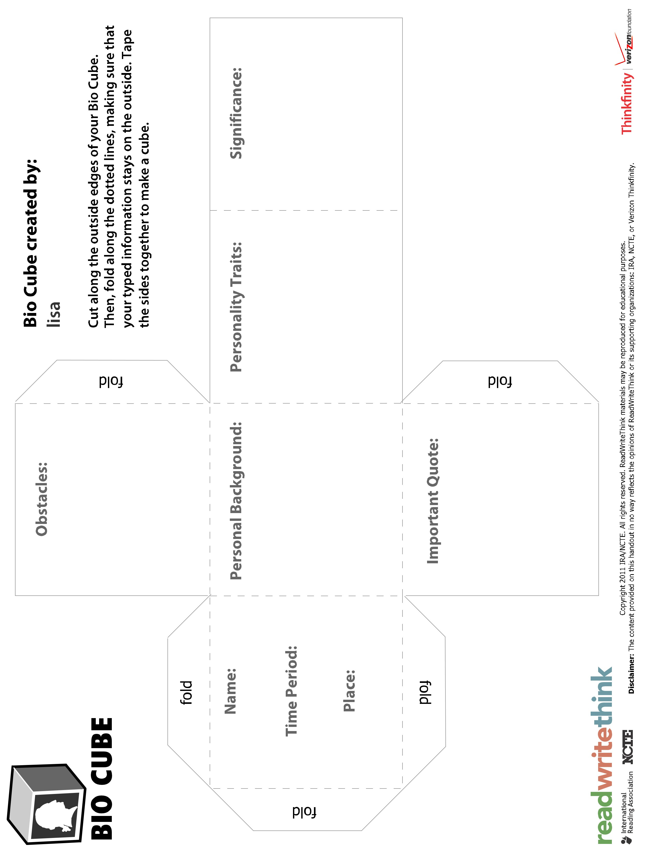

**THE BUS RIDE1**

**by Sahar Sabati**

I had finished my night shift in the ER and was on my way home. I actually was a full two hours early, as I had gone off for break so late that I was sent home by the head nurse. It was still dark outside; usually I left the ER around eight, and now it was barely six fifteen. We had had a good, easy night, and we certainly deserved it, as the last couple of weeks in the ER were horribly hectic to the point of the entire staff being ready to quit en masse.

When I got into the bus, I was relieved that my favorite seat at the back was empty. From that view point of the back corner of the bus, I could see everyone. I didn’t like being in a weak seat, where someone I couldn’t see could be watching me.**2**

A man came in a few moments later and chose the sideway seat in front of mine. He was carrying two bags. One was a red postman’s bag slung over his shoulder, the other was a black heavy-duty garbage bag he was half carrying, half dragging behind him. He put them both on the ground, propped his feet on them and leaned back in his seat.**3, 4**

For some kind of reason, I was particularly interested in this man. He had intrigued me, and I

didn’t know why. It happened sometimes that someone would catch my fancy. It made my imagination soar; made me weave an intricate web involving the person and the most insane stories.

In between quick glances, I noted that he was a middle-aged man, between forty to forty-five years of age, tall, thin but muscular, with an angular face and eyes set deep within their sockets. He had a five o’clock shadow and dark smudges under his eyes. His gaze was flickering around nervously, fluttering on each face around him, starting with the one on his right leading all the way to mine. I didn’t react to the scrutiny. I held his gaze, then slid my eyes away. Just enough contact to let him know I wasn’t afraid, but not too much so that he’d think I was interested.**5**

He continued watching the different people around him, his lips moving soundlessly, leaning his head back against the window and closing his eyes. He visibly relaxed. He was probably wary of meeting someone on the bus. An old girlfriend, maybe? Or maybe he was hoping to see someone, and was nervous about meeting again with that person.

I shrugged his eccentric behavior off—after all, he was just another one of the odd people who live in this city. I directed my gaze outside again at the city waking up. I still had thirty minutes of my ride to go.

Different scenarios explaining the man’s behavior spinning in my head, I was dozing off when a sharp, foul smell made my eyes snap open. The man has opened his red bag and taken out a

bottle, which seemed to be the source of the odor. I tried to control my wincing, as I didn’t want the man to see it. God only knew what his reaction would be.**6**

The man, unaware of my musings, took a long sip out of the bottle. It looked like plain, clean water—why did it stink so much?

Once again, my imagination started to wander. Maybe the man had gone down on luck, and had spent the night hunting for meat to feed his family. Maybe he worked as a sewage-cleaner during the night. Maybe his washing machine didn’t work, and when his clothes reached a state of utmost dinginess, he finally gave up and is now going to his mother’s house to use hers, which would explain his state and the smell emanating from the bag.

My imagination was now fired up; I was wide awake. Since he was looking the other way, I observed him more closely, to fine tune my story. I suddenly noticed the blood on his hands. Some of it was fresh, the rest caked. It formed an indistinct pattern, and I couldn’t see any visible wounds explaining the presence of blood.

However, it did correlate with my theory that he was a sewage-cleaner. After all, it wasn’t easy work, and he could hurt himself easily. I wondered if he had taken the time to disinfect his wounds, since he could get an infection.

I was musing on the dangers of simple wounds when the man slowly turned his head towards me. His gaze traveled from my hands, resting on my bag, up to my eyes.**7** He met them and I shuddered. His eyes were empty and cold. Eyes cold like this could only belong to someone who had no soul… Someone who could be capable of anything.

The man started fidgeting again, as if looking for a comfortable position. Maybe he had a guilty conscience. What had he done, that he couldn’t even sit comfortably in a bus?

My gaze fell on the ring that he was wearing. It was a gold chevalier, with a large green stone that could have been an emerald. The reason I noticed the ring was its spotlessness against the man’s dirty skin. It wasn’t a new ring; the stone showed obvious signs of wear. It didn’t match the man’s clothes and overall appearance, either. He was wearing the clothes of a construction worker, with visible wear and tear. He had no other jewelry on. It didn’t make sense that someone who was wearing old, torn up clothes, would be wearing such a clean, expensive looking ring.**8** Personally, I would leave such a piece of jewelry at home for when I’d wash up and put some cleaner clothes on.

The picture was becoming grimmer by the minute. What if that smell wasn’t that of sewage or an old sandwich? I had smelled that smell before. After all, I am a nurse. The smell was that of rotting meat. When taken in with the blood on his hands and the out of place ring, it did look like the man had killed someone and stuffed him or the clothes he was wearing during the killing in the bags he was wearing. It wasn’t his own ring the man was carrying. It was the ring of the person he had killed.**9**

My stop was coming up, but I decided to stay on the bus until the man had left. The fact that he might be a murderer was too serious for me to ignore, especially after he caught me looking at him with an odd look in his eyes. Had he guessed that I knew his secret? Would he follow me off the bus, then ambush me and kill me? Would my blood pouring over him add to the overall stench of his person?**10**

By then, my heart was pounding. Horrific visions of my mutilated body danced before my eyes. I forced them away with much difficulty. I didn’t know what to think; surely I was exaggerating. I had to be exaggerating. It was possible that the murder story I had read last evening had been lingering in my mind a little too long. When I thought about it, holes appeared in my carefully knitted theory. Surely a murderer wouldn’t take a public bus and face possible identification. But what about the proof? It couldn’t lead to any other conclusion. I was certain about it.

However, as I watched my stop roll by, the ridiculousness of the situation hit me and I felt a sudden sense of embarrassment. A grown woman such as myself should know better. What looked innocent could be more than that, whereas what looked horribly suspicious could be just as innocent.

Many people had questionable hygiene. Maybe he was a homeless man moving from one location to another. It was probably the long, sleepless night that had fueled my errand train of thoughts. That and that book that would find its way to the donations box as soon as I got home.

It was embarrassing to have to admit that I’d made a mistake. I rang the bell and was getting up to leave when the man looked at me and winked. It startled me. I tentatively smiled back. When he smiled, I felt utterly ridiculous. A man with such a nice smile couldn’t be a murderer. I got off and told myself that the extra walk would serve me as a lesson.

I finally got home, cold and tired. The wind had been blowing in my face the whole way, and every muscle in my body felt frozen. I took my keys out and opened the door. I kicked snow off the newspaper that was lying on the ground and gasped.**11**

Looking up at me was the man from the bus. Over his head was the title: “Man caught on tape killing wife and kids.” It seemed that I had been right, after all. I fearfully looked around. I had been right about the man’s past actions; had I guessed right about his future actions, including my possible demise? I hurried inside the house and closed the door firmly, knowing that I wouldn’t be able to sleep anytime soon.

Reprinted with permission of www.newmysteryreader.com. All rights reserved.

**VOCABULARY**

(listed in order of appearance in the story)

**hectic:** characterized by intense activity, confusion, or haste **en masse:** in one group or body; all together **intricate:** having many complexly arranged elements; elaborate **flickering:** making brief movements or tremors **nervously:** in an easily agitated or distressed way; in a high-strung or jumpy manner **scrutiny:** a close, careful examination or study **wary:** openly distrustful and unwilling to confide

**eccentric:** marked deviation from an established norm; especially used to describe odd or unconventional behavior **musings:** products of contemplation; thoughts **indistinct:** difficult to understand or make out **correlate:** to bear a reciprocal or mutual relation **grimmer:** more and more dismal; gloomier **horrific:** grossly offensive to decency or morality; causing horror **mutilated:** disfigured; irreparably damaged

**ridiculousness:** something deserving or inspiring ridicule; quality or state of being absurd, preposterous, or silly **hygiene:** conditions and practices that serve to promote or preserve health

**QUESTIONS**

1. Predict what the story will be about based on the title.
2. Why would the narrator want to sit at the back of the bus?
3. What do you think is in the bags?
4. If you would like to change your prediction, do so now.
5. Sketch what you think the man looks like.
6. What do you think the smell is?
7. How do you think the narrator feels right now?
8. Whose ring is the man wearing?
9. Do you think the man has killed someone? Use clues or evidence from the story to support your answer.
10. Do you think the narrator’s imagination is being overactive, or does he or she have something to worry about?
11. What does the narrator see that makes him or her worry?

Copyright 2005 IRA/NCTE. All rights reserved.

ReadWriteThink materials may be reproduced for educational purposes.



**Mystery Cube Planning Sheet**

Use this planning sheet to prepare for the online Mystery Cube interactive by filling in the information for each side of the cube. Because space on the cube is limited, you will need to briefly summarize your information.

|  |  |  |
| --- | --- | --- |
| **Side** | **Prompt** | **Information** |
| **1** | Setting |  |
| **2** | Detective |  |
| **3** | Crime or Mystery |  |
| **4** | Victim |  |
| **5** | Clues |  |
| **6** | Solution |  |



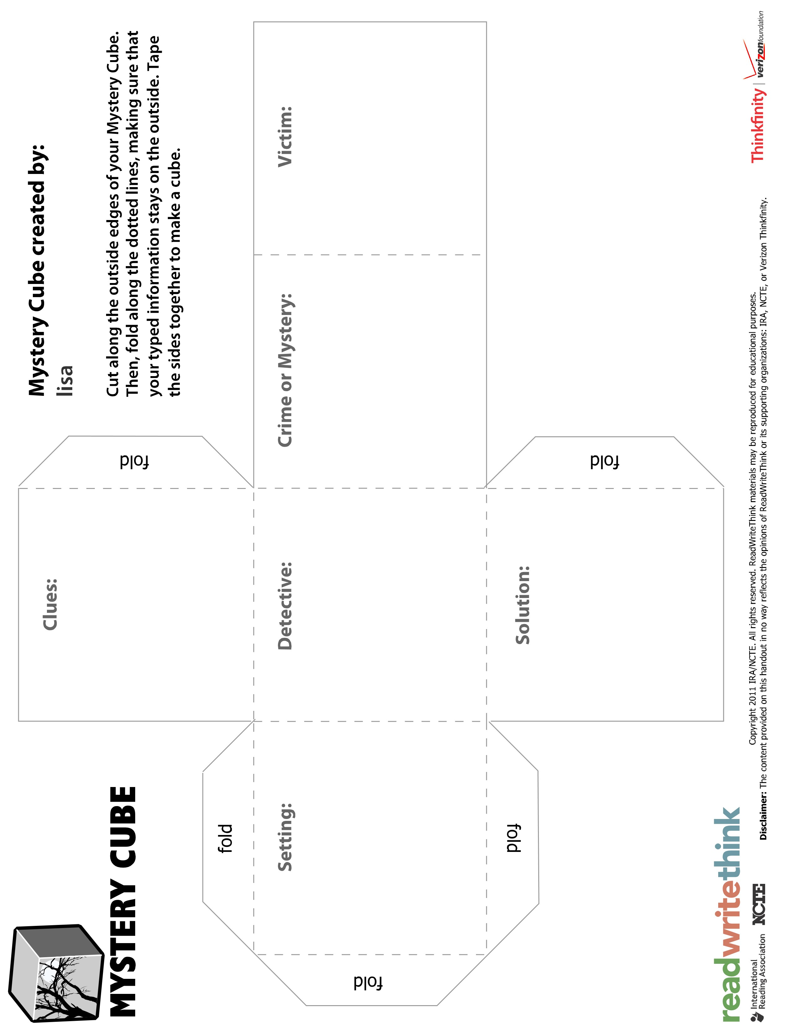

**Story Cube Planning Sheet**

Use this planning sheet to prepare for the online Story Cube interactive by filling in the information for each side of the cube. Because space on the cube is limited, you will need to briefly summarize your information.

|  |  |  |
| --- | --- | --- |
| **Side** | **Prompt** | **Information** |
| **1** | Characters |  |
| **2** | Setting |  |
| **3** | Conflict |  |
| **4** | Resolution |  |
| **5** | Theme |  |
| **6** | Favorite part |  |



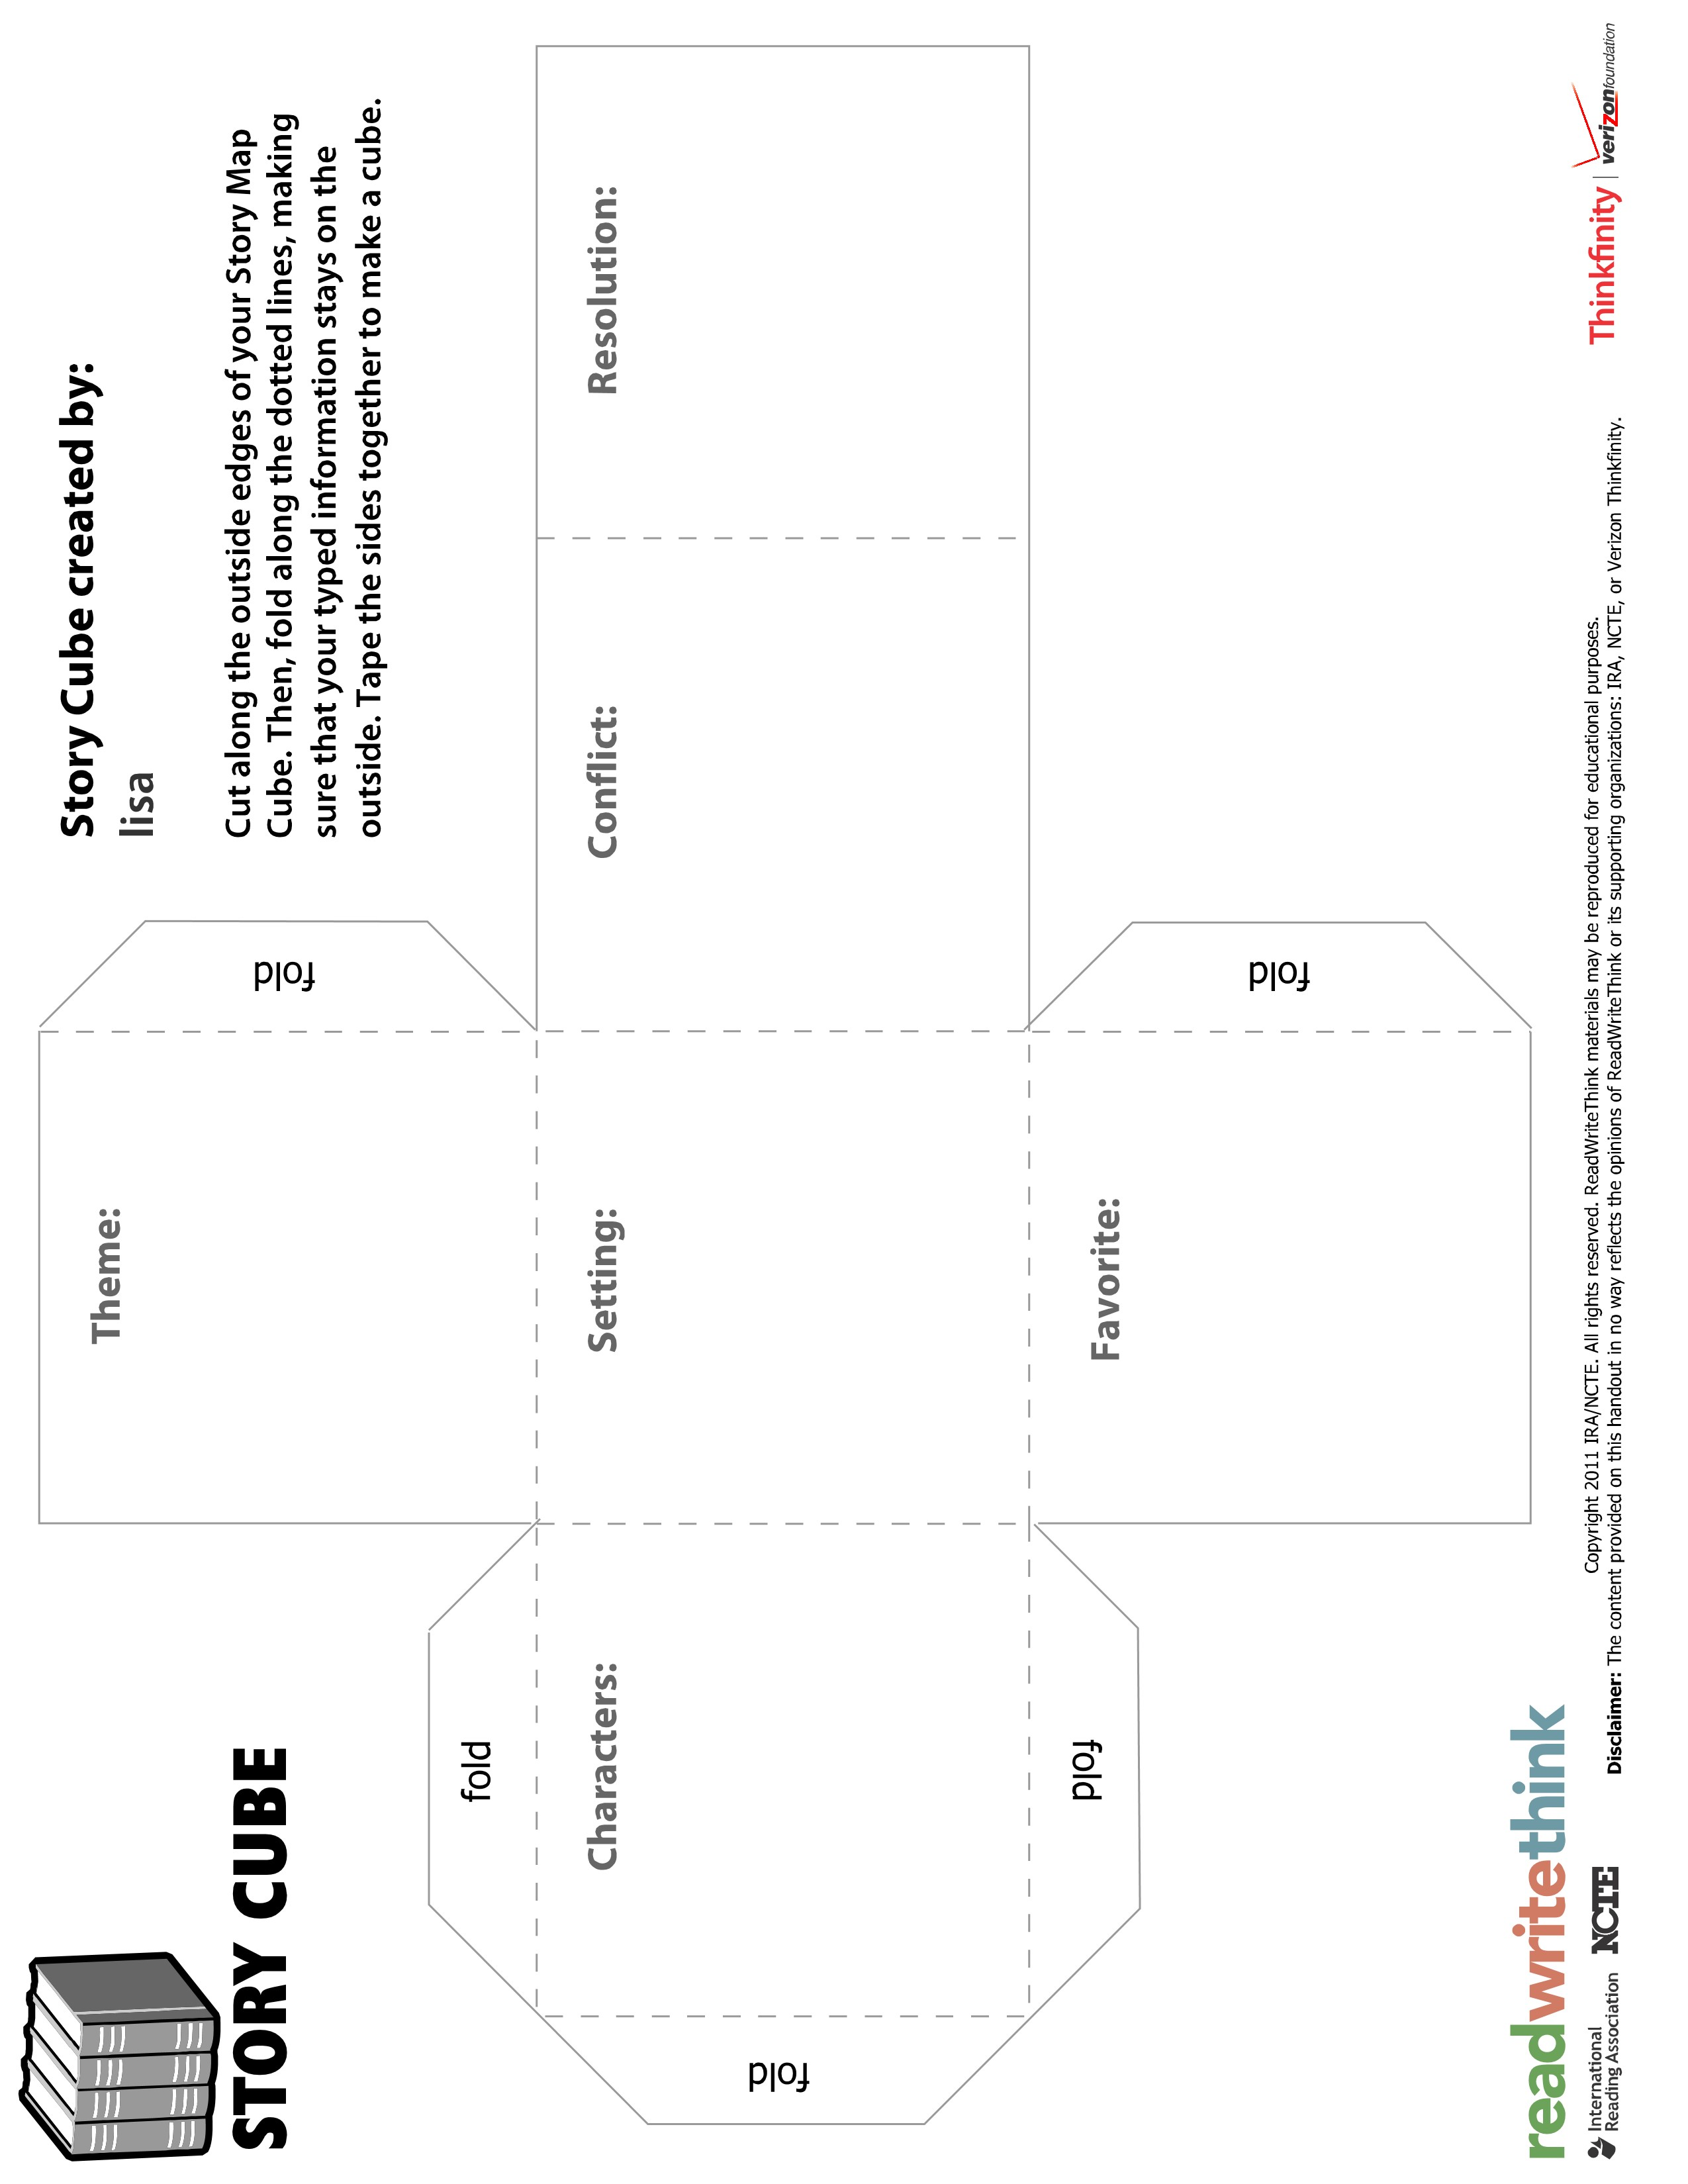

**Compare and Contrast Paragraph Examples**

**Directions: Read the paragraphs and answer the questions below.**

Thousands of years ago the Native people of North America had to build houses that fit their life. One kind of house was a tipi. The Plains people lived in tipis. Tipis were easy to put up and take down. In fact, it only took about half an hour to set them up. This was perfect for the Plains people who spent their time hunting and following herds of animals.

The Inuit, who lived in the cold Arctic region, spent part of the year living in igloos. Igloos were temporary homes like tipis. However, they were built for the cold winter months, whereas a tipi could be used year round. Both tipis and igloos had one main room that the family lived in and were usually made for a single family. Tipis and igloos were made of very different materials. Igloos were made from blocks of snow stacked on top of each other, while tipis were made from buffalo hide, tree bark, or grass. The shape of tipis and igloos was also different. Tipis were cone-shaped, using three or four poles for support. In contrast, igloos were dome-shaped.

1. **Is this paragraph comparing and contrasting two things?**

**Yes No**

1. **If no, how do you know it is not a compare and contrast paragraph?**
2. **If yes, what two things are being compared?**
3. **Circle the key words in the paragraph that show that the author was comparing and contrasting information.**

Are you tired of going on the same vacation year after year? Are you looking for an adventure? If you are, then a houseboat might be the thing for you. You can find places that rent houseboats in the United States, England, Asia, Australia, Canada, and New Zealand. This would be a great opportunity to travel the world in a unique way.

There are a wide variety of activities that you can participate in while vacationing on a houseboat. You can go fishing, swim in sparkling water, travel to different destinations, or just lie out and enjoy the sun and breeze. Cost is another factor to consider when renting a houseboat. You can actually rent a houseboat for about the same amount of money that you would spend on a nice hotel. One advantage of renting a houseboat is that you don’t have to go out to eat for every meal. Most houseboats have a kitchen area where you can cook meals. This will save you money on your vacation. So, if you want an affordable adventure, try renting a houseboat for your next vacation.

1. **Is this paragraph comparing and contrasting two things?**

**Yes No**

1. **If no, how do you know it is not a compare and contrast paragraph?**
2. **If yes, what two things are being compared?**
3. **Circle the key words in the paragraph that show that the author was comparing and contrasting information.**

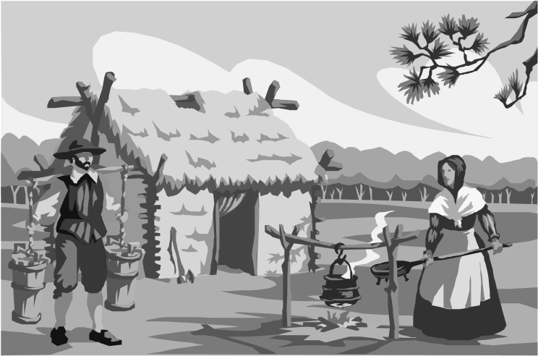Some settlers of the Great Plains built their houses out of sod. A sod house was made out of dirt bricks that the settlers uncovered when they plowed their fields. The settlers chose a place to build their sod house, marked out the corners in the dirt and began laying the sod bricks. They kept adding bricks until the sod house was tall enough for people to live in. The settlers left a small hole in the front for the door and an even smaller hole in the back for a window. Since the settlers didn’t have wood, they used blankets or quilts to make their door. They used paper to cover the windows. The roof was the last part added. To make this, the settlers laid long poles side by side and covered them with a thick layer of weeds and hay. Once the roof was finished, the settlers could move into their new house. Home sweet home!

1. **Is this paragraph comparing and contrasting two things?**

**Yes No**

1. **If no, how do you know it is not a compare and contrast paragraph?**
2. **If yes, what two things are being compared?**
3. **Circle the key words in the paragraph that show that the author was comparing and contrasting information.**

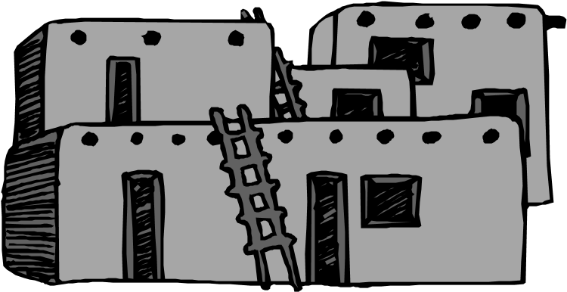A ger is a circular tent-like home that was often used by the nomadic people of Mongolia. Gers are easy to take down and put up. In fact, once the ger is fully collapsed it only takes one animal to carry it to the next place. This is perfect for people who need to move quickly from one place to the next. Unlike the ger, an adobe house does not move. It is permanent and is meant to stay in one place for a long time. An adobe house is built using bricks made of clay, water, and straw. A ger, on the other hand, is built using wooden poles and canvas material. Adobe buildings are perfect for people who live in hot climates. The adobe bricks help the home to stay cool when it is hot. In contrast, a ger is great for both cold and warm weather.

1. **Is this paragraph comparing and contrasting two things?**

**Yes No**

1. **If no, how do you know it is not a compare and contrast paragraph?**
2. **If yes, what two things are being compared?**
3. **Circle the key words in the paragraph that show that the author was comparing and contrasting information.**



Using the Found Poem and the Parallel Poem, complete the Venn diagram, to explore the similarities and differences between the two types of poems.

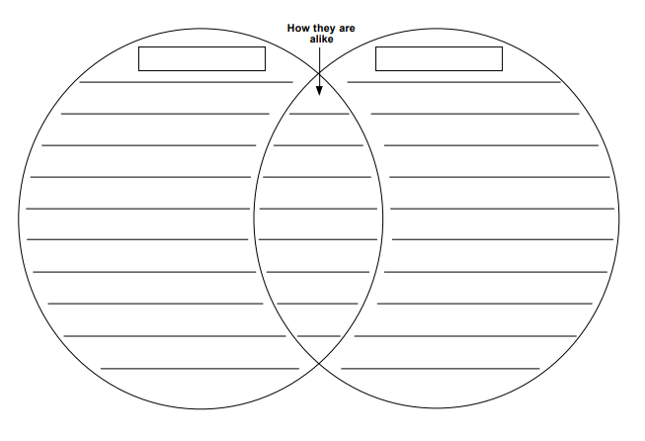

**Paragraph Writing Template - Hamburger**

Write your topic at the top. Add details to the middle layers. Add a concluding sentence at the bottom.

**Topic:**

**Detail:**

**Detail:**

**Detail:**

Copyright

©

Houghton

Mi

f

flin

Compan

y

.

All

Rights

Reserved.

**Basic Paragraph: Graphic Organizer**

|  |  |
| --- | --- |
| **possible transitional words and phrases**  likewise also furthermore    in addition moreover another reason |  |

t

opic

:

controlling idea:

supporting detail #1

supporting detail #3

supporting detail #2

© jp/Landmark Outreach 2016

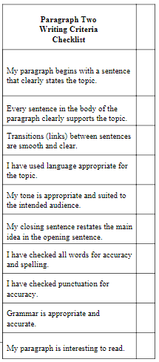

**Littératie : Français**

**« RESSEMBLER » et « SEMBLER »**

\***HERE, STUDENTS READ THE EXPLANATION PRESENTING A COMMON MISTAKE AND THE CORRECT SENTENCE STRUCTURES THEY CAN USE INSTEAD. They then try to apply the learned rule by filling in the blanks and inventing sentences using the correct structures.**

* ~~Ça regarde comme un chat~~. Ça ressemble **à** un chat.
* ~~Tu regardes comme ta cousine~~. Tu ressembles **à** ta cousine.
* ~~Ces personnes regardent gentils.~~ Ces personnes semblent gentilles.

*** On peut aussi utiliser « avoir l’air de »

Exemple : Mon chien a l’air d’un loup.

***Sembler ou ressembler?***

1. C’est incroyable comment Paige ___________________ à sa sœur.
2. Ils ______________ prêts à commencer.
3. Trouvez-vous que son chien lui ___________________ un peu?
4. Ce chien _____________ énervé!

Écris une phrase avec le verbe ressembler.

________________________________________________________________________________________________________________________________________________________________________________________

Écris une phrase avec le verbe sembler.

________________________________________________________________________________________________________________________________________________________________________________________

Source: Adaptation d’une ressource de Vicky Gudmunson (Collège Jeanne-Sauvé, DSL-R)

**Quand utiliser ER et É**

\***HERE, STUDENTS READ THE EXPLANATION PRESENTING HOW TO DETERMINE IF A VERB SHOULD END WITH -ER OR -É. They then try to apply the learned rule by identifying mistakes and correcting them.**

On utilise **ER** (l’infinitif) :

* Après un verbe conjugué qui **N’EST PAS** avoir ou être

Ex : Il veut regarder la télévision.

* Après une préposition (à, de, pour, par, sans, etc.)

Ex : Il a décidé de terminer ses études secondaires.

On utilise **É** (un participe passé) :

* Après le verbe avoir ou être

Ex : J’ai mangé une pomme. Je suis allé à l’école

**TRUC** : Remplacez le verbe en question par bâtir/vendre ou bâti/vendu et décidez quelle version a le plus de sens dans la phrase. Si c’est bâtir ou vendre, écrivez ER comme terminaison. Si c’est bâti ou vendu, écrivez É comme terminaison.

**Exercice - Corrige les phrases suivantes s’il y a lieu** (Il y a **5** erreurs parmi ces **6** phrases)

1. Il a décidé de quitté sa maison.
2. Elle voulait allée se baigner dans le lac.
3. Vous pouvez essayer de les attaqués, mais personne ne vous croira.
4. L'entraîneur a demander aux joueuses de joué comme équipe.
5. Après avoir fait son travail, il est rentré chez lui.
6. Il veut complété son travail dès que possible.

Source: Adaptation d’une ressource de Janelle Balcaen (Collège Jeanne-Sauvé, DSL-R)

**Des problèmes avec SUR…**

\***HERE, STUDENTS READ THE EXPLANATION PRESENTING A COMMON MISTAKE AND THE CORRECT SENTENCE STRUCTURES THEY CAN USE INSTEAD. They then try to apply the learned rule by identifying and correcting the mistakes and inventing sentences using the correct structures.**

* Elle est ~~sur le~~ téléphone = Elle est AU téléphone

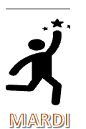 ?

* Un ~~programme sur~~ la télévision = Une ÉMISSION À LA télévision
* ~~Sur~~ mardi, on est allé au magasin = MARDI, on est allé au magasin.

***Corrige les erreurs de « sur » dans les phrases suivantes.***

1. Ça ne presse pas; tu peux me remettre ton travail sur jeudi.
2. J’ai tellement hâte de visionner American Idol, mon programme préféré sur la télévision.
3. Ginette ne pouvait pas répondre à la porte car elle était sur le téléphone.

Écris une phrase en incluant **un jour de la semaine** (lundi, mardi, mercredi, jeudi, vendredi, samedi ou dimanche)**.**

____________________________________________________________________________________________

____________________________________________________________________________________________

Écris une phrase en incluant **un téléphone.**

____________________________________________________________________________________________

____________________________________________________________________________________________

Source: Adaptation d’une ressource de Janelle Balcaen (Collège Jeanne-Sauvé, DSL-R)

**Utilisation des verbes «**CHERCHER**» et «**REGARDER**»**

\***HERE, STUDENTS READ THE EXPLANATION PRESENTING A COMMON MISTAKE AND THE CORRECT SENTENCE STRUCTURES THEY CAN USE INSTEAD. They then try to apply the learned rule by filling in the blanks and inventing sentences using the correct structures.**

* Tu ~~regardes pour~~ tes clés dans ton sac à main. = Tu CHERCHES tes clés dans ton sac à main.
* ~~Regardez~~ dans le dictionnaire pour la définition. = CHERCHEZ dans le dictionnaire pour la définition.
* REGARDER: Faire en sorte de voir qqn ou qqch (synonymes- examiner/observer)
* CHERCHER : Se déplacer, parcourir un lieu, faire des efforts pour trouverou retrouver quelque chose ou quelqu’un qui se trouve à un endroit inconnu ou oublié

Exemples : Il regarde sa montre. Il regarde par la fenêtre. Il cherche de l’information. Elle cherche sa mère dans la maison.

***Chercher ou regarder?***

1. Dylan aime beaucoup ___________________ les oiseaux par la fenêtre.
2. Si tu ___________________ assez longtemps, tu trouveras la réponse.
3. Chaque soir, Julie _____________ le beau coucher de soleil.
4. « Maman, où sont mes patins? J’ai _________________ partout! »

Écris une phrase avec le verbe regarder.

________________________________________________________________________________________________________________________________________________________________________________________

Écris une phrase avec le verbe chercher.

________________________________________________________________________________________________________________________________________________________________________________________

Source: Adaptation d’une ressource de Vicky Gudmunson (Collège Jeanne-Sauvé, DSL-R)

**Les expressions**

**HERE, STUDENTS READ COMMON FRENCH EXPRESSIONS AND LEARN THEIR MEANING AND ENGLISH EQUIVALENT. They then choose one expression to represent in the form of a drawing, painting or craft and write a caption using the expression in context.**

Choisis une de ces expressions et dessine, peint ou bricole afin de représenter l’image qu’elle communique et sa signification. Ajoute un exemple de phrase dans laquelle on peut utiliser cette expression idiomatique ou figée.

Si c’est-ce que tu fais aujourd’hui choisis une de ces expressions et choisis en une autre la prochaine fois.

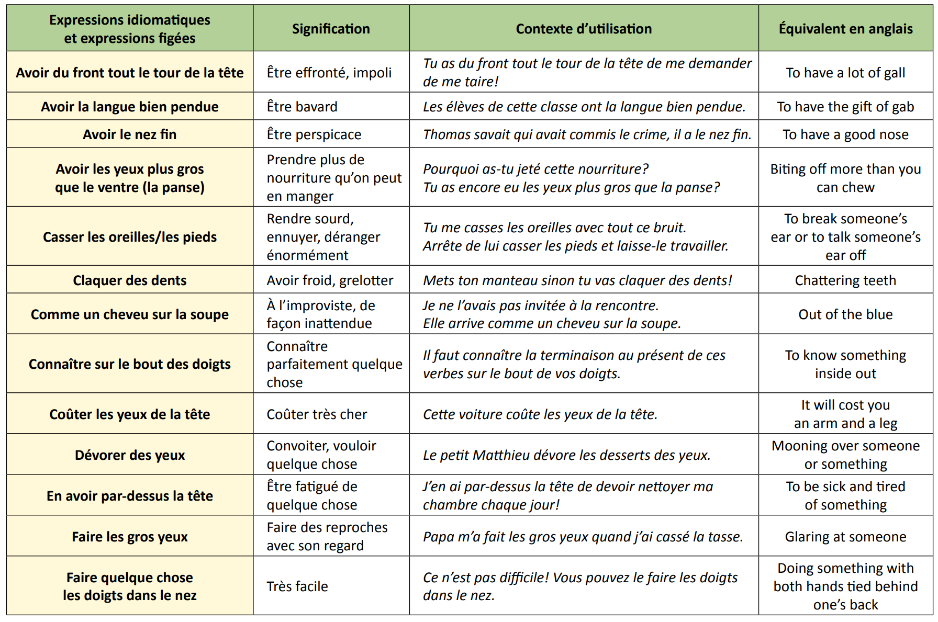

**Source:** [expressions_idiomatiques.pdf (gov.mb.ca)](https://www.edu.gov.mb.ca/m12/frpub/ped/fl2/cadre_m-8/docs/expressions_idiomatiques.pdf)

**Voici un exemple :**

Une phrase complète qui démontre une bonne utilisation de cette expression:

Stéphane s’est mis les pieds dans le plat en racontant son histoire à Jérémie. J’ai pris la voiture de mon père sans sa permission et j’ai eu un accident. Je me suis mis les pieds dans le plat car je n’avais qu’un permis provisoire.



**Illustration:**

<http://www.tv5monde.com/TV5Site/publication/galerie-282-10-Mettre_les_pieds_dans_le_plat_parler_tres_directement_d_un_fait_qui_derange.htm>

**Un défi des services secrets SS et bonne actions BA en 10 jours pendant la pandémie**

**HERE, STUDENTS TAKE ON THE ROLE OF A SECRET AGENT WHOSE MISSION IS TO PERFORM RANDOM ACTS OF KINDNESS FOR OTHERS ON A DAILY BASIS WITHOUT BEING DISCOVERED. They then record their actions in a daily log.**

Agent(e) secret(e)___________________________________.

En acceptant ton rôle comme agent secret en mission, tu vas servir les autres de manière secrète. Durant les prochains 10 jours, tu vas servir et aider les autres de façon aléatoire, mais tu dois le faire sans que ces personnes le sachent vraiment. Alors, tu choisis les personnes que tu serviras secrètement et puis tu décides d’un geste ou d’une bonne action (BA) à faire. Tu dois rendre ces services de façon Haut Top Secret! Surtout, NE TE FAIS PAS TROP reconnaître! ☺ 

**Idées pour des services que tu peux accomplir et qui peuvent compter !!**

|  |  |
| --- | --- |
| * Rends un service ou joue avec ton frère ou ta sœur. * Écris une note à quelqu’un en lui disant comment et combien tu l’apprécies (tu peux garder ceci en secret ou non). * Fais un sourire à 3 personnes pour ensoleiller leur journée. * Nettoie discrètement la voiture, la chambre, le salon ou la cuisine. * Demande à ta mère ou à ton père ce que tu peux faire pour les aider. * Prépare le déjeuner pour ta mère ou ton père et apporte-le au lit. * Aide ton petit frère ou ta petite sœur à se préparer pour aller à l’école ou pour une activité. * Ramasse les déchets que tu vois par terre pendant une journée. * Prépare un repas avec ta famille. * Aide ta famille à mettre la table sans qu’il te le demande. * Vide ou remplis le lave-vaisselle sans que personne ne le sache. * Offre un beau dessin à un ami pour ensoleiller sa journée | * Envoie une lettre par la poste à ta grand-maman ou à ton grand-papa. Tu devras demander à tes parents l’adresse de tes grands-parents et avoir un timbre. Utilise un modèle de carte postale. * Dis « je t’aime » à une personne que tu aimes beaucoup. * Lis un livre ou une histoire à un petit frère, une petite sœur, un petit cousin ou une petite cousine. * Parle gentiment pendant toute une journée. * Fais des gestes de politesse. Ex : tenir la porte pour une personne. * Offre un de tes jouets que tu n’utilises plus à un ami. * Prends soin d’un animal, amuse-toi et promène ton chien dehors. Il sera vraiment heureux ☺. * Ceux-ci sont quelques idées pour t’inspirer. Bonne chance avec ta mission!   Au retour, nous ferons une causerie sur vos bonnes actions. Nous avons hâte d’entendre vos réalisations pendant cette période d’apprentissage à distance.   Certaines de ces missions requièrent l’aide d’un parent☺. |

Adapté du document siteweb: Millemerveilles   
Document créé par: Katryne Mauviel

**Services secrets – Registre de bonnes actions**

|  |
| --- |
| 1er jour |
| Service rendu (geste ou bonne action) : |
| La personne qui reçoit le service : |
| Écris et dessine le service que tu as rendu |

|  |
| --- |
| 2e jour |
| Service rendu (geste ou bonne action) : |
| La personne qui reçoit le service : |
| Écris et dessine le service que tu as rendu |

|  |
| --- |
| 3e jour |
| Service rendu (geste ou bonne action) : |
| La personne qui reçoit le service : |
| Écris et dessine le service que tu as rendu |

**Services secrets – Registre de bonnes actions**

|  |
| --- |
| 4e jour |
| Service rendu (geste ou bonne action) : |
| La personne qui reçoit le service : |
| Écris et dessine le service que tu as rendu |

|  |
| --- |
| 5e jour |
| Service rendu (geste ou bonne action) : |
| La personne qui reçoit le service : |
| Écris et dessine le service que tu as rendu |

|  |
| --- |
| 6e jour |
| Service rendu (geste ou bonne action) : |
| La personne qui reçoit le service : |
| Écris et dessine le service que tu as rendu |

**Services secrets – Registre de bonnes actions**

|  |
| --- |
| 7e jour |
| Service rendu (geste ou bonne action) : |
| La personne qui reçoit le service : |
| Écris et dessine le service que tu as rendu |

|  |
| --- |
| 8e jour |
| Service rendu (geste ou bonne action) : |
| La personne qui reçoit le service : |
| Écris et dessine le service que tu as rendu |

|  |
| --- |
| 9e jour |
| Service rendu (geste ou bonne action) : |
| La personne qui reçoit le service : |
| Écris et dessine le service que tu as rendu |

**Services secrets – Registre de bonnes actions**

|  |
| --- |
| 10e jour |
| Service rendu (geste ou bonne action) : |
| La personne qui reçoit le service : |
| Écris et dessine le service que tu as rendu |

**Section de numératie**

**Jeux de maths : Le baseball**

|  |  |  |
| --- | --- | --- |
| **Addition simple  à 2 chiffres** | **Addition avancée  à 2 chiffres** | **Addition simple  à 3 chiffres** |
| **Matériaux requis**  Un jeu de cartes  Retirez les cartes 5 à 10 ainsi que les cartes de personnages (J, Q, K)  Papier brouillon pour faire les calculs  Crayon  **Comment jouer**  1. Chaque personne prend 4 cartes.  2. Les joueurs arrangent leurs cartes pour faire un problème d’addition à 2 chiffres.  3. As = 1  **L’objectif est de faire la plus grosse somme possible**.  **Exemple**  Le premier joueur pige les cartes  4, 3, 2, 4, les arrange et fait les calculs suivants :  43 34  + 42 OU + 42  85 76  Le deuxième joueur pige les cartes  4, 1, 2, 1, les arrange et fait les calculs suivants :  41 21  +21 OU +14  62 35  Chaque joueur vérifie les calculs de l’autre. Le premier joueur a la plus grosse somme dans cette ronde et marque donc un point. Le jeu se poursuit jusqu’à ce qu’un joueur ait marqué 9 points. Vous aurez peut-être besoin de mélanger les cartes si vous les utilisez toutes. | **Matériaux requis**  Un jeu de cartes  Retirez les 10 ainsi que les cartes de personnages (J, Q, K)  Papier brouillon pour faire les calculs  Crayon  **Comment jouer**  1. Chaque personne prend 4 cartes.  2. Les joueurs arrangent leurs cartes pour faire un problème d’addition à 2 chiffres.  3. As = 1  **L’objectif est de faire la plus grosse somme possible.**  **Exemple**  Le premier joueur pige les cartes 9, 6, 4, 5, les arrange et fait les calculs suivants :  96 95  +54 OU +64  150 159  Le deuxième joueur pige les cartes  8, 9, 1, 2, les arrange et fait les calculs suivants :  98 89  +54 OU +64  119 110  Chaque joueur vérifie les calculs de l’autre. Le premier joueur a la plus grosse somme dans cette ronde et marque donc un point. Le jeu se poursuit jusqu’à ce qu’un joueur ait marqué 9 points. Vous aurez peut-être besoin de mélanger les cartes si vous les utilisez toutes. | **Matériaux requis**  Un jeu de cartes  Retirez les cartes 5 à 10 ainsi que les cartes de personnages (J, Q, K)  Papier brouillon pour faire les calculs  Crayon  **Comment jouer**  1. Chaque personne prend 6 cartes.  2. Les joueurs arrangent leurs cartes pour faire un problème d’addition à 3 chiffres.  3. As = 1  **L’objectif est de faire la plus grosse somme possible.**  **Exemple**  Le premier joueur pige les cartes  4, 4, 3, 3, 2, 1, les arrange et fait les calculs suivants :  443   433   431  +321 OU +421 OU +432       764   854   863  Le deuxième joueur pige les cartes  4, 4, 2, 2, 3, 1, les arrange et fait les calculs suivants :  442   431   432  +321 OU +422 OU +421       763   853   853  Chaque joueur vérifie les calculs de l’autre. Le premier joueur a la plus grosse somme dans cette ronde et marque donc un point. Le jeu se poursuit jusqu’à ce qu’un joueur ait marqué 9 points. Vous aurez peut-être besoin de mélanger les cartes si vous les utilisez toutes. |

*Défi : Concevez un jeu d’addition avancée à trois chiffres.*

**Math Games: Baseball**

|  |  |  |
| --- | --- | --- |
| Baseball  Addition 1 | Baseball  Addition 2 | T-Ball  Addition |
| **Equipment:**  A deck of cards – use aces to 4  Remove face cards and cards 5 to 10  Scrap paper for calculating  Pencil  **How to play**  1. Each person takes 4 cards.  2. Players arrange their cards to make a 2-digit adding problem.  3. Ace = #1  **The object is to make the greatest sum possible**.  **Example**  Player 1 draws 4, 3, 2, 4, arranges the cards and calculates:    43 34  + 42 OR + 42  85 76  Player 2 draws 4, 1, 2, 1, arranges the cards and calculates:  41 21  +21 OR +14  62 35  Each player checks the other’s calculations. Player 1 has the greatest sum this round and scores one “run”. Play continues until one player has scored 9 points. You may need to shuffle the cards if you use them all. | **Equipment:**  A deck of cards – use aces to 9  Remove the 10s and face cards  Scrap paper for calculating  Pencil  **How to play**  1. Each person takes 4 cards.  2. Players arrange their cards to make a 2-digit adding problem.  3. Ace = #1  **The object is to make the greatest sum possible.**  **Example**  Player 1 draws 9, 6, 4, 5, arranges the cards and calculates:  96 95  +54 OR +64  150 159  Player 2 draws 8, 9, 1, 2, arranges the cards and calculates:  98 89  +54 OR +64  119 110  Each player checks the other’s calculations. Player 1 has the greatest sum this round and scores one “run”. Play continues until one player has scored 9 runs. You may need to shuffle the cards if you use them all. | **Equipment:**  A deck of cards – use aces to 4  Remove face cards and cards 5 to 10  Scrap paper for calculating  Pencil  **How to play**  1. Each person takes 6 cards.  2. Players arrange their cards to make a 3-digit adding problem.  3. Ace = #1  **The object is to make the greatest sum possible.**  **Example**  Player 1 draws 4, 4, 3, 3, 2, 1, arranges the cards and calculates:  443   433   431  +321 OR +421 OR +432       764   854   863  Player 2 draws 4, 4, 2, 2, 3,1, arranges the cards and calculates:  442   431   432  +321 OR +422 OR +421       763   853   853  Each player checks the other’s calculations. Player 1 has the greatest sum this round and scores one “run”. Play continues until one player has scored 9 runs. You may need to shuffle the cards if you use them all. |

*Extension: Design a similar game adding three-digit numbers with cards Ace to 9.*

**Photographes en herbe**

À l’aide des informations suivantes, prenez des photos d’autres objets qui seraient mesurés à l’aide de mm, cm et m. Estimez leurs longueurs, puis mesurez, si possible.

Utilisez les lignes directrices approximatives suivantes comme exemples, si vous n’avez pas un moyen de mesurer avec précision les objets.

|  |  |
| --- | --- |
| un millimètre | l’épaisseur d’une pièce de 10 cents |
| un centimètre | la largeur de l’ongle de pouce |
| un mètre | la hauteur d’une poignée de porte |

**Budding Photographers**

*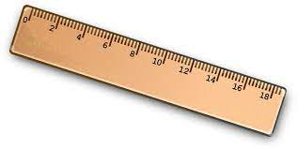Using the following information, take photos of other objects that would be measured using mm, cm and m. Estimate their lengths, the measure, if possible.*

*Use the following approximate guidelines as examples, if you do not have a way to accurately measure the objects.*

|  |  |
| --- | --- |
| one millimetre | the thickness of a dime |
| one centimetre | the width of your thumbnail |
| one metre | the height of a doorknob |

**Comptons les voyelles**

1. Trouvez chez vous un de vos aliments emballés préférés.
2. En regardant les étiquettes sur le paquet, faites une prédiction sur le nombre de chaque voyelle (a, e, i, o, u) que vous y trouverez.
3. 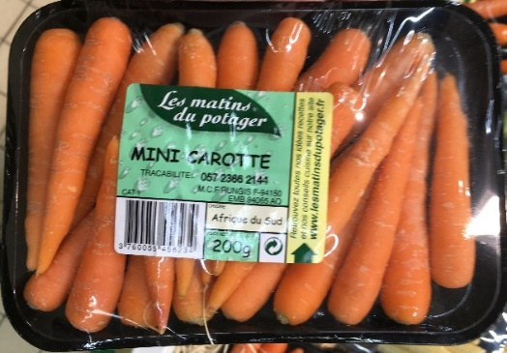Écrivez votre prédiction dans un tableau de fréquence, puis comptez—au moyen de marques de fréquence—le nombre de fois que chaque voyelle apparait sur l’emballage.

|  |  |  |  |
| --- | --- | --- | --- |
| **Voyelle** | **Prédiction** | **Marques de fréquence** | **Compte total** |
|  |  |  |  |
|  |  |  |  |
|  |  |  |  |
|  |  |  |  |
|  |  |  |  |

1. Une fois le compte terminé, comptez les marques de fréquence et inscrivez le nombre total dans le tableau.
2. Créez un diagramme à bandes pour afficher vos données. Placez les voyelles sur l’axe horizontal et la fréquence sur l’axe vertical. Indiquez un titre. Vous pouvez employer Excel pour dresser le tableau et préparer le graphique, si vous le désirez.
3. Répondez aux questions suivantes, en fonction de vos résultats :
4. À quel point vos prédictions étaient-elles proches de vos résultats réels ?
5. Quelle voyelle apparaît le plus souvent ? Le moins souvent ?
6. Si vous répétiez cet exercice en utilisant différents aliments, obtiendriez-vous des résultats semblables ?
7. Est-ce que la fréquence des voyelles est la même en anglais qu’en français ? Faites une prédiction, puis préparez des tableaux de fréquence distincts pour chaque langue.
8. Comparez vos résultats à ceux de vos camarades de classe. Peut-on tirer des conclusions ?
9. Comment la quantité de données recueillies influe-t-elle sur la validité de la conclusion tirée ou des prédictions sur les activités futures ?

**Counting Vowels**

1. Find a favourite packaged food item in your home.
2. As you look at the labels on the package, make a prediction about the number of each vowel (a, e, i, o, u) that you will see.
3. 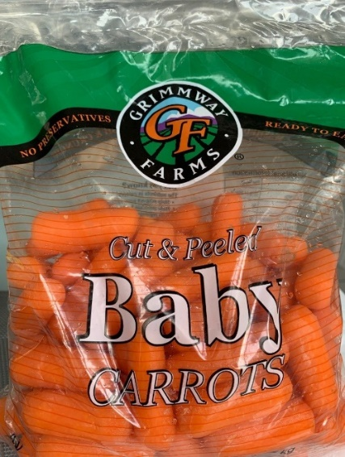Record your prediction on a tally chart, then count and keep track of the number of times each vowel appears on the packaging.

|  |  |  |  |
| --- | --- | --- | --- |
| **Vowel** | **Prediction** | **Tally Marks** | **Total** |
|  |  |  |  |
|  |  |  |  |
|  |  |  |  |
|  |  |  |  |
|  |  |  |  |

1. Once you have completed the tally chart, write each total number of tally marks on the chart.
2. Create a bar graph to display your data. Create a title for your graph, using the vowels along the horizontal axis, and the number of times they occur along the vertical axis. Colour your bars for added finishing details.
3. Answer the following questions, based on your results:
4. How close were your predictions to your actual results?
5. Which letter appears the most frequently? The least frequently?
6. If you repeated this exercise, using different food items, would you get similar results?
7. Does the language used on the packaging make a difference with your results, if you make separate tally charts for each language used?
8. Compare your results with your classmates. Can any conclusions be drawn?
9. Does the amount of collected data contribute to a valid conclusion or prediction about future activities?

**Puzzle de table de multiplication**

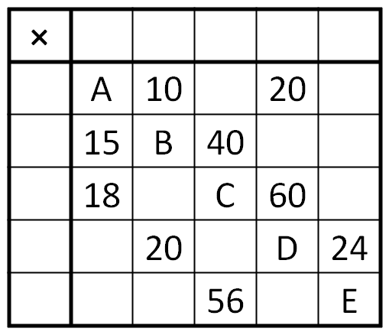

Dans la table de multiplication ci-dessus les titres de rangée et de colonne sont tous manquants, et seulement quelques-uns des produits dans la table sont remplis. Quelle est la valeur de *A*+*B*+*C*+*D*+*E* ?

****Rappelez-vous les étapes de résolution de problème :

1. Déterminer le problème à résoudre.
2. Énumérer les informations fournies.
3. Réfléchir sur comment résoudre le problème
4. Noter toutes les idées qui te parviennent à l’esprit.
5. Tenter de résoudre le problème.
6. Vérifier les résultats obtenus.
7. Recommencer au besoin jusqu’à ce que la solution soit trouvée. La persévérance fait partie intégrante du processus !

**Multiplication Table Puzzle**

In the multiplication table above, the row and column headings are all missing, and only some of the products in the table are filled in. What is the value of A+B+C+D+E?

Follow the problem-solving steps :

1. Determine the problem that needs solving.
2. List all information provided.
3. Think about how to solve to solve the problem.
4. Note all ideas that come to mind.
5. Try to solve the problem.
6. Check your answer.
7. Start over, as necessary, until you find the solution. Perseverance is part of the problem-solving process!

**Comparer des nombres**

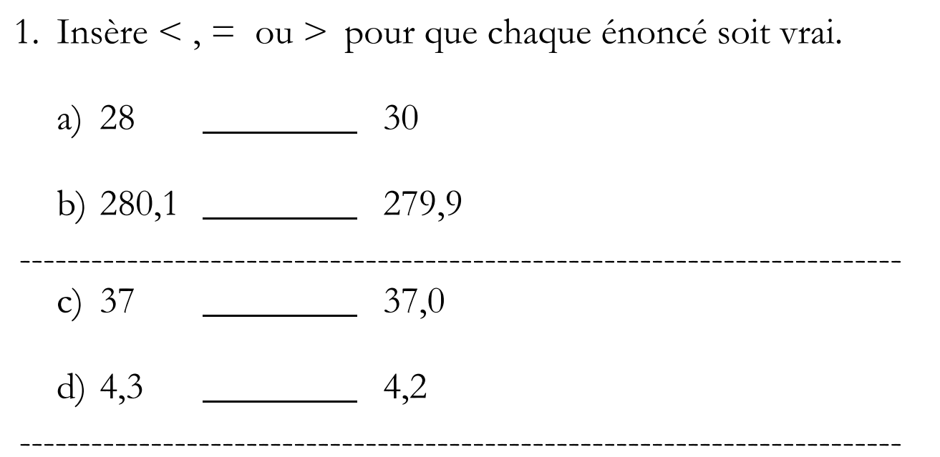

*Insert <, = or > to make each statement true.*

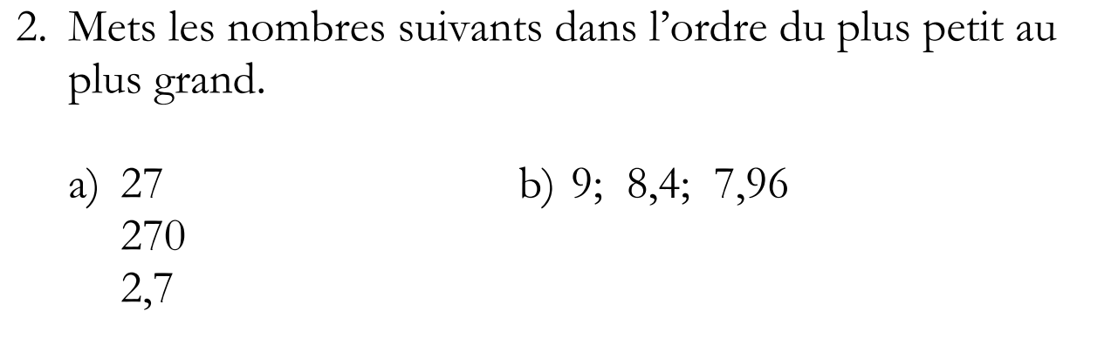

*Place the numbers in order from least to greatest.*

**Mettre des nombres à leur place**

Dans ce jeu, un nombre différent appartient à chaque carré du tableau de jeu. Il y a des indices fournis pour vous aider à décider quel numéro appartient à chaque carré et les nombres que vous pouvez utiliser sont indiqués. Par exemple, dans le jeu 1 ci-dessous, le deuxième indice nous indique que le nombre au ***carré b*** doit être supérieur à 4. Quelles possibilités y a-t-il ? Le dernier indice dit que le nombre dans ***le carré*** ***f*** doit être supérieur à 5. Quel nombre doit y figurer ? Cela signifie que ***le carré******b*** doit contenir le numéro 5. Pourquoi ? Terminez le reste du jeu 1.

*In this game a different number belongs in each square of the game board. There are clues given to help you*

*decide which number belongs in each square and the numbers you may use are listed. For example, in Game 1 below, the second clue tells us that the number in* ***square******b*** *must be more than 4. What choices do we have? The last clue says that the number in* ***square******f*** *must be greater than 5. What number belongs in* ***square******f****? This means that* ***square******b*** *must contain the number 5. Why? Complete the rest of Game 1.*

**Premier jeu: Indices. Utilise 1, 2, 3, 4, 5 et 6 Tableau de jeu**

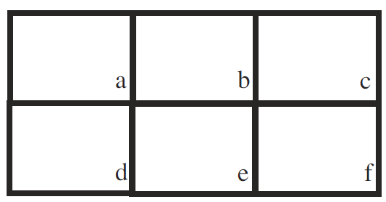

a. entre 3 et 6 b. plus de 4

c. moins que 2 d. moins que 4

e. entre 2 et 5 f. plus que 5

Complète les jeux 2 et 3 de la même façon. Le jeu 3 utilise un ensemble de nombres différent.

*Complete games 2 and 3 in the same fashion. Game 3 uses a different set of numbers.*

**Deuxième jeu: Indices. Utilise 1, 2, 3, 4, 5 et 6 Tableau de jeu**



a. plus que 3 b. entre 1 et 4

c. moins que 3 d. le quotient de 8 et 2

e. moins que 4 f. plus que 5

**Troisième jeu: Indices. Utilise 6, 7, 8, 9, 10, 11 Tableau de jeu**



a. plus petit que 8 b. plus petit que 7

c. entre 8 et 11 d. un nombre premier

e. plus grand que 9 f. un nombre pair

Les jeux 2 et 3 ont plus d’une solution possible chacun. Combien de solutions différentes peux-tu trouver?  
*Games 2 and 3 have more than one possible solution each. How many different solutions can you find?*

**Représenter les nombres**

|  |  |  |
| --- | --- | --- |
| 1. On peut représenter les nombres de différentes façons. Par exemple, « deux » peut être exprimé par : |  | *Numbers can be represented in different ways. For example, the number “two” can be expressed using:* |
| * + des mots   + des symboles   + des opérations   + des diagrammes |  | * + *words*   + *symbols*   + *operations*   + *diagrams* |
| Représente 12 de huit façons différentes. Sers-toi de mots, de symboles, d’opérations et de diagrammes. |  | *Represent 12 using eight different ways. Use words, symbols, operations and diagrams.* |
|  |  |  |
| 1. Quelle fraction de chaque figure est ombrée ? |  | *What fraction of each figure is shaded?* |

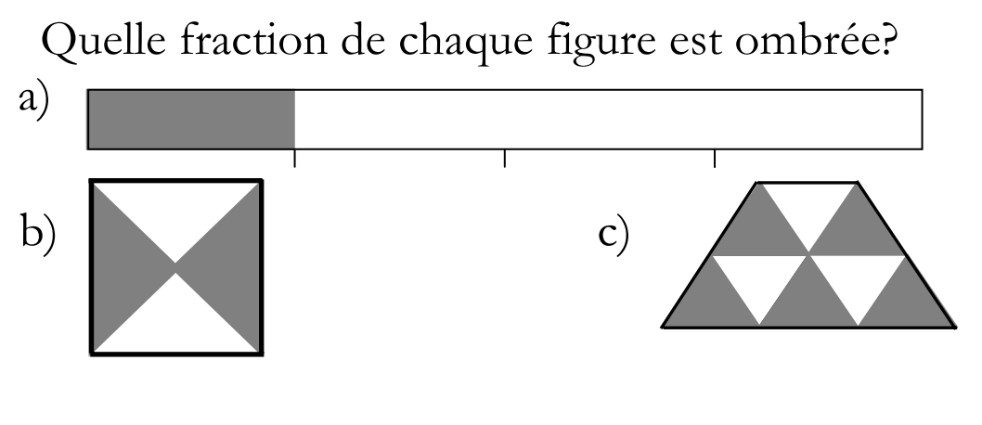

1. Fraction :

__________

1. Fraction :

___________

1. Fraction :

___________

|  |  |  |
| --- | --- | --- |
| 1. Combien de chiffres y a-t-il dans le nombre : 2. De jours dans un mois? 3. D’œufs dans une douzaine ? 4. De minutes dans trois heures ? | 1. _________________ 2. _________________ 3. _________________ | *How many digits are in the number of:*   1. *Days in a month?* 2. *Eggs in a dozen?* 3. *Minutes in three hours?* |

|  |  |  |
| --- | --- | --- |
| 1. Quel nombre correspond à : 2. 1 de plus que 89,6 ? 3. 10 de plus que 91 ? 4. 100 de plus que 6 387,4 ? 5. 1 de moins que 100,1 ? 6. 10 de moins que 89,50 ? 7. 1 de plus que 999 ? 8. 10 de plus que 989,9 ? 9. 10 de moins que 989,9 ? 10. 100 de moins que 699,41 ? 11. 1 de moins que 10 000 ? | 1. _________________ 2. _________________ 3. _________________ 4. _________________ 5. _________________ 6. _________________ 7. _________________ 8. _________________ 9. _________________ 10. _________________ | *What number is:*   1. *1 more than 89.6?* 2. *10 more than 91?* 3. *100 more than 6387.4?* 4. *1 less than 100.1?* 5. *10 more than 89.50?* 6. *1 more than 999?* 7. *10 more than 989.9?* 8. *10 less than 989.9?* 9. *100 less than 699.41?* 10. *1 less than 10 000?* |
| 1. Quel nombre ne va pas avec les autres ? Donne deux raisons.  2,7 24 6,8 2,54   Le nombre qui ne va pas avec les autres est :    Parce que :     Et : |  | *Which number doesn’t go with the others? Give two reasons.  2.7 24 6.8 2.54   The number that doesn’t go with the others is:    Because:     And:* |

|  |  |  |
| --- | --- | --- |
| 1. Choisis une des fractions ci-contre. Écris la fraction que tu as choisie dans l’ovale ci-dessous. Puis, représente cette fraction par des mots, des symboles, des opérations et des diagrammes.   Donnes-en au moins 6 représentations différentes. | $\frac{1}{5}$ $\frac{1}{4}$ $\frac{1}{2}$ $\frac{3}{4}$ | *Choose one of the fractions to the left. Write the fraction you choose in the oval below. Then, represent it using words, symbols, operations and diagrams.  Use at least 6 different ways.* |

**Opérations des nombres entiers**

|  |  |  |
| --- | --- | --- |
| 1. Écris les chiffres 1, 2, et 3 dans les boîtes de façon à obtenir la plus petite réponse possible. |  | *Write the numbers 1, 2 and 3 in the boxes in order to generate the smallest possible answer.* |
|  |  |  |
| 1. Écris les chiffres 1, 2, et 3 dans les boîtes de façon à obtenir la plus petite réponse possible. |  | *Write the numbers 1, 2 and 3 in the boxes in order to generate the smallest possible answer.* |
|  |  |  |
| 1. Le produit de la multiplication de 412 par un nombre à 1 chiffre se termine par 4. Quels nombres pourrait-on employer pour la multiplication ? | **412 x ___ =** | *When 412 is multiplied by a single-digit number, the product ends with a 4. What single-digit numbers could produce this result?* |

**Apprentissage par projet :  
Sciences de la nature et Sciences humaines  
5e et 6e années**

Les activités proposées proviennent des modules suivants de Sciences de la nature et Sciences humaines :

**Les débuts de la colonisation européenne***5e année – Sciences humaines*

**Le temps qu’il fait**   
*5e année – Sciences de la nature*

**Bâtir une nation**   
*6e année – Sciences humaines*

**Le vol***6e année – Sciences de la nature*

On invite les élèves à choisir **trois** ou **quatre** activités à compléter pendant la période d’apprentissage à distance. Ce n’est pas nécessaire de compléter toutes les activités. Fais tes choix en fonction de tes intérêts, de tes connaissances antérieures, ou de ce que tu as récemment étudié en classe.

*Activities have been chosen from the following Science and Social Studies units:*

**Early European Colonization***Grade 5 – Social Studies*

**Weather**   
*Grade 5 - Science*

**Building a Nation**   
*Grade 6 – Social Studies*

**Flight***Grade 6 - Science*

*Students can choose 3 or 4 activities in total to complete during the remote learning period. Activities can be selected based on grade level/interests/prior knowledge/topics previously studied.*

**LES DÉBUTS DE LA COLONISATION EUROPÉENNE**

**(1600-1763)**

**SCIENCES HUMAINES 5E ANNÉE**

|  |  |  |
| --- | --- | --- |
| **Choix 1** |  | **Choice 1** |
| À votre avis, à quoi ressemblaient les bâtiments il y a 300 ans au Canada ? Dessinez quelques bâtiments qui pourraient faire partie d’une communauté canadienne au cours des premières explorations européennes.  [Source](http://archeologie.ville.quebec.qc.ca/sites/port-de-la-basse-ville/histoire-du-port-de-la-basse-ville/)  [Source](https://www.pc.gc.ca/apps/dfhd/page_nhs_fra.aspx?id=311) |  | What do you think buildings looked like 300 years ago in Canada? Draw some buildings that might be a part of a Canadian community during early European exploration. [Source](http://www.canadiangeographic.ca) |
|  |  |  |
| **Choix 2** |  | **Choice 2** |
| Imaginez que vous quittez l’Europe à la recherche d’un nouveau foyer (maison) au Canada.   * Quelles sont les raisons pour lesquelles vous avez décidé de quitter votre pays d’origine ? * Où décideriez-vous de vous installer ? * Dans quelle partie du Canada vous installeriez-vous ? * Comment le territoire influencerait-t-elle votre décision ? |  | Imagine you are leaving Europe to search for a new home in Canada. Write about your ideas.   * + What were the reasons you decided to leave your home country?   + Where would you decide to settle?   + What part of Canada would you call home?   + How does the land influence your decision? |

**LE TEMPS QU’IL FAIT**

**SCIENCES DE LA NATURE 5E ANNÉE**

|  |  |  |
| --- | --- | --- |
| **Choix 3** |  | **Choice 3** |
| Créez une représentation visuelle de quatre différents types de nuages à l’aide de matériaux autour de votre maison ou à l’extérieur. Étiquetez chaque représentation, prenez des photos de vos créations et envoyez-les à un ami ou un membre de la famille. |  | Create a visual representation of four different types of clouds using materials from around your house or outside. Label each representation, take pictures of your creations and send them to a friend or family member. |
|  |  |  |
| **Choix 4** |  | **Choice 4** |
| Lisez, visionnez et écoutez aux différents bulletins météorologiques pour identifier et décrire les composantes qu’ils ont tous en commun. Les bulletins météorologiques peuvent être obtenus à partir des journaux, de l’Internet, de la télévision et de la radio. Pour chaque composante, familiarisez-vous avec ce qu’il mesure, les unités utilisées et la façon dont il est rapporté.  Créez votre propre bulletin météo pour aujourd’hui. |  | Read, view, and listen to different weather reports to identify and describe the components that they all have in common. Weather reports can be obtained from newspapers, the Internet, television, and radio. For each component, become familiar with what it measures, the units used, and how it is reported.  Create your own weather report for today. |

**BÂTIR UNE NATION**

**SCIENCES HUMAINES 6E ANNÉE**

|  |  |  |
| --- | --- | --- |
| **Choix 5** |  | **Choice 5** |
| Évaluez vos repas en une journée et retracez chaque aliment jusqu’à leur connexion originale à la terre. (Ex. Toast au petit déjeuner avec confiture, lait, pomme, etc.)  D’où est-ce que ça vient ? Qui sont les producteurs d’aliments ? |  | Evaluate your meals in a day and trace each item back to their original connection to the land.  (Ex. Breakfast toast with jam, milk, apple, etc.) Where is it from? Who are the food producers?  Research, then write about or record your findings using Flipgrid. |
|  |  |  |
| **Choix 6** |  | **Choice 6** |
| Il y a eu beaucoup d’emplois différents au cours de cette période de l’histoire du Canada qui ont façonné notre pays. (1867-1914)   * Fermier (quel genre de ferme ?) * La GRC/RCMP * Travailleurs des chemins de fer (transport de matériaux, explosifs qui fabriquent des tunnels à travers les montagnes ; ouvrier) * Mineur * Chercheur d’or dans le Nord-Ouest   Pensez au travail que vous feriez.  Quelles pourraient être certaines des qualifications, afin de bien faire le travail ? Pourquoi pensez-vous que vous seriez bien adapté à ce travail ? Imaginez que vous viviez à cette époque. Composez une lettre à votre famille expliquant vos choix. |  | There were many different jobs during this time in Canadian history that shaped our country.   * + Farmer (what kind of farm?)   + RCMP   + Railway worker (transporting materials; explosives expert-making tunnels through mountains; labourer)   + Miner   + Prospector - Panning for Gold in the North   Think about which job you would do. What might some of the qualifications be, in order to do the job well? Why do you think you would be well suited to this job? Pretend you lived in this time period. Write a letter to your family, explaining your choices. |

**LE VOL**

**SCIENCES DE LA NATURE 6E ANNÉE**

|  |  |  |
| --- | --- | --- |
| **Choix 7** |  | **Choice 7** |
| Concevez un avion en papier  et mesurez la distance qu’il parcourt.  Que pouvez-vous faire pour ajuster votre prototype pour que votre avion vole plus loin ?  Comment pouvez-vous doubler votre distance de vol ? |  | Design a paper airplane and measure how far it travels.   * What can you do to adjust your design to have your plane fly further? * How can you double your flight distance?   Explain your findings to a family member. |
|  |  |  |
| **Choix 8** |  | **Choice 8** |
| Imaginez un nouvel objet volant ou un animal volant. Créez une représentation visuelle et incluez des détails sur la façon dont elle obtiendra la portance. |  | Imagine a new flying object or flying animal. Create a visual representation and include details of how it will achieve lift. |

**Créons 🙪 Let’s Create**

|  |  |  |
| --- | --- | --- |
| **Éducation physique** |  | **Physical Education** |
| **Choix 1** |  | **Choice 1** |
| Pige une carte d’un jeu de cartes. Mets-toi en mouvement en suivant les directives dans le diagramme ci-contre. |  | Pick a card from a deck of cards. Get active by following the directions in the diagram to the left. |
|  |  |  |
| **Choix 2** |  | **Choice 2** |
| Lance une pièce de monnaie en l’air. Pendant une minute, fais l’un des exercices assignés dans le tableau ci-contre dépendant de si tu obtiens pile ou face. Répète trois ou quatre fois. |  | Toss a coin. Do one of the exercises in the table to the left for one minute, depending on whether you flip heads or tails. Repeat three or four times. |
|  |  |  |
| **Choix 3** |  | **Choice 3** |
| Sors de chez toi. Prend de l’air frais en faisant une promenade ou une autre activité que tu aimes. |  | Go outside. Get some fresh air while taking a walk or doing another activity that you like. |

**Créons 🙪 Let’s Create**

|  |  |  |
| --- | --- | --- |
| **Travail rigoureux** |  | **Heavy Muscle Work** |
| **Choix 1** |  | **Choice 1** |
| Choisis une activité parmi les suivantes :   * Monter les marches * S’étirer * Jouer à tir à la corde * Marcher à quatre pattes * Faire des redressements assis * Faire des sauts en étoile * Travailler la pâte à modeler |  | Choose one of the following:   * Stair climbing * Stretching * Playing tug-of-war * Crawling * Sit-ups * Jumping jacks * Working clay |
|  |  |  |
| **Choix 2** |  | **Choice 2** |
| 1. Saisis ton oreille gauche avec ta main droite, en gardant ton bras tout près du corps. 2. En maintenant la pose précédente, touche maintenant ton nez avec ta main gauche. 3. Maintenant, fais l’inverse. Décroise tes bras, saisis ton oreille droite avec ta main gauche, et touche ton nez avec la main droite. Ton bras gauche devrait maintenant être plus près du corps. 4. Change de pose aussi vite que tu le peux.   **Source :** Energizing Brain Breaks by D. Sladkev. |  | 1. Take your right hand and grab your left ear, keeping your right arm close to your body. 2. While holding the previous pose, take you left hand and touch your nose. 3. Now switch; uncross your arms and move your left hand to your right ear and your right hand to your nose. Your left arm should now be closest to their body. 4. Switch back and forth as fast as you can. |
|  |  |  |
| **Choix 3** |  | **Choice 3** |
| * 1. Assis, saisis le devant de la chaise en pliant tes doigts en-dessous.   2. Les pieds plats par terre et les genoux pliés, glisse ton corps vers l’avant et soutiens ton poids avec tes bras.   3. Plie tes coudes et laisse descendre ton corps devant la chaise.   4. Redresse tes coudes et fais remonter ton corps.   5. Répète 5 à 25 fois.   **Source :** Brain Breaks for the Classroom, Michelle Gay, 2009. |  | 1. As you sit in a chair, grasp the front of your seat, curling your fingers under to grip the edge. 2. With your feet flat on the floor and your knees bent, slide your body off your chair. Hold yourself up with your arms. 3. Bend your elbows and lower your body in front of the chair. 4. Straighten your elbows and raise your body back up. 5. Repeat 5 to 25 times. |

**Créons 🙪 Let’s Create**

|  |  |  |
| --- | --- | --- |
| **Mouvement & Drame** |  | **Movement & Drama** |
| **Choix 1** |  | **Choice 1** |
| Trouve l’un de tes livres préférés. Choisis ton personnage préféré et promènes-toi dans la pièce comme il le ferait. À quoi ressemblerait leur voix ? Si vous deviez choisir la musique de fond pour l’histoire ce serait quoi ? | Find one of your favourite books. Pick your favourite character and walk around the room like they would. What would their voice sound like? If you had to pick background music for the story what would it be? |
|  |  |
| **Choix 2** | **Choice 2** |
| Rassemble ta famille pour voir qui peut faire les meilleures impressions animales. Essayez de faire les sons des animaux et d’imiter leurs mouvements :   * Chien * Singe * Éléphant * Lion * Serpent | Gather your family together to see who can do the best animal impressions. Try to make the sounds of the animals and imitate their movements:   * Dog * Monkey * Elephant * Lion * Snake |
|  |  |  |
| **Choix 3** |  | **Choice 3** |
| Fais semblant de lancer un baseball dans l’air et de l’attraper. Qu’est-ce que ça fait dans ta main ? C’est lourd ? Léger ? Répète en prenant :   1. Un basketball 2. Une balle de ping-pong 3. Une balle de golf 4. Un ballon de plage | Pretend you are throwing a baseball up in the air and catching it. How does it feel in your hand? How heavy is it? Repeat using the following:   1. Basketball 2. Ping pong ball 3. Golf ball 4. Beach ball |
| **Choix 4** |  | **Choice 4** |
| Tu auras besoin d’un autre membre de la famille pour cette activité. Asseyez-vous face à face. Désigne de vous comme leader. L’autre doit suivre chaque mouvement que le leader fait comme si elle regardait dans un miroir. Cet exercice fonctionne mieux avec des mouvements lents et contrôlés. Changez de leader au bout de quelques minutes.  [Source](https://howtoadult.com/physical-activities-toddlers-child-care-centers-3829.html) |  | You’ll need another family member for this one. Sit facing each other and one person starts as the leader. The other person must follow every move the leader makes as if they were looking in a mirror. This exercise works best with slow, controlled movements. Switch leaders after a few minutes. |

**Créons 🙪 Let’s Create**

|  |  |  |
| --- | --- | --- |
| **Mouvement & Musique** |  | **Movement & Music** |
| **Choix 1** |  | **Choice 1** |
| Fête de la danse ! Mets de la musique et fais danser toute la famille ! Fais des actions et enseigne-les à quelqu’un d’autre. | Have a Dance Party! Put on some music and get your entire family to dance around the room! Make up some actions and teach them to someone else. |
|  |  |
| **Choix 2** | **Choice 2** |
| Mets de la musique – déplace-toi de la façon dont la musique te fait sentir. Si la musique est saccadée et rapide, déplace-toi de façon saccadée et rapide. Si elle est lente et fluide, déplace-toi lentement et en douceur. Change la musique – déplace-toi à nouveau et change tes mouvements corporels pour correspondre à la musique. | Put on some music – move the way the music makes you feel. If the music is jerky and fast – move jerky and fast. If it slow and smooth, you move slowly and smoothly. Change the music – move again and change your body movements to match the music. |
|  |  |  |
| **Choix 3** |  | **Choice 3** |
| Assieds-toi à l’extérieur en silence pendant 5 minutes tout en écrivant tous les sons que tu entends. Écoute très attentivement ! Catégorise ta liste en sons naturels et sons artificiels. Répète cet exercice assis à l’intérieur. Compare tes listes de sons à l’intérieur et à l’extérieur ! | Sit outside silently for 5 minutes while writing down every sound you hear. Listen very carefully! Categorize your list into natural sounds and human-made sounds. Repeat this exercise while sitting inside. Compare your inside and outside lists! |
| **Choix 4** |  | **Choice 4** |
| Chante tout fort ta chanson préférée !! Chante comme s’il n’y avait personne qui écoutait ! |  | Sing along to your favourite song!! Sing like there is nobody listening! |
| **Choix 5** |  | **Choice 5** |
| Fais un instrument de musique à partir de matériaux que tu as chez toi. Par exemple, fais un tambour à partir d’une poubelle ou d’un seau ; prend des baguettes pour taper. Fais jouer ta chanson préférée et joue ton instrument en chantant. |  | Make a musical instrument using materials that you have at home. For example, make a drum using a wastepaper basket or a bucket; use chopsticks to tap out the rhythm. Play your instrument while listening to your favourite song; add vocals! |

**Créons 🙪 Let’s Create**

**Art**

Materials:

* sticky notepad or square pad of paper (you can make your own if you don’t have one. Just cut as many pieces of white paper as you need to the same size square, then staple or tape the pages to form the “binding” for your book. It is a good idea to keep the pages about between 1 ½ and 2 ½ inches square so that the pages flip properly.
* pencil or pen

Instructions:

1. Start with a blank stack of sticky notes. You might want to split one notepad into thirds, so you end up with three smaller stacks to make more than one flip book.
2. Wrap tape around the sticky end of one of the stacks to prevent it from breaking apart when you draw in it.
3. Start on the last sticky note and draw a picture on the bottom half of the page. If your drawing is too close to the top, where the notes stick together, you might not see it when you thumb the flip book at the end.
4. Flip to the next sticky note (the second-to-last one in the stack) and see how your first drawing shows through the paper.
5. Trace the still parts of the picture, the ones you don't want to move in the animation.
6. Change the parts of your drawing that you do want to animate, or move.
7. Flip to the next page. Repeat tracing the still parts and changing the parts that you are animating.
8. As you fill the notepad from back to front, animate the movements little by little, page by page. You can flip your notepad (from back to front) to check your progress and see if you want to make changes.
9. Once you finish your series of drawings or fill the entire notepad, use your thumb to flip the pages from back to front to watch your animation.

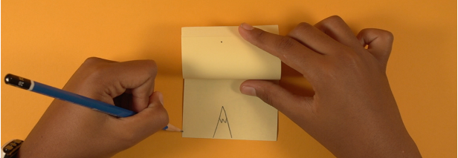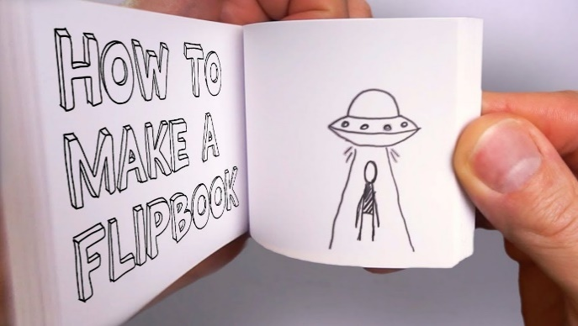

[Source](https://www.metmuseum.org/art/online-features/metkids/videos/MetKids-Create-a-Flip-Book)

**Cardboard Tube Sculptures**

<https://www.artbarblog.com/category/recycled/>

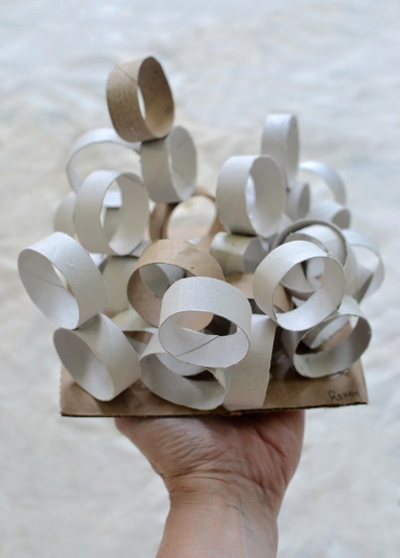 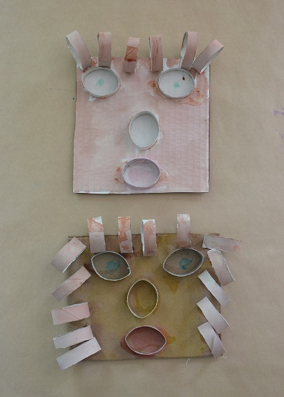 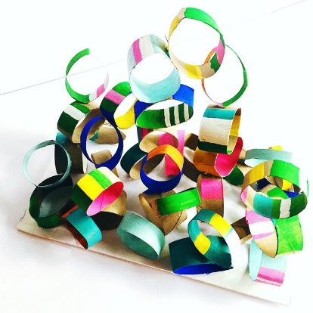

## SUPPLIES

* Toilet paper rolls, cut into circles (about 5 or 6 circles can be made from each tube). You’ll need a lot of tubes so start saving them over the break!
* [Exacto knife](http://amzn.to/2y49W4a) – this makes cutting the circles way easier, but should be done by or closely supervised by an adult. If you do not have an Exacto knife, you can cut the rolls using scissors.
* [White school glue](http://amzn.to/2ytcz0A).
* Cardboard base. This base can be any size. You can cut off one side of any carboard box you happen to have at home.
* Paints, markers, pencil crayons or crayons if you want to make your sculpture colourful.

INSTRUCTIONS

Step 1: Cut the tubes into 5 or 6 sections

Step 2: Paint the tubes sections any way you want. You will have to let the paint dry before you begin to glue. Do this the day before you want to begin to assemble your sculpture.

Step 3: Start gluing the tube pieces onto the cardboard base. Be careful not to use too much glue as it will take a long time to dry.

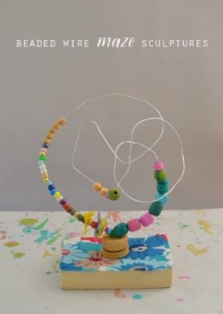**Beaded Wire Maze Sculpture**

<https://www.artbarblog.com/beaded-wire-maze-sculptures/>

Supplies:

* Length of wire (between 24” and 36”) that is rigid enough to hold up small beads (approx. 16 gauge).
* Beads large enough to slide onto the wire. A variety of colour and sizes will help make the sculpture interesting
* 2 approx. 1” buttons
* Felt pieces or construction paper cut into geometric shapes with a hole punched in the middle. Again, a variety of colour will add interest to your finished product
* Other objects (cut up pieces of straw, buttons, etc. that will fit onto the wire to add interest to your sculpture.
* Solid base (like a piece of wood or thick carboard
* White glue
* Glue gun
* Markers, paint

Instructions:

Step 1: Decorate your base with markers, paint. Make it as colourful and interesting as you want.

Step 2: String one end of the wire through the holes of the button. Twist the wire to secure it to the button.

Step 3: Begin to assemble your sculpture using your beads, straw pieces, felt, buttons, etc. Bead about ½ of the wire and then stop.

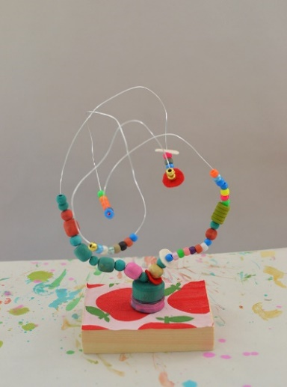Step 4: Attach the button to the base with the hot glue gun. Hold the wire in place until the glue has cooled and is secure. (If you don’t have a button or a hot glue gun, playdough will work to secure the wire to the base. Use a glob of playdough to form a base. Twist up the end of the wire to make it stick into the playdough more securely and poke this end in the playdough).

Step 5: Put a twist or a curl in the wire.

Step 6: continue to add decorations to the wire on the other side of the curl/twist.

Step 7: Continue to add curls and decorations to your sculpture for the length of the wire.

Step 8: Once you get to the other end of the wire, thread the wire through the holes in the second buttons and twist the wire to secure it to the button. As with the first button, hot glue the button to the base on top of or beside the first one. (if you are using playdough, twist this end up and poke it into the playdough to secure).

**Alexander Calder Inspired Paper Sculpture**

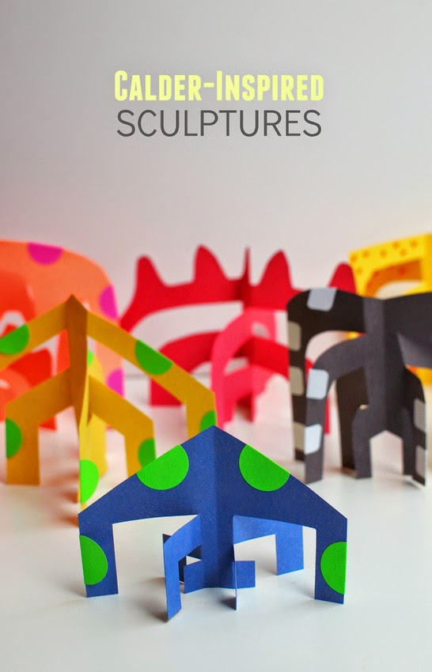<http://www.pinkstripeysocks.com/2015/05/calder-inspired-sculptures-kids-art-project.html>

Supplies:

* Construction paper or card stock or other rigid paper. You could even use the cardboard from a cereal box.
* Markers, pencil crayons, crayons
* Scissors

Instructions:

Step 1: Cut the construction paper into a square (if using a rectangular paper such as a letter or legal size, fold the paper diagonally so that the top edge is level with one of the side edges. Cut off the extra and voila, you have a square!)

Fold edge 1 down so that it is even with edge 2

1

Cut this part off along this line

2

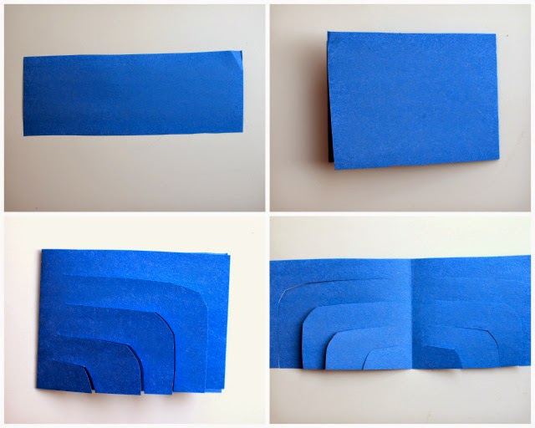Step 2: Once you have a square, fold it in half either hamburger or hotdog style (images 1 and 2)

Step 3: Makes cuts like in image 3

1

2

Step 4: unfold

Step 5: Begin to fold the strips to the front and back in an alternating fashion (image 5). Start on the left side of the top strip and fold the strip toward the front at the middle, then the next strip down would fold to the back at the middle. The third strip would fold toward the front and so on to the last strip on the left. Do the opposite on the right side. Since the strips will be opposite each other, your sculpture will stand up.

3

4

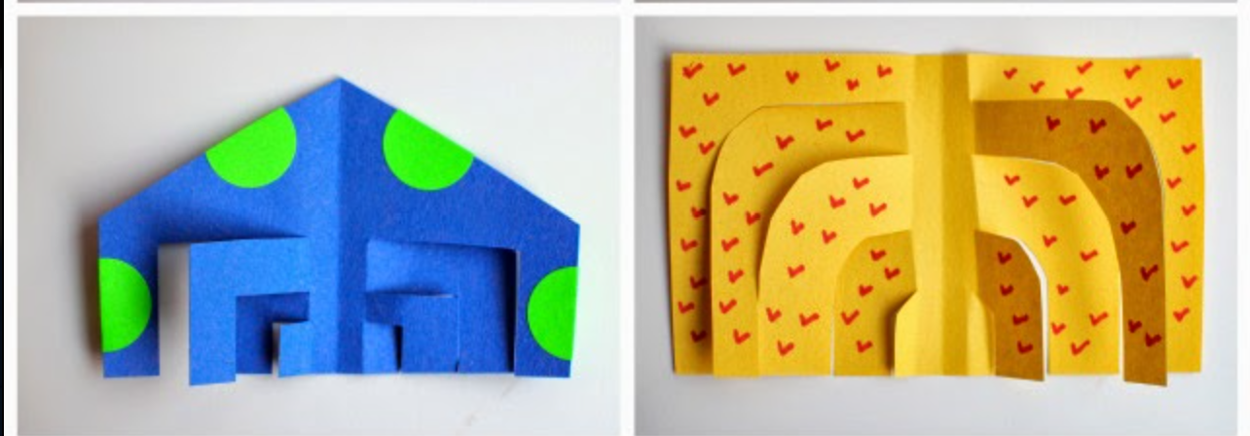

**Réflexion sur l’apprentissage**

Prendre le temps de réfléchir à l’apprentissage nous aide à retenir l’apprentissage à long terme. De plus, il nous aide également à mieux nous connaître en tant qu’apprenants. À la fin de ta journée d’apprentissage, choisis quelques-unes des incitations ci-dessous pour stimuler ta pensée. Note tes idées dans un journal de bord. Plus tard dans la semaine, prend du temps pour relire tes idées et pour voir comment elles ont évolué.

1. Quelque chose que j’ai remarqué aujourd’hui est ___
2. Quelque chose que je me demande est ___
3. Quelque chose qui m’a confondu aujourd’hui est ___
4. Une chose que j’ai appris aujourd’hui est ___
5. Aujourd’hui, j’ai compris___
6. Aujourd’hui, j’ai exploré ___
7. Je suis déterminé(e) à ___
8. Quelque chose que j’ai lu aujourd’hui qui m’a surpris(e) est ___
9. J’espère que les gens savent que je ___
10. Quelque chose que j’ai trouvé difficile à faire aujourd’hui était ___
11. Quelque chose qui m’a fait rire aujourd’hui était ___
12. Dans le passé, je pensais ___ au sujet de ___. Maintenant, je sais que ___
13. En regardant comment j’ai ___ (fait une expérience scientifique/rédigé une rédaction de journal/résolu un problème de mathématiques, etc.), un aspect que j’ai vraiment réussi est ___. Je le ferais de cette façon à nouveau.
14. En regardant comment j’ai ___ (fait une expérience scientifique/rédigé une rédaction de journal/résolu un problème de mathématiques, etc.), un aspect que ferais différemment à l’avenir est ___.
15. Mon personnage préféré ___ (dans l’histoire d’aujourd’hui, dans notre roman, de tous les temps, etc.) est ___ parce que ___
16. Ma meilleure erreur aujourd’hui était ___ parce que ___
17. Une nouvelle stratégie que je vais essayer en ___ (mathématiques, français, anglais, etc.) demain est ___
18. L’animal que je choisirais de me représenter est ___ parce que ___. Je pense que d’autres pourraient choisir ____ parce que ___.
19. En pensant à la différence entre les besoins et les désirs, je constate que ___ est un besoin, alors que ___ est un désir.
20. Mon endroit préféré dans mon quartier ___ parce que ___
21. Tout le monde a des responsabilités. Une de mes responsabilités est de _____
22. Un pouvoir magique que j’aimerais avoir est ___
23. Je peux rendre le monde meilleur en ___
24. Une chose qui influence mon identité est ___
25. Mon endroit préféré à explorer est ___
26. Si je pouvais aller n’importe où, je voudrais explorer ___
27. Pense à une communauté ou une culture que tu étudies. Une chose que je me demande est ___
28. Partage une nouvelle de la journée en employant une voix d’annonceur.
29. Si nous n’apprenions que trois matières à l’école, les trois plus importantes seraient ___
30. Quelque chose que j’ai appris aujourd’hui que je peux utiliser dans la vie de tous les jours est ___

**Reflecting on a Day’s Work**

Taking time to reflect on learning helps learning to stick. It also helps us know ourselves better as learners. At the end of your day of learning, choose some of the following prompts to stimulate your thinking. Note your ideas in a journal. Later in the week, read your ideas and see have they have changed over time.

1. Something I noticed today is _____________________.
2. Something I’m wondering about is __________________.
3. Something that made me think hard today was_____________.
4. One thing I learned today____________________.
5. Today I figured out _______________________.
6. Today I explored ____________________.
7. I’m determined to ____________________________.
8. Something that I read today that really stuck with me was_________.
9. I hope people know that I _______________.
10. Something I found hard to do today was ________________.
11. Something that made me laugh today was ___________________.
12. I used to think ___ about ___ but now I know _______.
13. Looking back at my (science experiment, journal writing, math....) I did well on________, and I would do it that way again.
14. Next time I (do this type of math problem, write a character analysis, complete a science experiment....) I will do this differently______________.
15. My favourite character in (today’s story, our novel, of all time....) is ________________, because___________.
16. My best mistake today was _________________, because________________.
17. A new strategy I will try in math (or other area) tomorrow is _________________.
18. The animal I would choose to represent me is _______________.  I think others might choose ______________ for me.
19. Thinking about the difference between needs and wants, I know ______________is a need and ______________is a want.
20. My favourite place in my neighbourhood is_____________because_______________.
21. Everyone has responsibilities.  One of my responsibilities is ___________________.
22. A magic power I would like to have is _______________.
23. I can make the world a better place by __________________________.
24. One thing that influences my identity is _________________.
25. My favourite place to explore is __________________.
26. If I could go anywhere, I would like to explore _______________.
27. For a community or culture you are studying... One thing I am wondering about _________ is _____________.
28. Share a piece of news from the day using a news anchor voice
29. If we only learned three subjects at school, the three most important would be ______________.
30. Something I learned today that I can use in daily life is __________________.