|  |
| --- |
| Instructions for Using Remote Learning Projects |
| These materials were developed with the intention of easing the transition between in-class and temporary remote learning. Learning experiences are aligned with curricular outcomes and assessment tools have been included with each project.  **Note:**   * 1. The teacher either sends a link to the appropriate project or sends the document itself.   2. The teacher ensures that parents/caregivers receive any required school supplies (bin with pencils, markers, paper, etc.).   3. The teacher reassures parents/caregivers that communication will be maintained between home and school.   4. Parents/caregivers may access additional resources at:      + My Learning at Home ([www.edu.gov.mb.ca/k12/mylearning](http://www.edu.gov.mb.ca/k12/mylearning))      + My Child in School ([www.edu.gov.mb.ca/k12/mychild/index.html](http://www.edu.gov.mb.ca/k12/mychild/index.html)) |

|  |  |
| --- | --- |
| PROJECT OVERVIEW | |
| Grade: | 2 |
| Main Subject: | Social Studies |
| Big Idea: | Recognize that First Nations and Inuit people are Canada’s original peoples |
| Title: | FIRST NATIONS COMMUNITIES IN CANADA |
| Cluster: | Communities in Canada |
| Duration: | 1–2 weeks |
| Materials: | PowerPoint Presentation, Blackline Masters, Internet |
| Short Description: | Mini-unit about First Nations communities in Manitoba. Students will learn about wants and needs of community members, locations of First Nations communities in Manitoba, cultural/linguistic groups, different community roles/jobs, and buildings that you can find in a community. This is predominately designed to be teacher-led or it could also be student independent work supported by caregivers. |

|  |
| --- |
| Learning Outcomes |
| Social Studies: <https://www.edu.gov.mb.ca/k12/cur/socstud/foundation_gr7>  KH-027, KI-012, KE-037, VI-006, VI-006A  English Language Arts: www.edu.gov.mb.ca/k12/cur/ela/index.html  Language as Sense Making, Language as System, Language as Power and Agency, Language as Exploration and Design  Mathematics: www.edu.gov.mb.ca/k12/cur/math/index.html 2.N.9, 2.N.10 |

|  |  |  |  |  |  |  |  |  |  |  |  |  |  |
| --- | --- | --- | --- | --- | --- | --- | --- | --- | --- | --- | --- | --- | --- |
| Assessment | | | | | | | | | | | | | |
| LANGUAGE ARTS | | | | | MATHEMATICS | | | SCIENCE | | | SOCIAL STUDIES | | |
| COMP.  Listening &  Viewing | COMP.  Reading | COMM. Speaking & Represent. | COMM. Writing | Critical Thinking | Knowledge  and  Understanding | Mental Math &  Estimation | Problem Solving | Knowledge  and Understanding | Scientific Inquiry Process | Design Process &  Problem Solving | Knowledge  and Understanding | Research  and Communication | Critical Thinking and  Citizenship |
| x |  | x | x | x | x | x | x |  |  |  | X | X | X |

|  |  |
| --- | --- |
| Original concept created by: | Jill Fast and Kim Berezka |

|  |
| --- |
| Learning Experiences and Assessment |
| Question: How do communities in Canada meet the needs of the people that live in them? |
| Teacher’s instructions  Follow the PowerPoint presentation, use the BLM and rubrics as support. Activities may be adapted or rearranged to better suit your context and expectations may be amended up or down depending on student interests, skills, and availability. See the PowerPoint presentation for websites and book suggestions.  Step-by-step instructions for students:   1. Think about your community (activating). 2. Locate your community on a Map of Manitoba. 3. Reflect on the Inquiry Question “How do communities in Canada meet the needs of the people that live in them?” 4. Analyze wants and needs. 5. Learn about Indigenous peoples. 6. Choose a First Nation community to learn more about (research and mapping). 7. Learn about roles/jobs in a First Nation community. 8. Imagine what it would be like to take on a role/job of someone from a First Nation community. 9. Reflection: compare similarities and differences between a First Nation community and your community. 10. Reflection: think about how communities in Canada meet the needs of the people that live in them. |

|  |
| --- |
| APPENDIX (Printable Support Materials Including Assessment) |
| First Nations Communities in Manitoba PowerPointGeographic Features and Natural Resources—Manitoba MapManitoba First Nation Communities Number SentencesCommunity Role Reflection in Words or PicturesCanadian Needs, Choices, and Decisions—T-ChartCommunities in Canada Inquiry Project Rubric |

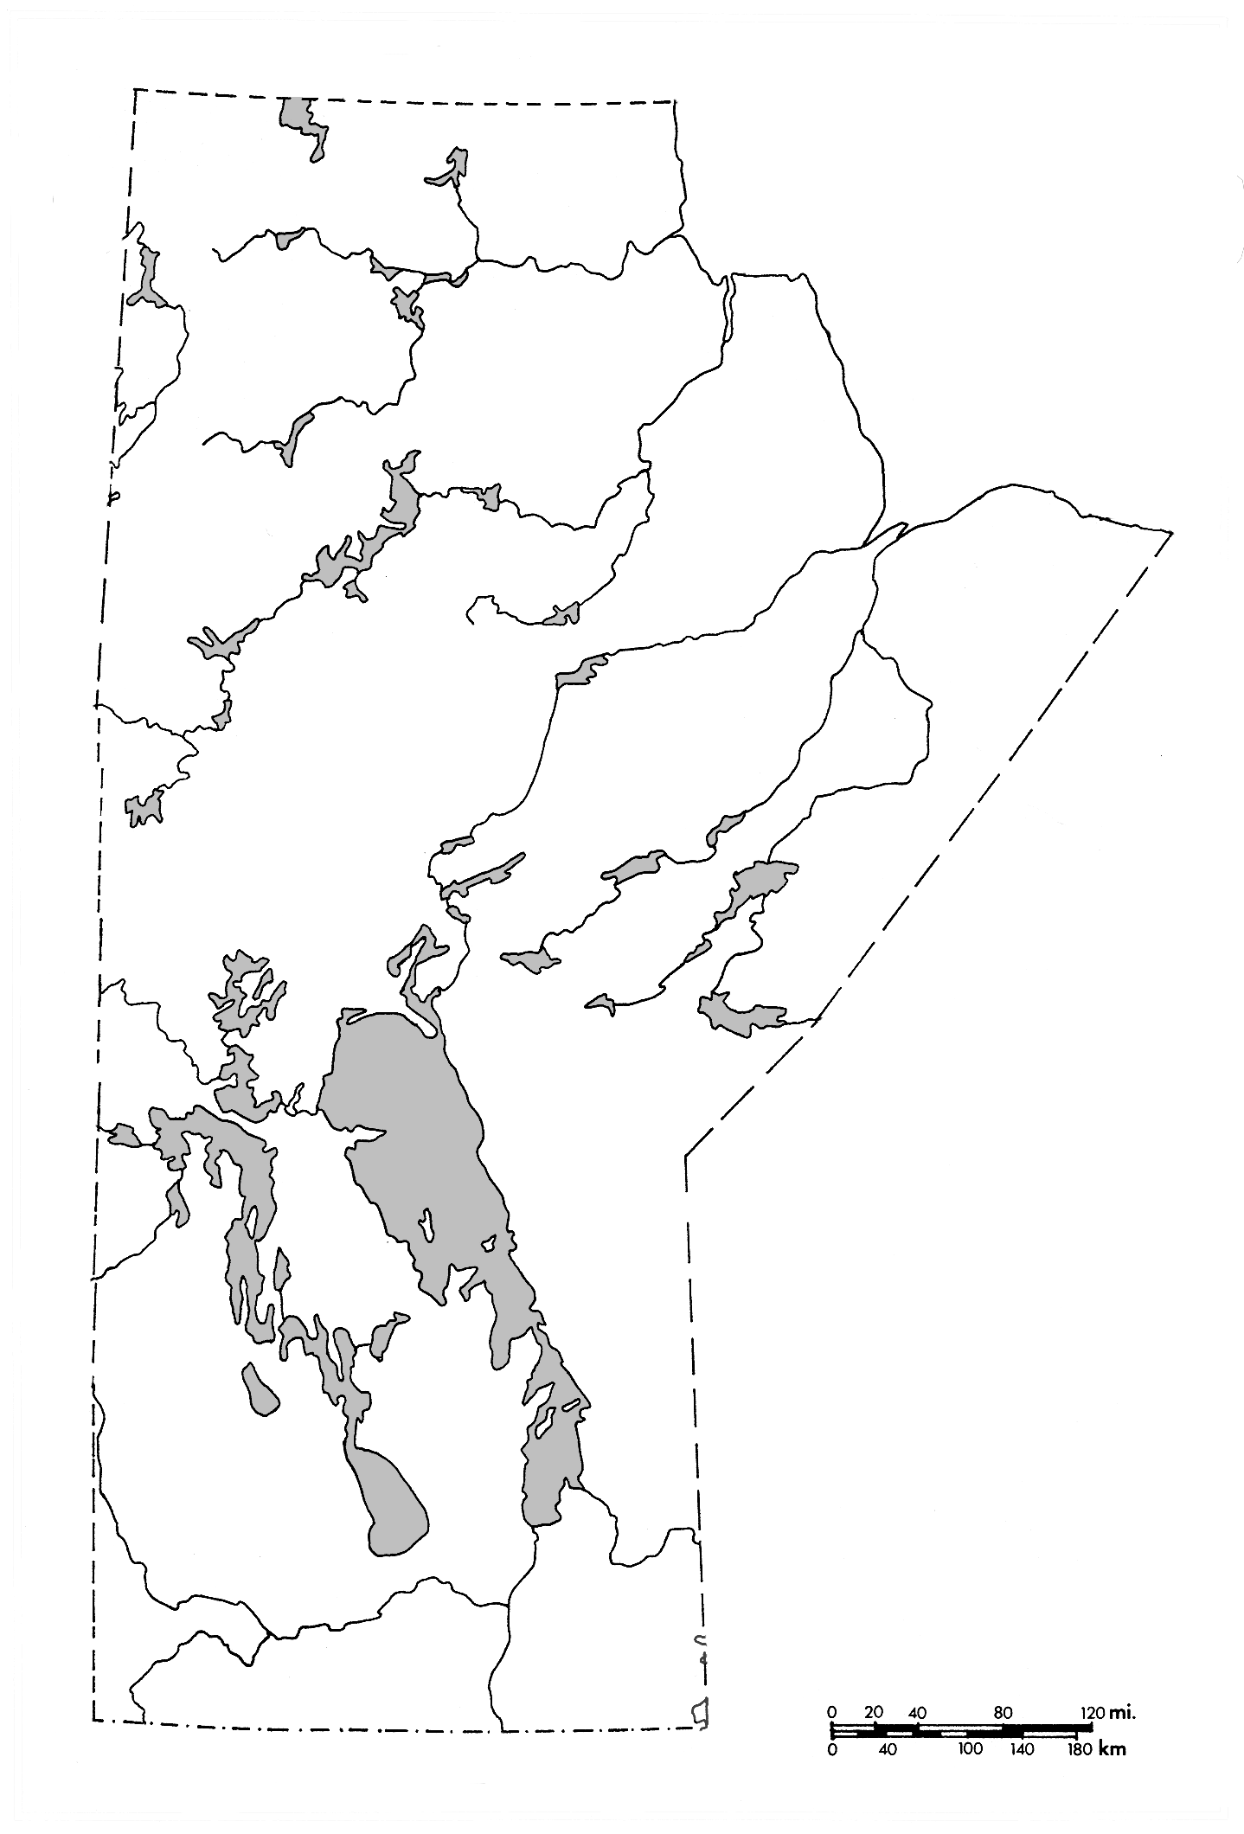**Map of Manitoba**

**Manitoba First Nation Communities Number Sentences**



Cree + Dene + Oji-Cree + Ojibway + Dakota = Total Manitoba First Nation Communities

____ + ____ + ____ + ____ + ____ = ______ Manitoba First Nation Communities

**Other Addition Sentences:**



**Subtraction Sentences:**

**Community Role Reflection in Words or Pictures**

****Today I am going to imagine what it would be like to take on   
a role/job of someone from a First Nation Community!

My name is

I am a

I work at the

Today I

What I like about my job

What I dislike about my job

**Canadian Needs, Choices, and Decisions—T-Chart**

|  |  |  |  |
| --- | --- | --- | --- |
| basketball  bed  bike  candy  car | clothing  computer  doll  food  game | horse  love  money  safety  shelter | sunglasses  telephone  toys  vacation  water |

|  |  |
| --- | --- |
| **A close up of a logo  Description automatically generatedNeeds** | **A drawing of a cartoon character  Description automatically generatedWants** |
|  |  |

[This Photo](http://www.dailyclipart.net/clipart/category/heart-clip-art/) by Unknown author is licensed under [CC BY-ND](https://creativecommons.org/licenses/by-nd/3.0/).

[This Photo](http://www.dailyclipart.net/clipart/category/toy-clip-art/page/2/) by Unknown author is licensed under [CC BY-ND](https://creativecommons.org/licenses/by-nd/3.0/).

|  |  |  |  |  |  |
| --- | --- | --- | --- | --- | --- |
| **Grade 2 Communities in Canada Inquiry Project Rubric**  **How do communities in Canada meet the needs of the people that live in them?** | | | | | |
| **Report Card Subject Category** | **Very good to excellent (4)** | **Good**  **(3)** | **Basic**  **(2)** | **Limited**  **(1)** | **Not demonstrated**  **(ND)** |
| **Social Studies— Knowledge and Understanding** | Student insightfully makes connections across cultural and geographical contexts and fluently uses appropriate vocabulary about their community and a First Nation community and maps those communities on a map of Manitoba. | Student makes connections across cultural and geographical contexts and uses key vocabulary about their community and a First Nation community and can map those communities on a map of Manitoba. | Student requires occasional teacher or peer support to make connections across cultural and geographical contexts and to use key vocabulary about their community and a First Nation community and to map those communities on a map of Manitoba. | Student requires considerable, ongoing teacher support to make connections across cultural and geographical contexts and to use key vocabulary about their community and a First Nation community and to map those communities on a map of Manitoba. | Does not yet demonstrate the required understanding and application of concepts and skills. |
| **Social Studies— Research and Communication** | Student asks thought-provoking questions during activities/ discussions, and accurately and comprehensively records and clearly communicates First Nation community and own community information and ideas. | Student asks relevant questions during activities/discussions, and records and communicates First Nation community and own community information and ideas. | Student requires occasional teacher or peer support to ask relevant questions and, record and communicate First Nation community and own community information and ideas. | Requires considerable, ongoing teacher support to asks relevant questions, and record and communicate First Nation community and own community information and ideas. | Does not yet demonstrate the required understanding and application of concepts and skills. |
| **Social Studies— Critical Thinking and Citizenship** | Student easily compares First Nation community to their community, and spontaneously expresses thoughtful opinions about their community and First Nations communities. | Student compares First Nation community to their community and recognizes and responds to thoughtful opinions about their community and First Nations communities. | Student requires occasional teacher or peer support to compare First Nation community to their community and to recognize and responds to thoughtful opinions about their community and First Nations communities. | Student requires considerable, ongoing teacher support to compare First Nation community to their community and to recognize and responds to thoughtful opinions about their community and First Nations communities. | Does not yet demonstrate the required understanding and application of concepts and skills. |
| **Lang. Arts - COMP.**  **Listening &**  **Viewing** | Student uses strategies and cues before, during and after listening and viewing to develop understanding of First Nations and other communities in Manitoba. | Student uses strategies and cues with some prompting before, during and after listening and viewing to develop understanding of First Nations and other communities in Manitoba. | Requires occasional teacher or peer support or modelling to use strategies and cues before, during and after listening and viewing to develop understanding of First Nations and other communities in Canada. | Requires considerable, ongoing teacher support to use strategies and cues before, during and after listening and viewing to develop understanding of First Nations and other communities in Manitoba. | Does not yet demonstrate the required understanding and application of concepts and skills. |
| **Language Arts—COMM. Writing** | Student uses strategies and cues to independently generate and communicate their **ideas and information** about their community and a First Nation Community Role with very few **convention** errors. | Student uses strategies and cues with occasional prompting to generate and communicate their **ideas and information** about their community and a First Nation Community Role with some **convention** errors. | Student requires occasional teacher or peer support to use strategies and cues to generate and communicate their **ideas and information** about their community and a First Nation Community Role and correct **convention** errors. | Student requires considerable, ongoing teacher support to use strategies and cues to generate and communicate their **ideas and information** about their community and a First Nation Community Role and correct **convention** errors. | Does not yet demonstrate the required understanding and application of concepts and skills. |
| **Language Arts— COMM. Speaking and Representing** | Student uses strategies and cues to independently generate and clearly communicate, thinking, ideas, and information about their community, a First Nation Community and a First Nation Community Role. | Student uses strategies and cues with some prompting to generate and clearly communicate, thinking, ideas, and information about their community, a First Nation Community and a First Nation Community Role. | Requires occasional teacher or peer support to generate and clearly communicate, thinking, ideas, and information about their community, a First Nation Community and a First Nation Community Role. | Requires considerable, ongoing teacher support to generate and clearly communicate, thinking, ideas, and information about their community, a First Nation Community and a First Nation Community Role. | Does not yet demonstrate the required understanding and application of concepts and skills. |
| **Language Arts— Critical Thinking** | Student insightfully interprets evidence and draws a conclusion about a First Nation community and their community. | Student interprets evidence and draws a conclusion with some prompting about a First Nation community and their community. | Requires occasional teacher or peer support to interpret evidence and draw a conclusion about a First Nation community and their community. | Requires considerable, ongoing teacher support to interpret evidence and draw a conclusion about a First Nation community and their community. | Does not yet demonstrate the required understanding and application of concepts and skills. |
| **Mathematics—Knowledge and Understanding (number sentences)** | Student chooses and can explain efficient strategies to accurately write addition **and** subtraction sentences (within 100) about the different and total Manitoba First Nation Communities. | Student uses strategies to accurately write addition **and** subtraction sentences (within 100) about the different and total Manitoba First Nation Communities. | Requires occasional teacher or peer support to use strategies to accurately write addition **or** subtraction sentences (within 100) about the different and total Manitoba First Nation Communities. | Requires considerable, ongoing teacher support to use strategies to accurately write addition **or** subtraction sentences (within 100) about the different and total Manitoba First Nation Communities. | Does not yet demonstrate the required understanding and application of concepts and skills. |
| **Mathematics— Mental Math and Estimation (number sentences)** | Student efficiently and flexibly chooses and uses mental math strategies to solve addition **and** subtraction sentences (within 100) about the different and total Manitoba First Nation Communities. | Student accurately chooses and uses mental math strategies to solve addition **and** subtraction sentences (within 100) about the different and total Manitoba First Nation Communities. | Requires occasional teacher or peer support to choose and use mental math strategies to solve addition **or** subtraction sentences (within 100) about the different and total Manitoba First Nation Communities. | Requires considerable, ongoing teacher support to choose and use mental math strategies to solve addition **or** subtraction sentences (within 100) about the different and total Manitoba First Nation Communities. | Does not yet demonstrate the required understanding and application of concepts and skills. |
| **Mathematics—Problem Solving (number sentences)** | Student initiates and efficiently explains and uses a strategy to determine the number of Indigenous cultural-linguistic groups in Manitoba. | Student explains and uses a strategy with some prompting to determine the Indigenous cultural-linguistic groups in Manitoba. | Requires occasional teacher or peer support to think of and use a strategy to determine the number of Indigenous cultural-linguistic groups in Manitoba. | Requires considerable, ongoing teacher support to think of and use a strategy to determine the number of Indigenous cultural-linguistic groups in Manitoba. | Does not yet demonstrate the required understanding and application of concepts and skills. |