|  |
| --- |
| DIRECTIVES SUR L’UTILISATION DE PROJETS D’APPRENTISSAGE À DISTANCE |
| Ce matériel a été élaboré dans le but de faciliter la transition entre l'apprentissage en salle de classe et l’apprentissage à distance temporaire. Les expériences d'apprentissage correspondent aux résultats d'apprentissage et les outils d’évaluation ont été inclus dans chaque projet. **Remarques :**  * 1. L'enseignant doit envoyer le lien au projet approprié ou envoyer le document lui-même.   2. L'enseignant doit s'assurer que les parents ou les gardiens d’enfants reçoivent les fournitures scolaires requises (bac avec crayons, marqueurs, papier, etc.).   3. L'enseignant rassure les parents, les tuteurs ou les gardiens d'enfants et les élèves, qu’une communication sera maintenue entre la maison et l’école.   4. Les parents, les tuteurs et les gardiens d'enfants peuvent avoir accès à des ressources additionnelles à :      + Mon apprentissage chez moi ([www.edu.gov.mb.ca/m12/monapprentissage/index.html](http://www.edu.gov.mb.ca/m12/monapprentissage/index.html));      + Mon enfant à l’école ([www.edu.gov.mb.ca/m12/monenfant/index.html](http://www.edu.gov.mb.ca/m12/monenfant/index.html)). |

|  |  |
| --- | --- |
| APERÇU DU PROJET | |
| Année d’études : | Maternelle |
| Matières principales : | Français arts langagiers, *English Language Arts*, mathématiques, arts visuels |
| Titre : | RESSOURCES POUR LES PARENTS D’ÉLÈVES D’IMMERSION FRANÇAISE |
| Thème : | Mini-leçons |
| Durée : | 10 jours |
| Matériel : | Papiers, feutres, crayons, colle, peinture |
| Brève description : | Mini-leçons portant sur différentes matières, partagées par la Division scolaire Louis Riel. |

|  |  |
| --- | --- |
| Concept original créé par : | Les enseignants de l’École Apprendre-chez-soi de la Division scolaire Louis Riel |

|  |
| --- |
| AnnexeS (Matériel d'appui en format imprimable, lES évaluationS, LES CORRECTIONS) |

**Kindergarten / Maternelle**

**Learning from Home Package / Trousse d’apprentissage-chez-soi**

You will need:

5-6 storybooks

The following materials would be helpful, but in most cases can be substituted with what you have available:

Paper (white copier paper, construction paper)  
Markers, crayons, or pencil crayons  
Gluesticks  
Watercolour paints

**Kindergarten LFH Learning Package (French Immersion)**

At the direction of Manitoba Education, the Louis Riel School Division has planned for students in Kindergarten- Grade 8 to temporarily learn from home from January 4th- January 18th. While the Restricted Level (Orange) is in effect under the Manitoba Pandemic Response System, temporary remote learning options may be provided to Kindergarten to Grade 8 Students who can be supported while learning from home. In doing so our goals are to:

* Continue to engage children in achieving essential learning outcomes while learning from home.
* Address continuity of learning in response to higher levels of absenteeism due to concerns about safety as a result of COVID-19.
* Ensure children who are at home on a temporary basis maintain a connection to their school community while learning from home.

Students in Kindergarten- Grade 6 will receive a learning package developed by the division along with each student’s school community. They will be provided with a daily schedule and learning opportunities focused on essential learning outcomes and emphasizing literacy and numeracy. In addition to the print package provided, students, parents, and guardians will have access to online invitations to learning. These will be accessible via the LRSD homepage. At the end of the period of temporary learning from home, students are invited to share their work with their classroom teacher. Teachers will acknowledge the learning and provide feedback to students in a timely manner.

Staff members from the student’s school community will be in regular contact during the temporary learning from home period to ensure each student understands the learning tasks and to answer any questions and to nurture well-being.

Parents and guardians are encouraged to establish a learning space for their child and to maintain a regular schedule to maximize engagement and capitalize on learning:

* regular bedtime, wake-up and mealtimes
* getting dressed and ready for school (even though they are at home)
* time for learning
* time for breaks
* daily physical activity
* daily communication with friends and family

Setting up a home learning space to work can help children focus. If possible, the space should include:

* a quiet atmosphere
* good lighting
* a desk or table at a comfortable height for your child
* a storage basket or bin to keep supplies (paper, pens, pencils, markers, books, etc.)
* access to a computer/tablet or other smart device, if possible

Parents and guardians of French Immersion students may not be able to read or speak French. For this reason, this package is presented in English with optional French resources that you may find helpful. If you are unable to support learning *en français*, please proceed in English.

|  |  |
| --- | --- |
|  | Kindergarten / Maternelle |
|  | Daily Schedule |
| 9:00 | Getting bodies and brains ready for learning |
| 9:15 | Literacy |
| 9:45 | Let's Create (art/dance/drama) |
| 10:15 | Snack and tumble book/video/board game/time to play  **Conversation prompts:**  What do you hope to try/learn/do today?  What are you wondering about?  Let’s talk about what happened in the story.  What was your favourite activity today and why? |
| 10:30 | Numeracy |
| 11:00 | Choice time/Family Reading (Tips in the Resources Section) |
| 11:30 | End of School Day |

**Day 1**

**Begin your day with an activity to get your brain and body ready for learning.**Put on some relaxing music and doodle with someone.

French Tip: A pared-down vocabulary is used in FI Kindergarten. The verb “dessiner/draw” is used rather than “doodle/griffonner”.

**Literacy**Select a book to read together. Take a book walk (see instructions, p. 38-39). Flip through the pages prior to reading. Talk about what the story might be about.

French Tip: It is perfectly fine to select a book in English or another language.

Read the story and discuss what happened in the beginning, middle and the end.

Create an accordion book (see instructions, p. 39-41) and draw a picture from the beginning, middle and end of the story. Ask your child to tell you about the sequence of events.

French Vocabulary:   
Beginning = *Début*  
Middle = *Milieu*  
End = *Fin*

**Let’s Create!**Choose an art activity from the menu in the “Let’s Create” section at the end of the package (p. 42-45).

**Snack and Break Time**

**Numeracy**

Patterns  
Select small items for your child to use to create patterns. These items should not be too big. Ensure you have at least four different items (either by colour or shape or size for example) and that you have at least four of each. So, you would need four yellow, four green etc. with a total of 16 for example. All items should be off to one side of the table. As your child works, items will be moved in front of them.

We will be creating repeating patterns (*= des régularités*). The core of the pattern is the part that repeats. Have you child identify the core (*= la base*) each time a new pattern is created. Patterns of varying elements should be explored, i.e., shapes, colours, size, category (dinosaur, farm animals etc.).

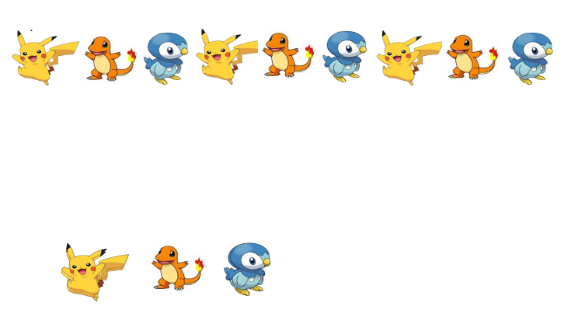 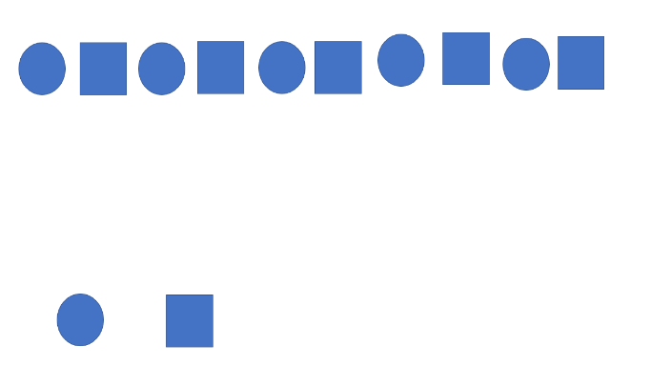

Core

*Base*

Pattern

*Régularité*

**Choice Time/Family Reading**

See Optional Resources, p. 21-41.

**Day 2**

**Begin your day with an activity to get your brain and body ready for learning.**

*The Heartbeat Exercise*

French Tip: Have them count their heartbeats (*= battements de coeur*) *en français*.

Ask your child to stand up and either jump up and down (*= sauter*) or do jumping jacks (*= faire des sauts en étoile*) for one minute. At the end of that minute, have them place their hand on their heart and pay attention to how their heartbeat and their breathing feels. You can even get them to count along with their heartbeats!

**Literacy**

Select a book to read together. Take a book walk, flipping through the pages prior to reading. Talk about what the story might be about. Read the story and discuss what happened in the beginning, middle and the end. Talk about one of the characters in the story. What does the character look like, what is special or unique about the character? (*= À quoi ressemble ton personnage ? A-t-il quelque chose de spécial ?)*

Draw a picture of the main character and using whatever materials you have on hand, create a frame around your picture (*= créer un beau cadre pour ton dessin*).

**Let’s Create!**

Choose an art activity from the menu in the “Let’s Create” section at the end of the package (p. 42-45).

**Snack and Break Time**

Practice mindfulness today by having a ‘slow motion’ snack (= *le goûter au ralenti*). Enjoy your snack together in slow motion while taking notice of the taste (*= le goût*). Take one bite, chew it slowly and talk about the taste. Continue to do this until you have finished your snack.

**Numeracy**

Shape Walk (Materials: yourself, pictures of different shapes)

What to do:

Draw shapes on a piece of paper — a triangle, circle, square, rectangle, oval, and diamond.  
Look at the shape drawings with your child.

French Tip: A lot of math terms are very similar in French and English because they have the same Latin or Greek root.

triangle *= triangle*circle *= cercle*  
square *= carré*  
rectangle *= rectangle*  
oval *= ovale*  
diamond *= losange*

Play follow the leader! Walk in the outline of a shape and let your child follow you. Narrate what you're doing: When you turn a corner to make a square, for example, you might say "Sharp turn coming!”

Ask your child to match the shape that he/she walked with the drawing of the shape.

For an additional challenge, draw a shape with your finger on your child’s back. Can he /she identify the shape?

Go outside for a walk and see how many different shapes you can identify in nature. Take pictures of what you see or draw pictures of the objects in nature.

**Choice Time/Family Reading**

See Optional Resources, p. 21-41.

**Day 3**

**Begin your day with an activity to get your brain and body ready for learning.**

Listen to some music and talk about all of the different instruments that you hear. Can you make a different movement for every instrument that you hear?

**Literacy**

Select a book to read together. Take a book walk, flipping through the pages prior to reading. Talk about what the story might be about. Read the story and discuss what happened in the beginning, middle and the end. Pause throughout the book to ask specific questions about what has taken place in the story so far   
(= *Qu’est-ce qui se passe dans l’histoire ?* ) and what might happen next (*= Que penses-tu va arriver ?*).

Use paper bags (*= des sacs en papier*), socks (*= bas*) or whatever material you have on hand to make puppets (*= marionnettes*) of the main characters and reenact the story together.

**Let’s Create!**

Choose an art activity from the menu in the “Let’s Create” section at the end of the package (p. 42-45).

**Snack and Break Time**

**Numeracy**

Patterns/Shapes/Mindfulness

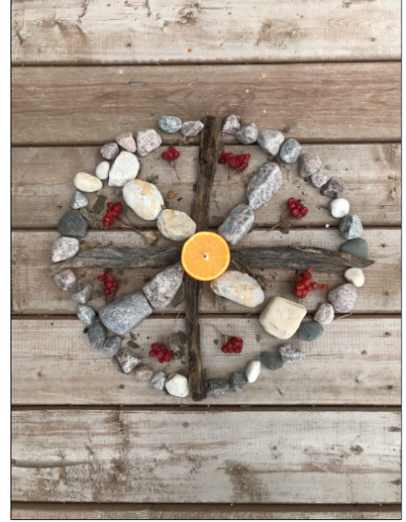

Mandala created by Ethan Creighton.

Mandalas (This topic will take 4 days.)

A mandala (*= un mandala*) is a geometric figure representing the universe.

Mandala, Day 1 – Nature walk and item collection.

This is an opportunity to be creative and explore nature as a family. You may also choose to use materials you have available indoors.

Children should use this opportunity to count and sort objects.

Step 1: They will plan the design (can draw a picture first).

**Choice Time/Family Reading**See Optional Resources, p. 21-41.

**Day 4**

**Begin your day with an activity to get your brain and body ready for learning.**

Muscle Relaxation Exercise

Starting at the feet, gently squeeze the muscles in the feet by tightening them, then slowly releasing.

Next, squeeze the large muscles in the calves for 5 seconds, then gently release. Working your way up the body, squeeze the thigh muscles for 5 seconds then gently release.

Continue moving up the body for more relaxation.

**Literacy**

Your child can pick their favourite book at home to read together. Afterwards, you can discuss why this is their favourite book (*= Pourquoi ce livre est-il ton préféré ?*). You can ask them about some connections to their own lives/other stories/television programs etc. Prompting question – what does this book remind you of? (*= Ça te fait penser à quoi ce livre ?*)

Think about one of the connections that you made. Can you write your own story about that?

If time permits, you may wish to complete another activity (see Optional Resources, p. 21-41).

**Let’s Create!**

Choose an art activity from the menu in the “Let’s Create” section at the end of the package (p. 42-45).

**Snack and Break Time**

**Numeracy**

Mandala, Day 2: Counting and Sorting

Sort the objects into groups. What sorting rules will you choose?

* Colour (*= la couleur*)
* Shape (*= la forme*)
* Size (*= la grandeur*)
* Texture (*= la texture*)

Step 2: Estimate the number of objects needed for every part of the mandala. The children may not end up using all the items. Their counted items will not likely be their final quantities used in the mandala; it depends on the design.

French Tip: Encourage your child to count the items *en français*.

**Choice Time/Family Reading**

See Optional Resources, p. 21-41.

**Day 5**

**Begin your day with an activity to get your brain and body ready for learning.**

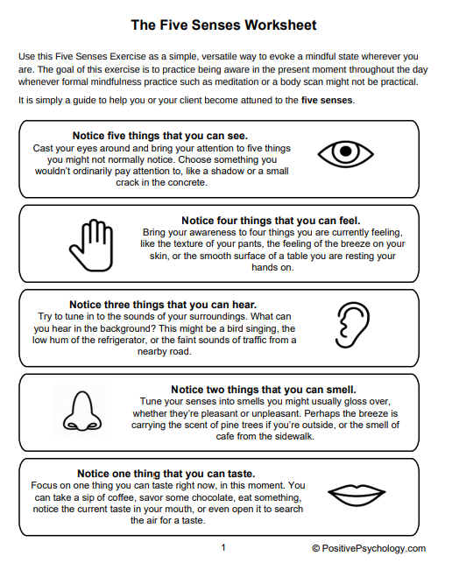

French Tip: You may wish to encourage your child use French verbs to describe each action or the terms for the body parts associated with each sense.

I see *= je vois*I feel *= je ressens*I hear *= j’entends*I smell *= je sens*I taste *= je goûte*

eyes *= les yeux*hands *= les mains*ears *= les oreilles*nose *= le nez*mouth *= la bouche*

**Literacy**

French Tip: Canadian packaging is bilingual. Help your child to find familiar French words.

Go on a word hunt around the house together. Have your child write down all the words they see. They may notice writing on food packages, wall art, books, and receipts. If time permits, you may wish to complete another activity (see Optional Resources, p. 21-41).

**Let’s Create!**

Choose an art activity from the menu in the “Let’s Create” section at the end of the package (p. 42-45).

**Snack and Break Time**

**Numeracy**

Mandala, Day 3

If you have not already done so, draw a picture of the design you are going to create. Looking at your picture, estimate how many of each object you will need to make your design. Record your estimates on the chart below.

Step 3: Create, adjust and chart the number of objects used and compare this to their estimated quantities.

|  |  |  |
| --- | --- | --- |
| **Item** | **Estimate** | **Quantity** |
|  |  |  |
|  |  |  |
|  |  |  |
|  |  |  |
|  |  |  |
|  |  |  |
|  |  |  |
|  |  |  |
|  |  |  |

**Choice Time/Family Reading**

See Optional Resources, p. 21-41.

**Day 6**

**Begin your day with an activity to get your brain and body ready for learning.**

Dance Freeze

Put on some music. Everyone dances while the music plays. When the music stops, each person must freeze immediately and hold that position until the music begins again.

**Literacy** (Materials: Magazine with lots of pictures, paper, and a pencil)

Practice Beginning Letter Sounds Scavenger Hunt Game

French Tip: Encourage your child to use both French and English vocabulary. For example, they could place a dog (*= un chien*) under both C & D.

The object of the game is to find something on the page that begins with each letter of the alphabet. List the letters A-Z on a piece of paper (or choose as many letters of the alphabet as you want). Look at the picture and try to find an object that starts with the first letter sound of each letter of the alphabet. The adult can help the student to write down the word. If time permits, you may wish to complete another activity (see Optional Resources, p. 21-41).

**Let’s Create!**

Choose an art activity from the menu in the “Let’s Create” section at the end of the package (p. 42-45).

**Snack and Break Time**

**Numeracy**

Mandala, Day 4

Create your mandala by looking at your design and using your collected objects. As you make your mandala record the number of each item that you use on your chart.

**Choice Time/Family Reading**

See Optional Resources, p. 21-41.

**Day 7**

**Begin your day with an activity to get your brain and body ready for learning.**

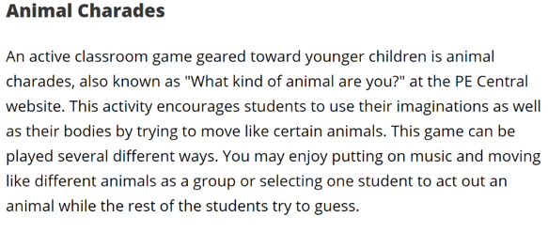

French Tip: Encourage your child to name the animal *en français*. Look it up if you don’t know it.

<https://howtoadult.com/physical-activities-toddlers-child-care-centers-3829.html>

**Literacy**

Make some pudding together. Read the recipe together and have your child notice the words that they know. If you don’t have pudding mix you could use something else like yogurt. Use enough for snack and to put in a large Ziplock bag so that when you lay it flat, and squeeze out the air, it fills up the space in the bag and lays flat on the table.

French Tip: Encourage your child to say the letter names in both English and *en français*. There are many videos on YouTube that model the correct pronunciation.

Sing the alphabet together and have your child trace the letters on the bag with their finger.

If you do not want to use a food item, you could do this activity outside and trace letters in the snow. Add a bit of food colouring to the snow for a special effect!

If time permits, you may wish to complete another activity (see Optional Resources, p. 21-41).

**Let’s Create!**

Choose an art activity from the menu in the “Let’s Create” section at the end of the package (p. 42-45).

**Snack and Break Time**

**Numeracy**

|  |
| --- |
| Let’s measure |
| * Scarf (*= un foulard*) * Piece of white paper and a pencil |
| Draw a line in the middle of your paper. Make a + sign on one side of the paper and a – sign on the other side.    Take your scarf and go around your house to find items that are longer than your scarf (*= plus long que ton foulard*); draw these items in the “+” column of the table. Find other items that are shorter than your scarf (*= plus court que ton foulard*); draw these items in the “-“ column. |

French Tip: The measuring lesson gives students an excellent opportunity to apply a useful structure, comparisons. To say “longer” in French, you say “more long”.  
This works with almost any adjective:

shorter *= plus court, plus courte*  
taller *= plus grand, plus grande*  
colder *= plus froid, plus froide*  
hotter *= plus chaud, plus chaude*

**Choice Time/Family Reading**

See Optional Resources, p. 21-41.

**Day 8**

**Begin your day with an activity to get your brain and body ready for learning.**

French Tip: Encourage your child to use both French vocabulary they know related to body parts. You may wish to look up unfamiliar terms—this a great way to model learning a second language.

Play *Mirror, Mirror.*

Identify the adult or child as the “leader”. Stand facing each other.  The leader positions his/her body and asks the other person to mimic that position.  For instance, the leader may put one hand on their head and one hand on their belly. The other person tries to match the action. See if you can trick your partner!

**Literacy**

Letter bag - Put a piece of fruit in the bag (pick a bag that you cannot see through) and tell your child the beginning sound of the fruit. Have your child guess the fruit in the bag. Next, your child can put a piece of fruit in the bag and tell you the beginning sound of the fruit. You can guess the fruit. If you don’t have any fruit, play the game with other small objects you can find in the house. If time permits, you may wish to complete another activity (see Optional Resources, p. 21-41).

French Tip: This game can also be played using French words.

**Let’s Create!**

Choose an art activity from the menu in the “Let’s Create” section at the end of the package (p. 42-45).

**Snack and Break Time**

**Numeracy**

|  |  |
| --- | --- |
| Build a Snowflake with Shapes  Source: https://alittlepinchofperfect.com/build-a-snowflake-winter-shape-math-activity-and-free-template/  Templates recreated by R. Plouffe-Hingley | |
| Required Materials | Scissors  Glue  Printable pages |
| Instructions | Students can cut out different shapes to design a snowflake in the centre of the large circle. They can count how many of each shape they used to make their unique snowflake design. |

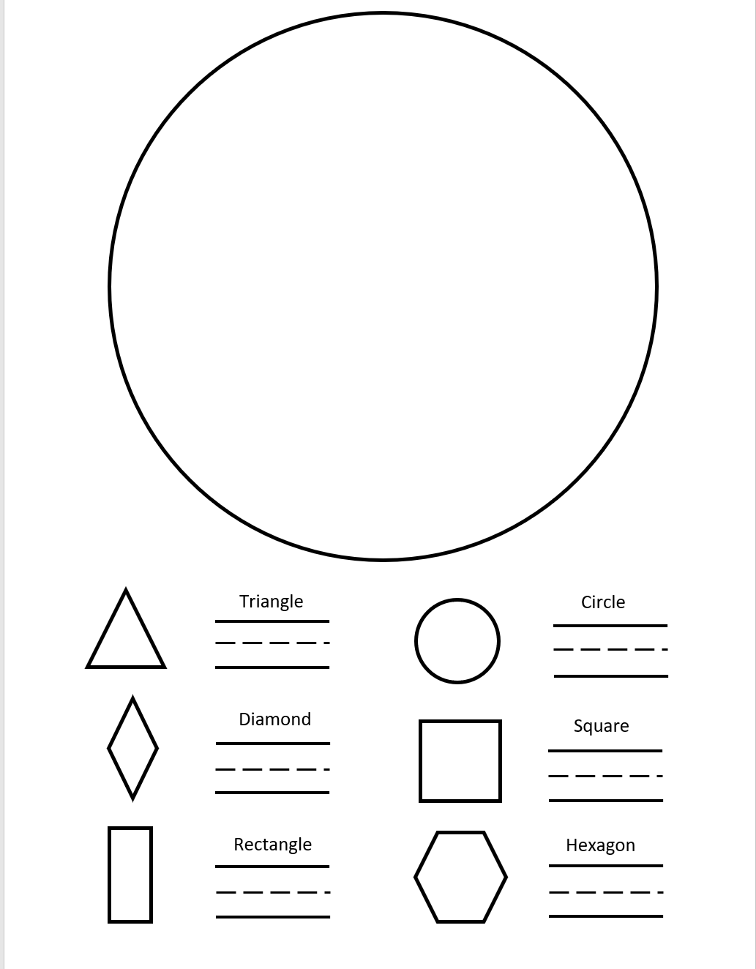

French Vocabulary:

triangle *= triangle*circle *= cercle*  
diamond *= losange*  
square *= carré*  
rectangle *= rectangle*  
hexagon *= hexagone*

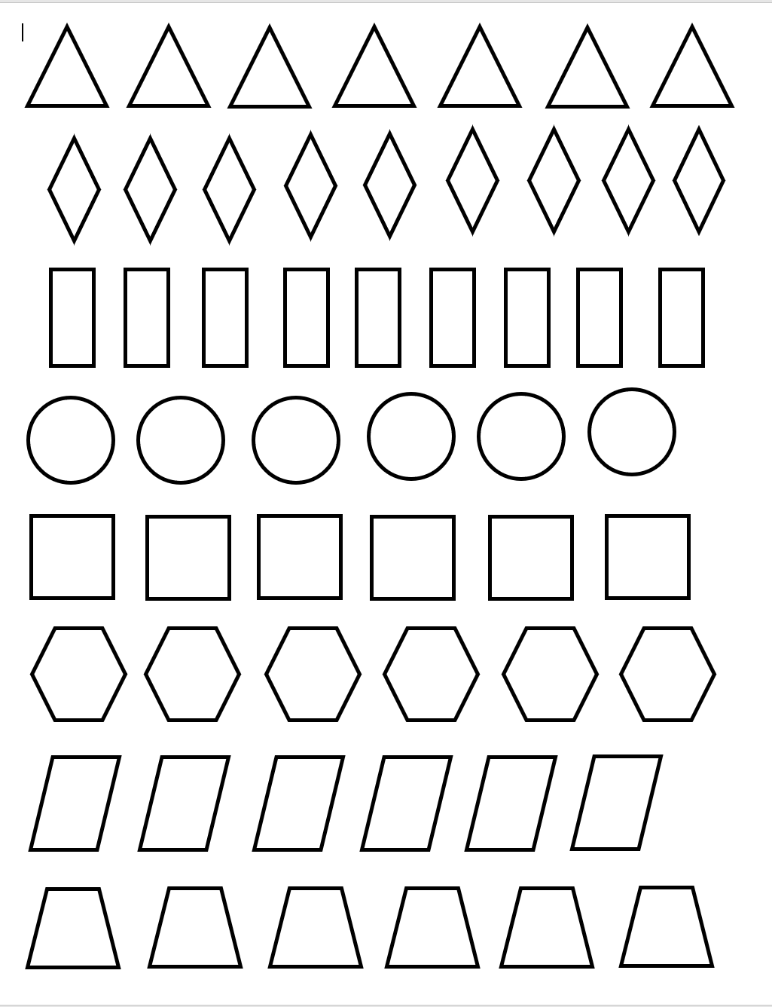

**Choice Time/Family Reading**See Optional Resources, p. 21-41.

**Day 9**

Begin your day with an activity to get your brain and body ready for learning.

Gather your family together to see who can do the best animal impressions. Try to make the sounds of the animals and imitate their movements:

1. Dog (= un chien)
2. Monkey (= un singe)
3. Elephant (= un éléphant)
4. Lion (= un lion)
5. Snake (= un serpent)

<https://howtoadult.com/physical-activities-toddlers-child-care-centers-3829.html>

**Literacy**

Rhyme shares – Have your child select an item to place in a bag. This should be an item that is special to them. Then, have your child find a word to rhyme with that item. They can present the rhyming word to another family member and have them guess the item in the bag that rhymes with that word. The hint will be that this item is special to them. If time permits, you may wish to complete another activity (see Optional Resources, p. 21-41).

**Let’s Create!**

Choose an art activity from the menu in the “Let’s Create” section at the end of the package (p. 42-45).

**Snack and Break Time**

**Numeracy**

|  |  |
| --- | --- |
| Mitten Roll and Colour  Source: <https://littlezizzers.blogspot.com/2018/12/16-literacy-and-math-activities-for.html>  Templates recreated by R. Plouffe-Hingley | |
| Required Materials | Printable mitten page  Two dice  Crayons |
| Instructions | This can be done alone or with a partner.  Roll the dice and count the dots. Each time a new number is rolled, colour the mitten (*= la mitaine*) with the corresponding number. Partners can take turns filling in the mittens. This activity ends will all mittens are coloured.  Example:  If you roll two Colour the “2” mitten. |

French Tip: Encourage your child to count *en français*.

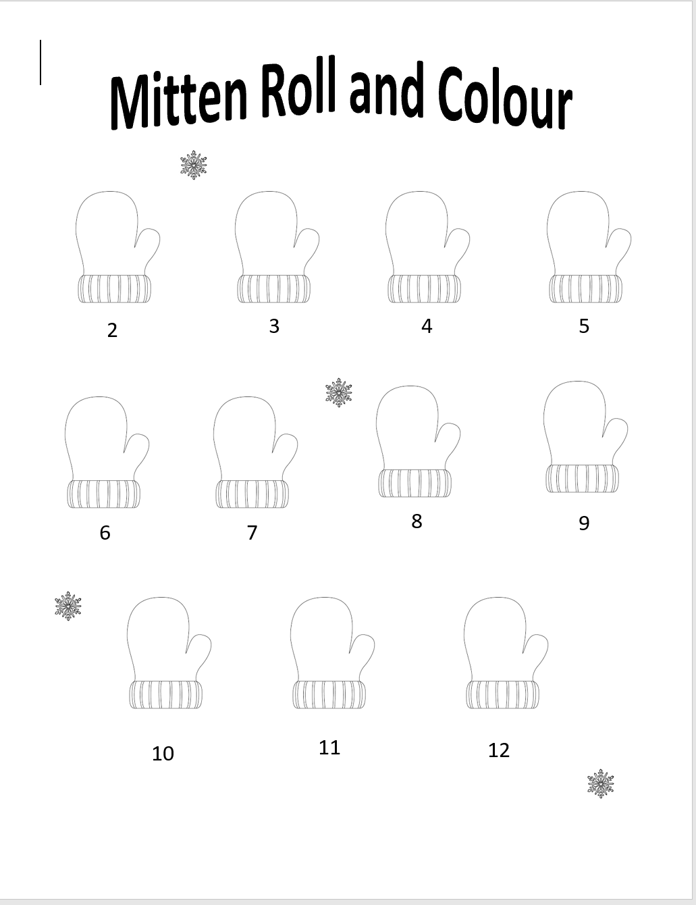

**Choice Time/Family Reading**

See Optional Resources, p. 21-41.

**Day 10**

Begin your day with an activity to get your brain and body ready for learning.

Toss a Ball up in the air BUT you don’t actually have a ball. Pretend you are throwing a baseball up in the air and catching it. How does it feel in your hand? How heavy is it? Try it with the following:

1. Basketball (*= un basketball*)
2. Ping pong ball (*= une balle de ping-pong*)
3. Balloon (*= un ballon*)
4. Beach ball (*= un ballon de plage*)

<https://howtoadult.com/physical-activities-toddlers-child-care-centers-3829.html>

**Literacy**

Have your child reflect on the last nine days of activities and pick their favourite learning experience. They can repeat that activity today. If time permits, you may wish to complete another activity (see Optional Resources, p. 21-41).

**Let’s Create!**

Choose an art activity from the menu in the “Let’s Create” section at the end of the package (p. 42-45).

**Snack and Break Time**

**Numeracy**

|  |  |
| --- | --- |
| Penguin Counting!  Source: https://funlearningforkids.com/editable-penguin-board-game/  Templates recreated by R. Plouffe-Hingley | |
| Required Materials | Printable Penguin Counting Board Game  One die/ six sided cube  Small objects to be used as game pieces (Cheerios, dimes, paperclips) |
| Instructions | Players begin on the start circle.  The youngest player will start and roll the die and count the dots on top. The player will move their game piece to the corresponding square on the game board. For example, if the player rolls a 4, they would move their game piece to the nearest 4 on the board.  Game play continues until one player reaches the end of the board. |

French Tip: Encourage your child to count *en français*.

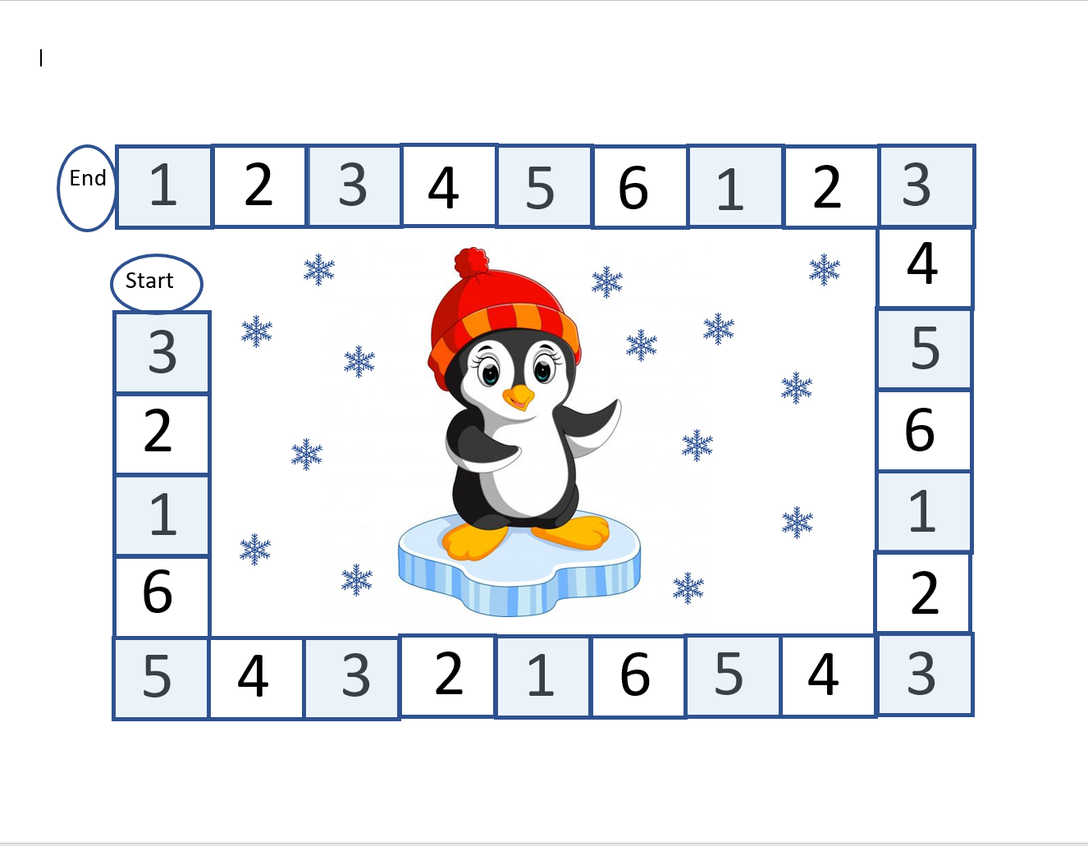

**Choice Time/Family Reading**  
See Optional Resources, p. 21-41.

**Optional Resources**

If you have access to the internet and to a device at home, you may enjoy the following activities:

There are many choices to pick from in the Bookmates’ activities. Set aside some time with your child prior to beginning to make selections.

**Days 1 & 2**

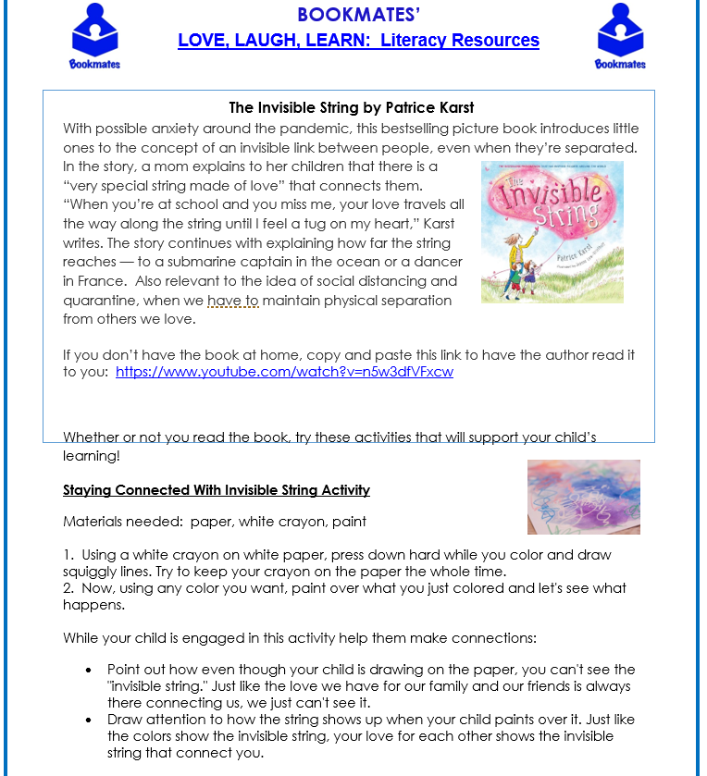

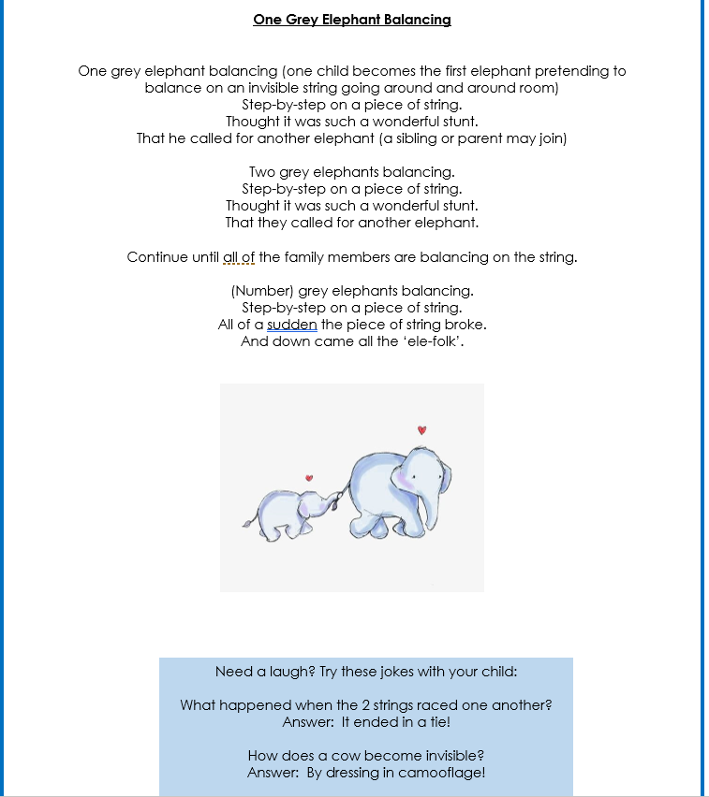

**Days 3, 4 and 5**

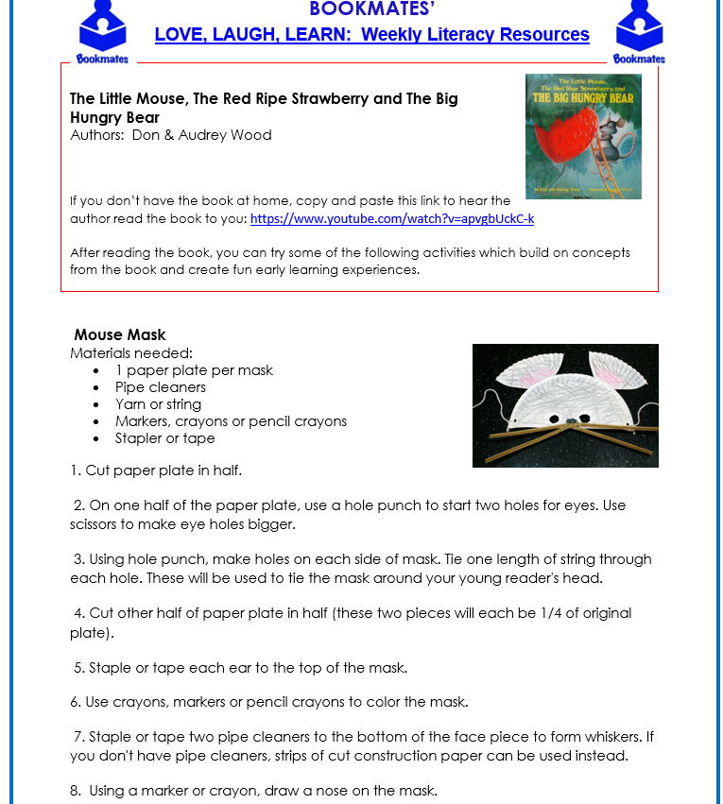

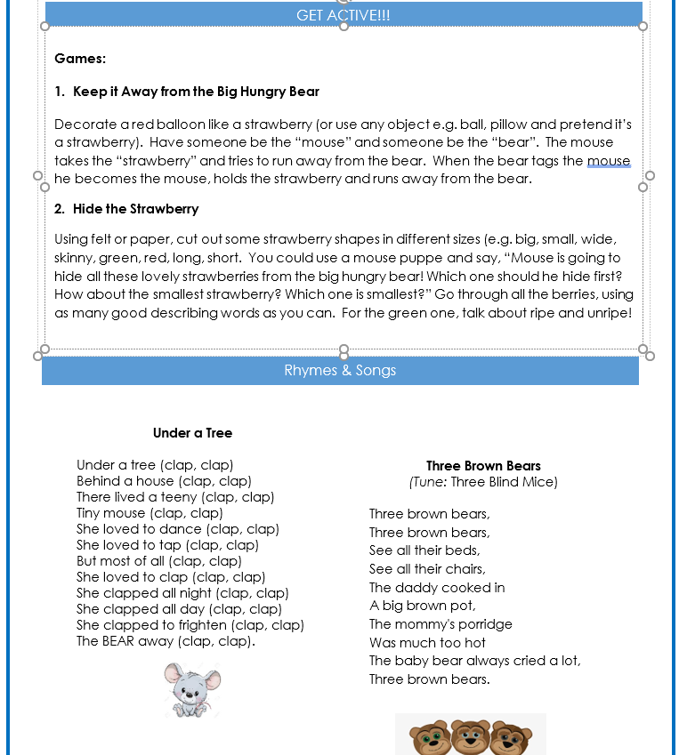

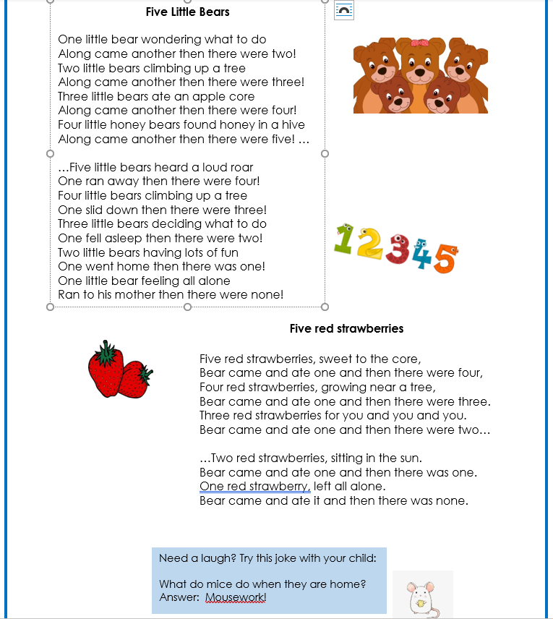

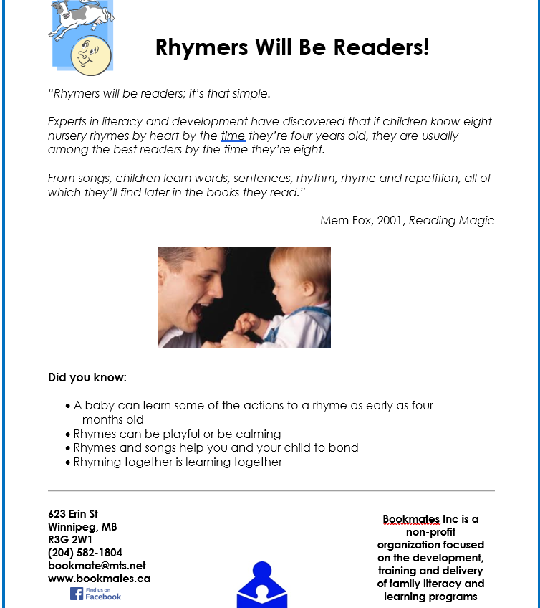

**Days 6, 7 and 8**

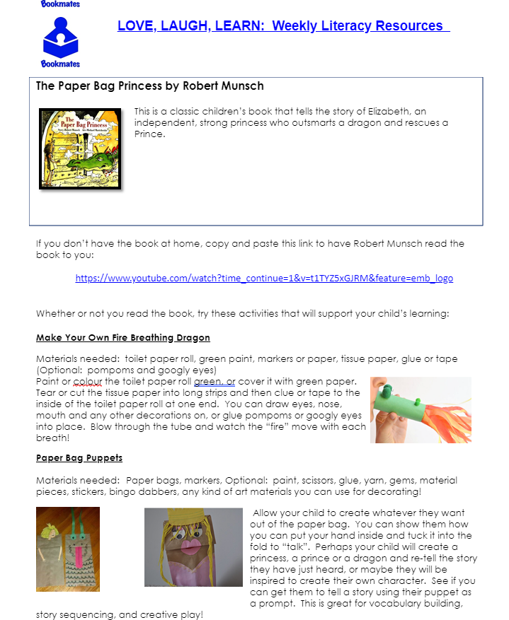

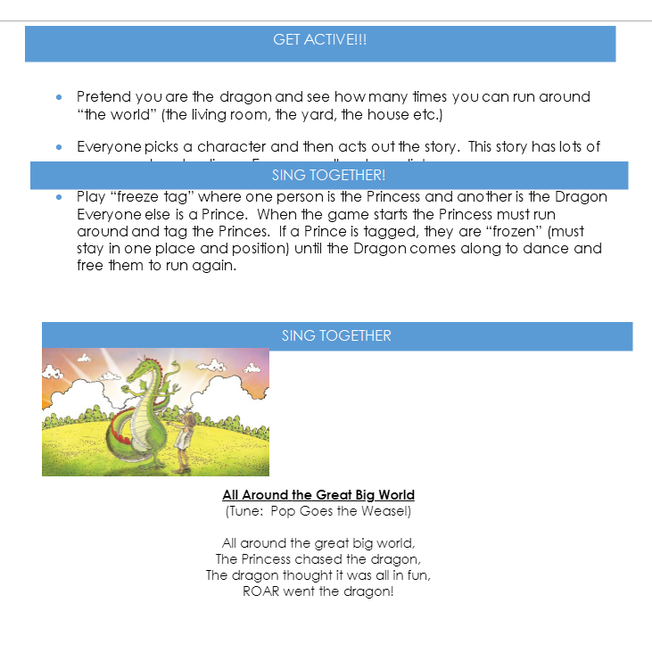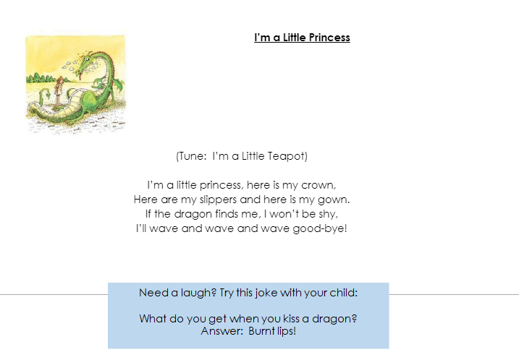

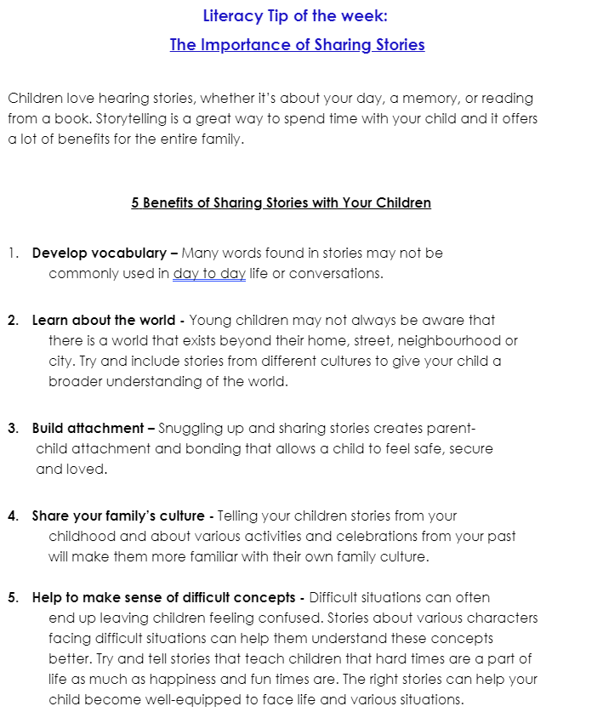

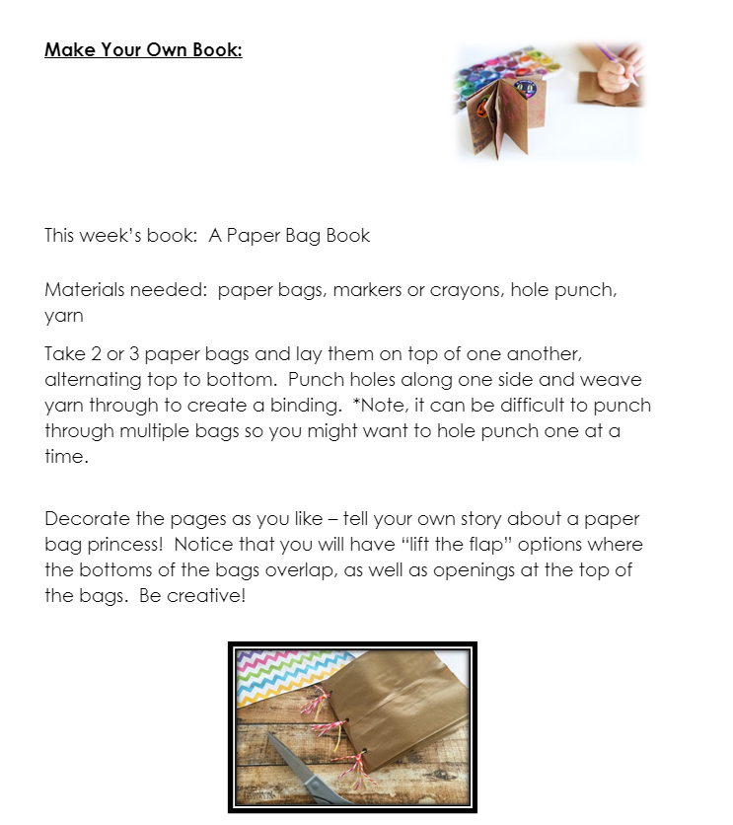

**Days 9 and 10**

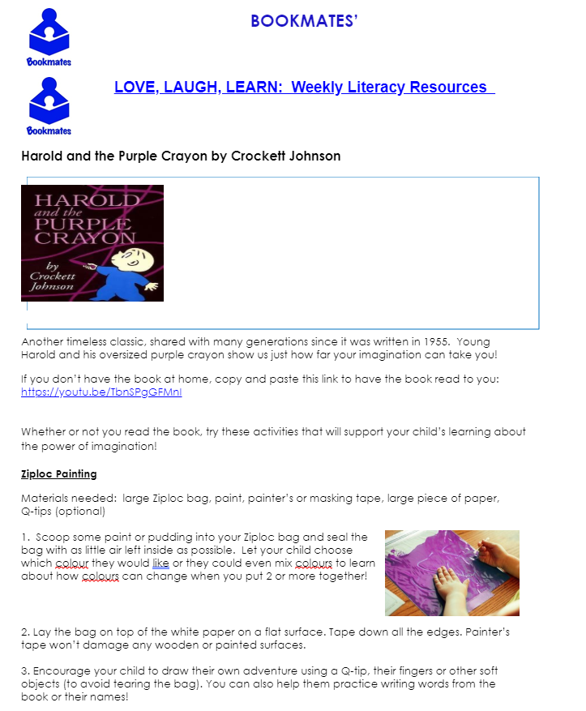

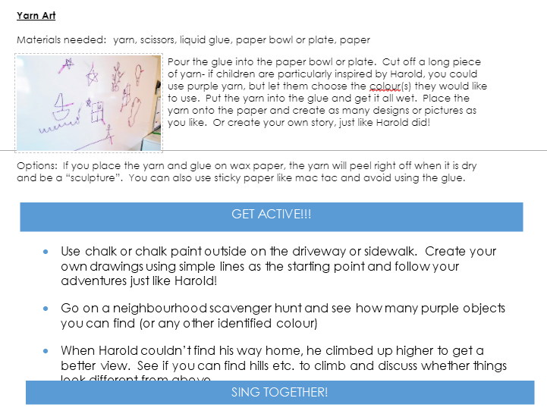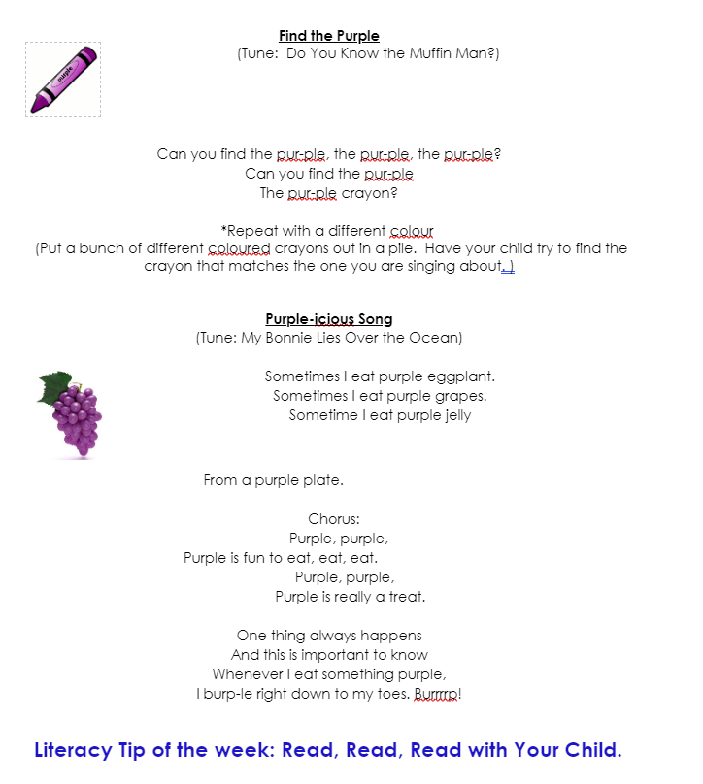

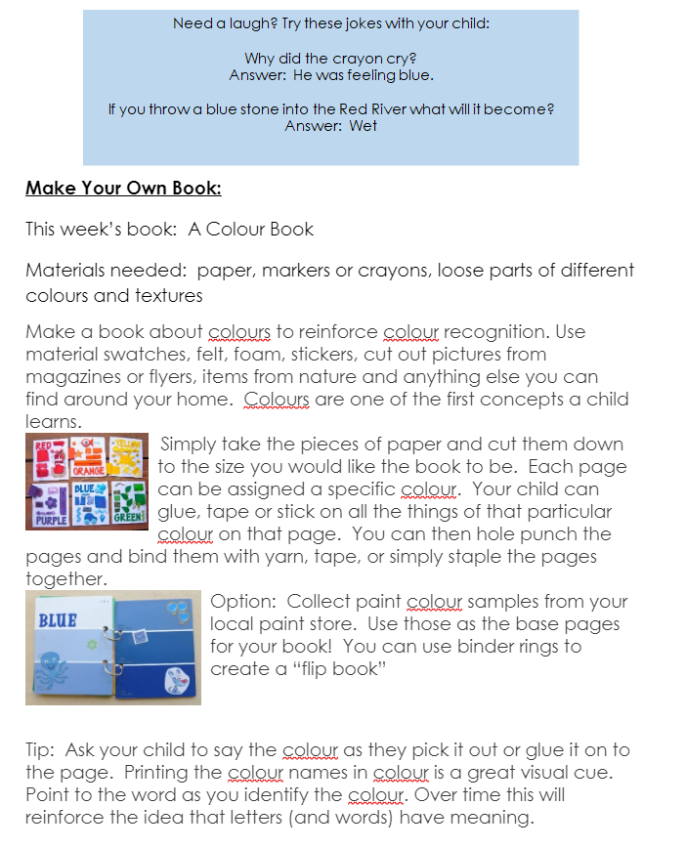

Bookmates resources are shared with permission and are created by:



Other Options:

**Literacy and Math Activities: abcya.com**

<https://www.abcya.com/>

Literacy:

Click on the ‘K’ bubble

Then click on - Alphabet Bubble

Or/and

Click on the ‘K’ bubble

Then go to – Talk to Me Alphabet

Then, select Keyboard layout and Audio – letter sounds

Then you click on the letters and the program produces the letter sounds

Your child to attempt the letter sounds prior to clicking the audio

Click on the ‘K’ bubble

Then click on – Alphabats Rhyming Words or Syllables

Click on the ‘K’ bubble

Then go to - Alphabet Bubble

or

Alphabet Order

Math:

Click on the ‘K’ bubble

Then scroll down to – Kindergarten Math Games

Then, select Fuzz Bugs – Counting, Sorting & Comparing

Click on the ‘K’ bubble

Then scroll down to – Kindergarten Math Games

Then, select Counting Fish

Click on the ‘K’ bubble

Then click on Fun with the Fridge and practice letters, numbers and shapes

Or

Scroll down to Kindergarten Math Games

Click 100 Snowballs

Click on the ‘K’ bubble

Then scroll down to – Kindergarten Math Games

Then, select Number Bingo – numbers 10-20 or 20-30 and pick the middle grid

**Kindergarten Learning from Home Package Resources**

**Tips for Family Reading**

1. Invite your child to read with you every day!

2. Too many words in the book? Take a picture walk. You can make up your own story together!

3. Have fun and enjoy your time together. When reading aloud use different voices for the characters.

4. Talk about the details in the pictures. Ask what they think will happen on the next page?

5. Have your child retell the story-it helps them to understand the meaning of the words.

6. It’s ok to read your child’s favourite book over and over, repetition is great for word recognition.

7. Make connections between things in the story and the child’s life.

**How to do a ‘Book Walk’**

For the younger grades, a picture walk is a tool that teaches emerging readers to use pictures as clues to understand the meaning of a story and guess at unfamiliar words.

Here’s how it works: First show the children the cover and read the title. Ask them what they think the story will be about, based only on what they see. Then slowly flip through the book, page by page (or by picking several key pages in advance) without reading a single word. Ask them questions about each picture they see. "What is going on here?" "Who is this?" "Why does the character look so excited?" "When is this story taking place?" "How do you think the story is going to end?"

French Vocabulary:   
What is going on here? *Qu’est-ce qui se passe ici ?*  
Who is this? *Qui est-ce ?*  
Why does the character look so excited? *Pourquoi a-t-il l’air si excité ?*  
When is this story taking place? *Quand se passe cette histoire ?*  
How do you think the story is going to end?   
*Comment penses-tu que l’histoire va finir ?*

Ask plenty of questions that will engage the kids’ imaginations and encourage their active participation. Remember when you ask questions your responses should be vague so that don't give away your knowledge of the storyline. Good responses leave open the possibility of many “correct” answers, and include follow up questions to encourage the children to think about the reason they gave an answer, for example: "That's very possible!" "Are you sure about that?" “How can you tell she is feeling _____?”

Once you're done with the "picture walk" and have started the actual read-aloud session, short discussions while you're reading can be very beneficial to the children because they reinforce the critical thinking that you fueled by stimulating their curiosity during the "picture walk."

Some good topics for discussion include: 1) Testing their storyline hypotheses ("Do you still think the story is going to end like that? Why or why not?"), 2) Appraising characters' actions ("Was it a good idea for the character to do that? How would you have solved that problem?") 3) Examining cause-and-effect relationships ("So now that you know what really happened, why do you think the character looks so excited?").

Kids will be excited to find that outcomes they have predicted are correct or they will be surprised to find that the plot has taken some unexpected turns. The picture walk can serve as a great tool to stir interest in both the story and in the read-aloud session. Not only can it encourage the children's participation in group discussion, but it can also improve their comprehension of the story. Providing them with a tantalizing glimpse of visual story elements should help stir their imaginations and help them weave an intellectual frame of reference for better organizing and evaluating what they hear as you read the actual story.

**Foldable Books** (Materials: paper, stapler, markers/pencil crayons/crayons)

**Accordion Books** (Materials: paper, scissors, glue, art supplies)

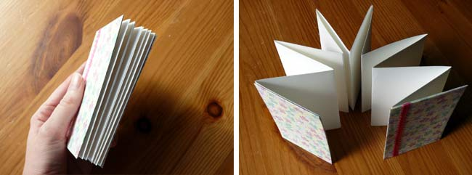

What to Do:

Step 1: Cut a piece of white cardstock in half lengthwise to make two long, skinny rectangles.

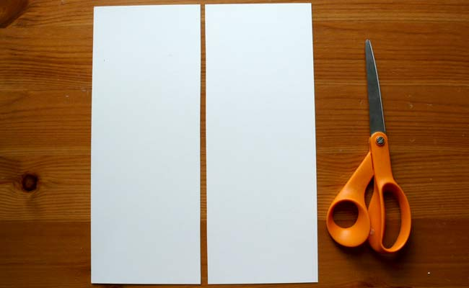

Step 2: Fold the paper in half widthwise.

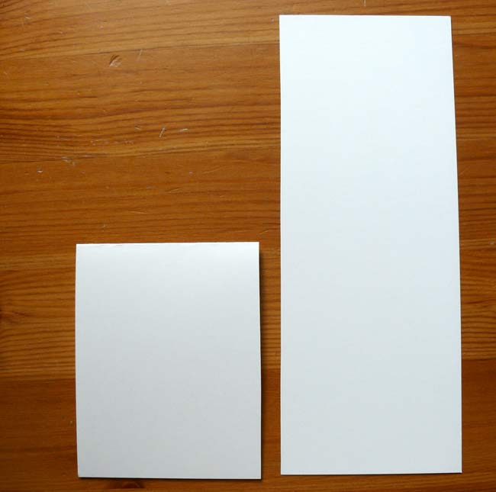

Step 3: Fold the top flap in half again, aligning the bottom edge to the top crease.

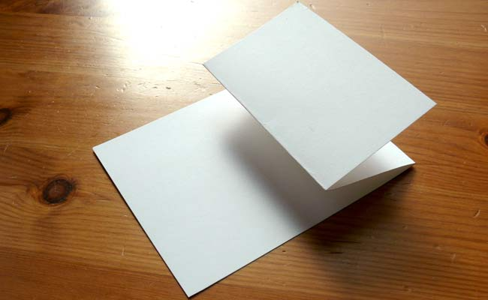

Step 4: Flip the paper over and do the same to the other side. Your paper should resemble a W when finished.

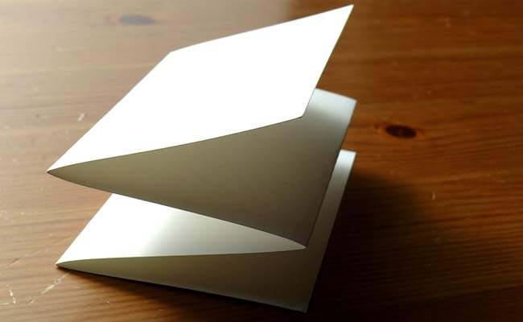

Step 5: Make as many as you need and glue the ends together to create a longer accordion.

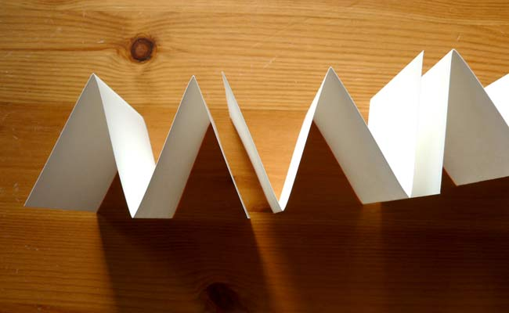

Creating a [foldable book](https://www.youtube.com/watch?v=R7UZ6Iv8b_Y).

**Let’s Create – Art Choices**

**1.Melting Crayon Art**

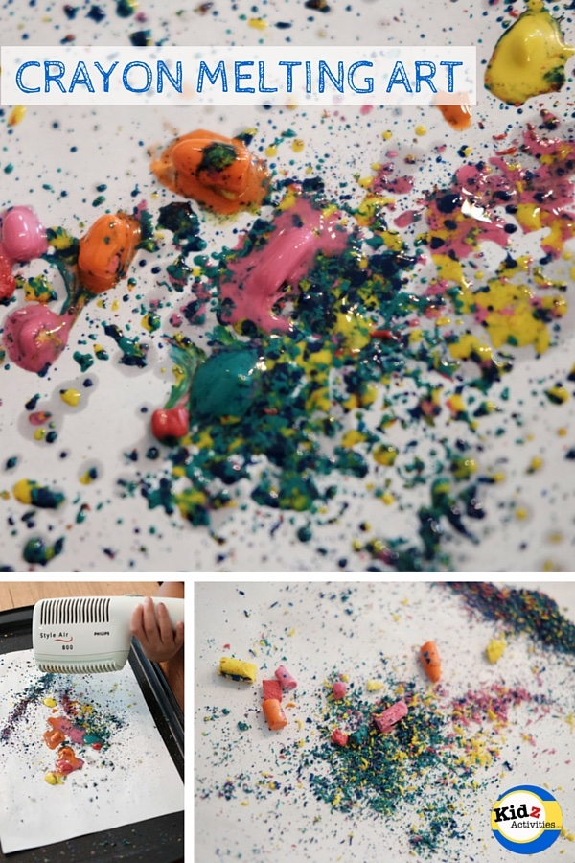Supplies:

* broken crayon bits
* paper or poster board for a “canvas”
* hair dryer

Instructions:

Step 1: Cover your work space in newspaper or a dropcloth

Step 2: Grate, smash or shave crayon bits into smaller pieces. The smaller the piece, the more easily it will melt

Step 3: sprinkle the broken crayon pieces onto the “canvas”. There are no rules to how much or little you sprinkle. Mix the colours together, keep them separate, sprinkle all over the page or leave blank space. You are the artist!

Step 4: Turn your hair dryer on to a low setting. Holding the dryer at least a foot above the “canvas” to start (so the small bits of crayon don’t get blown away) begin to melt the crayon. Once the crayon begins to soften, you can hold it closer to melt the crayon more quickly.

Step 5: Optional. If you hold the dryer a bit to the side, it will make the melting crayon spread out in interesting shapes.

Step 6: Continue melting until you have achieved a look that you find pleasing.

**2. Connecting Music and Art**

Listen to music together and dance. Then, your child can draw a picture afterwards while the music continues to play.

**3. DIY puffy paint**

<https://artfulparent.com/salt-puffy-paint/>

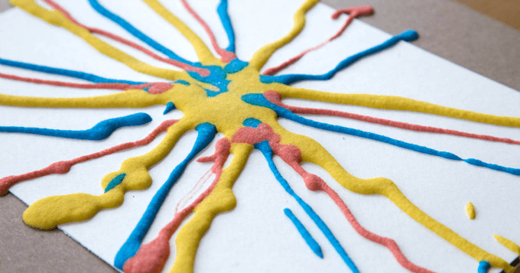 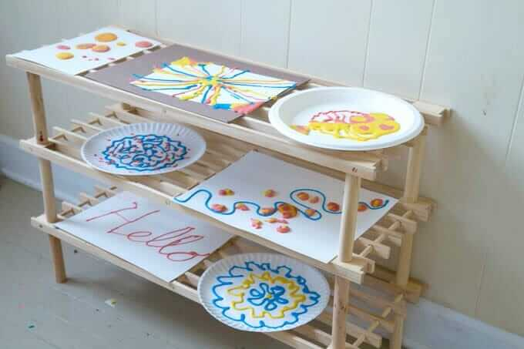

**Ingredients:** The paint is simply a mix of equal parts salt, flour, and water with a bit of tempera paint added for colour.

**How to:** You can apply it with a squeeze bottleor an icing bag, and because of the viscosity of the paint, it stays raised, like frosting. Hence the “puffy paint” even though it’s not actually puffy to the touch. Once the paint dries, it’s hard and crystalline because of the salt.

**What’s cool is that the colours stay separate rather than mix.** You could squeeze out a puddle of yellow salt paint, then add drops of blue on top and those drops of blue would hold their shape and colour and separateness until dried.

**Everyone seems to love using this kind of paint!**From youngest toddlers just getting the joy of squeezing a bottle and watching the paint come out to older kids and even adults.

**4. Make your own playdough!**

[**https://www.iheartnaptime.net/play-dough-recipe/**](https://www.iheartnaptime.net/play-dough-recipe/)

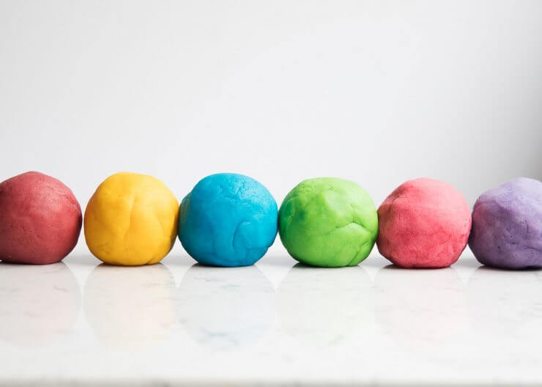

Playdough (*= la pâte à modeler*) ingredients:

* 2 cups all-purpose flour
* 3/4 cup salt
* 4 teaspoons cream of tartar
* 2 cups lukewarm water
* 2 Tablespoons of vegetable oil (coconut oil works too)
* Food colouring, optional
* Quart sized bags

Instructions:

1. Stir together the flour, salt and cream of tartar in a large pot.
2. Add the water and oil. If you’re only making one colour, add in the colour now as well.
3. Cook over medium heat, stirring constantly. Continue stirring until the dough has thickened and begins to form into a ball.
4. Remove from heat and then place inside a gallon sized bag or onto wax paper.
5. Allow to cool slightly and then knead until smooth.
6. If are making multiple colours, divide the ball of dough up into as many smaller balls as the number of colours you want. Put each small ball of dough into a Ziploc bag. Add about 5 drops of food colouring to each bag. Zip the bag up. Squish and knead the food colouring into the dough. By mixing the colour into the dough in the bag, you don’t get food colouring all over your hands!
7. If you want, you can add glitter to your dough in the bag as well.
8. When you are not having fun with your playdough, keep it in a Ziploc bag with all the air squeezed out of it. Your playdough should keep for up to 3 months.

**5. Ice Suncatchers**

<http://twigandtoadstool.blogspot.com/2014/01/ice-rainbow-sun-catchers.html>

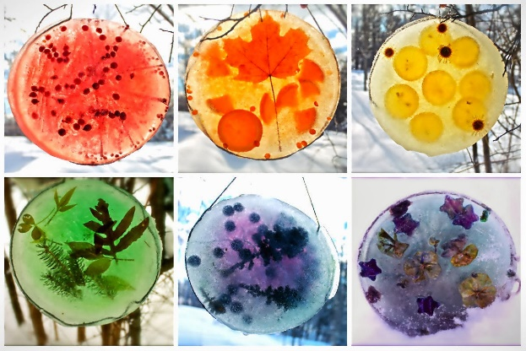

Supplies: round foil cake tins

Bits of nature (branches, berries, leaves, fruit slices, whole spices, etc)

Food Colouring (optional)

String

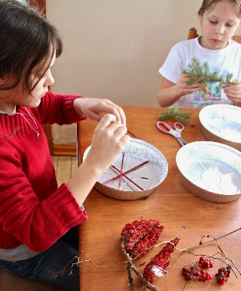 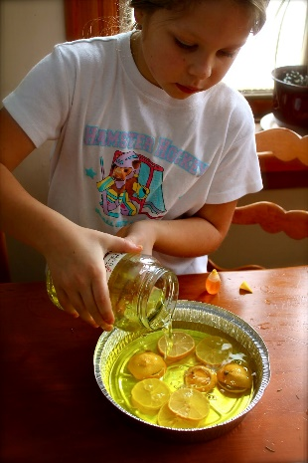 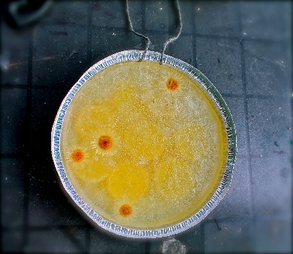 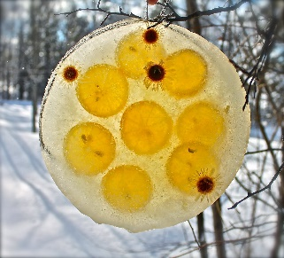

How to:

Step 1: Measure how much water will fit into your cake tins. Pour the water into a food colouring safe container like a glass measuring cup.

Step 2: Place the natural objects that you found into the tins

Step 3: Add food colouring to a container of water (optional)

Step 4: Pour water back into the cake tin over the natural objects

Step 5: loop a string with the ends into the cake tin. This will be used to hang your suncatcher

Step 6: put the cake tin somewhere to freeze. Once it is frozen, hand it outside so you can enjoy its beauty! As the ice melts, the natural objects will become more exposed and the birds and squirrels will have a tasty treat!