|  |
| --- |
| Instructions for Using Remote Learning Projects |
| These materials were developed with the intention of easing the transition between in-class and temporary remote learning. Learning experiences are aligned with curricular outcomes and assessment tools have been included with each project.  **Note:**   * 1. The teacher either sends a link to the appropriate project or sends the document itself.   2. The teacher ensures that parents/caregivers receive any required school supplies (bin with pencils, markers, paper, etc.).   3. The teacher reassures parents/caregivers that communication will be maintained between home and school.   4. Parents/caregivers may access additional resources at:      + My Learning at Home ([www.edu.gov.mb.ca/k12/mylearning](http://www.edu.gov.mb.ca/k12/mylearning))      + My Child in School ([www.edu.gov.mb.ca/k12/mychild/index.html](http://www.edu.gov.mb.ca/k12/mychild/index.html)) |

|  |  |
| --- | --- |
| PROJECT OVERVIEW | |
| Grade: | 7 |
| Main Subject: | Social Studies |
| Big Idea: | Interrelationship between Physical and Human Geography |
| Title: | DESIGN AN ISLAND |
| Cluster: | World Geography/Global Quality of Life |
| Duration: | 4 weeks |
| Materials: | Optional: Clay (home made or purchased) or dry wall, paper, coloured markers, paints, outline map of the world |
| Short Description: | This teacher-led, culminating course project (which could begin after Clusters 1 and 2) engages students to create their own island. Students write their own “geography story” for an island they create to highlight the interrelationship between the physical and human geography of their island. Students can work on this project independently with teacher check-ins. |

|  |
| --- |
| Learning Outcomes |
| Social Studies: <https://www.edu.gov.mb.ca/k12/cur/socstud/foundation_gr7>  7.11, 7.12, 7.13, 7.2.1, 7.2.2, 7.2.3, 7.2.4, 7.2.5 |

|  |  |  |  |  |  |  |  |  |  |  |  |  |  |
| --- | --- | --- | --- | --- | --- | --- | --- | --- | --- | --- | --- | --- | --- |
| Assessment | | | | | | | | | | | | | |
| LANGUAGE ARTS | | | | | MATHEMATICS | | | SCIENCE | | | SOCIAL STUDIES | | |
| COMP.  Listening &  Viewing | COMP.  Reading | COMM. Speaking & Represent. | COMM. Writing | Critical Thinking | Knowledge  and  Understanding | Mental Math &  Estimation | Problem Solving | Knowledge  and Understanding | Scientific Inquiry Process | Design Process &  Problem Solving | Knowledge  and Understanding | Research  and Communication | Critical Thinking and  Citizenship |
|  |  | X | X |  |  |  |  |  |  |  | X | X | X |

|  |  |
| --- | --- |
| Original concept created by: | Linda Connor and Val Noseworthy |

|  |
| --- |
| Learning Experiences and Assessment |
| Teacher’s instructions  The General Learning Outcomes for this project include economics, resources, power and authority, the land: people and places, and global interdependence. The project is cumulative and targets the outcomes for Grade 7 Social Studies Clusters 1 and 2. The project could be done online or as a hands-on project. Students can work on this project independently with teacher check-ins.  **Project steps:** The project will be divided into five main stages:  1. The Map of Island  2. The Physical Geography of Island  3. The Human Geography of Island  4. Tourist Brochure  5. Oral Presentation  **Project Presentation:**   1. Start a discussion with students about the intent of the project and what students might include. Some suggestions for information and questions to ask:   **Information about the intent of the project**:  You will design, label and describe an imaginary island to demonstrate your understanding of physical and human geography. Your island should be connected to one of your interests and should include the characteristics of that interest. For example, Basketball Island could be drawn in the shape of a basketball and have basketball related names for geographic features, such as Point Guard Lake, Hoop Mountain, etc. At the end of the project, you will present the island to your classmates.  **Instructions and questions to ask students:**   * + - * What are your favourite interests or hobbies?       * Make a short list (for example, a sport, a game, a musical instrument, an animal, etc.).  (Hand in the Appendix “My Interests.”)       * Among the items on your interests list, choose one that will be the theme of your island.       * Brainstorm and research the vocabulary and characteristics of your island. (See Appendix.)   **The format of the final project:**   * + - * As a culminating project, you will create a booklet (see the example, Ladybug Island, in the appendices section), or a digital presentation such as a PowerPoint presentation that you will present to the class.   2. Present the project evaluation criteria.  Note: It would be useful to review the essential elements of a map such as the title, the compass rose, the legend as well as the physical elements, the political elements (cities, borders), vegetation, bodies of water, etc.:  **Instructions for students:**   * Design your own island. Choose a shape for your island that represents the theme of something you are interested in, such as a turtle, basketball, microscope, book, calculator, musical instrument, etc. * Create a geographic history of your island. Your story should link to the shape/theme of your island as well as explain how the location of your island shapes the physical and human characteristics of the island. For example, if your island is in the shape of basketball, you have to learn how to shoot a 3-point basket! Or if your island is in the shape of a dancer, the provinces can be named according to dance styles. |
| Part 1: Maps |
| * Draw the shape of your island and place it on a map of the world in one of the world’s oceans (Atlantic Ocean, Pacific Ocean, Arctic Ocean, Southern Ocean/Antarctic, Indian Ocean). * Indicate the lines of latitude and longitude every 10 degrees as well as the main lines of latitude and longitude such as the equator, the tropics, and the main meridian. Don’t forget to add all the key map elements such as a map key or legend, compass rose, and scale. * Add the contours of the continents that are near the island. * Create a second map that only shows the island. The map can be a digital map, a three-dimensional relief map or a coloured paper map showing the main features (cities, villages, reliefs, borders, bodies of water, etc.) listed below for your island. |
| Parts 2 and 3: Choose the format you will use to present this part of your project, for example, in the form of a booklet, digital presentation such as PowerPoint, or different format that you discuss with your teacher: |
| Part 2: Physical Geographical Story of Your Island |
| This part of your story will focus on the Physical Geography of your island. It will describe how the location of your island shapes its physical characteristics. Considering the location of your island, describe how the location affects your island:   * Vegetation (for example, if Basketball Island is near the equator, are there rubber trees or other tropical plants?) * The landforms (for example, Hoop Mountain, the highest mountain on your island, as part of the Ring of Fire?) * Climate (average temperatures, precipitation, seasons, winds, currents, climate chart) * Bodies of water (lakes and rivers on the island) |

|  |
| --- |
| **Part 3: Human Geographical Story of Your Island** |
| This part of your story will be about the Human Geography of your island. As much as possible, relate the story back to your island’s shape/theme. It will describe how the island’s location influences the lives of the people. Given your island’s physical geography, describe your island’s:   * history … include a motto, flag, and the national anthem for the island based on this history * population … include a population pyramid/graph * culture (traditions, customs, music, celebrations) * cities and towns * immigration and citizenship * life expectancy/wellbeing * education/ways of knowing * careers/community roles * transportation systems/routes * land use |
| Part 4: Tourist Brochure |
| The fourth part of your story should include a Tourist Brochure for your island. Given your island’s shape and human geography, highlight what tourists might see and do when they visit your island, as well as travel arrangements and how to prepare for their visit:   * special events * historical sites * food * points of interest * music/art/theatre * sports * language * information technology * markets/shopping * currency/trade * recreation |

|  |
| --- |
| APPENDIX (Printable Support Materials Including Assessment) |

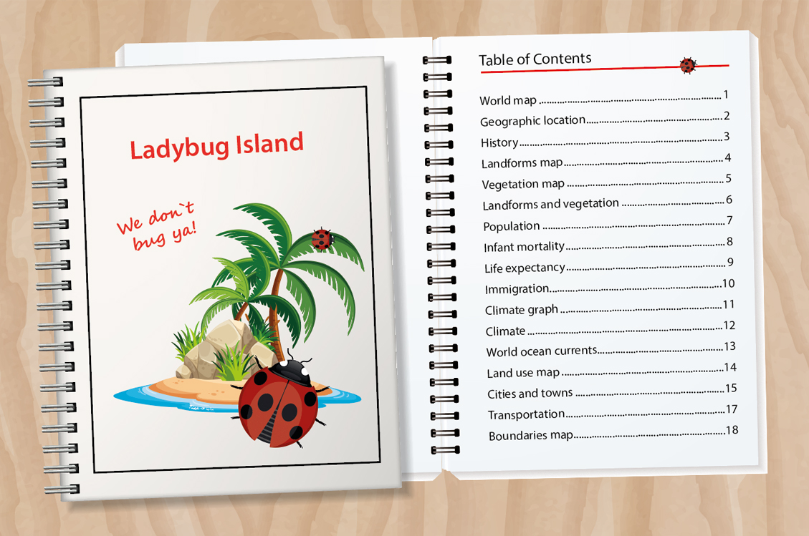

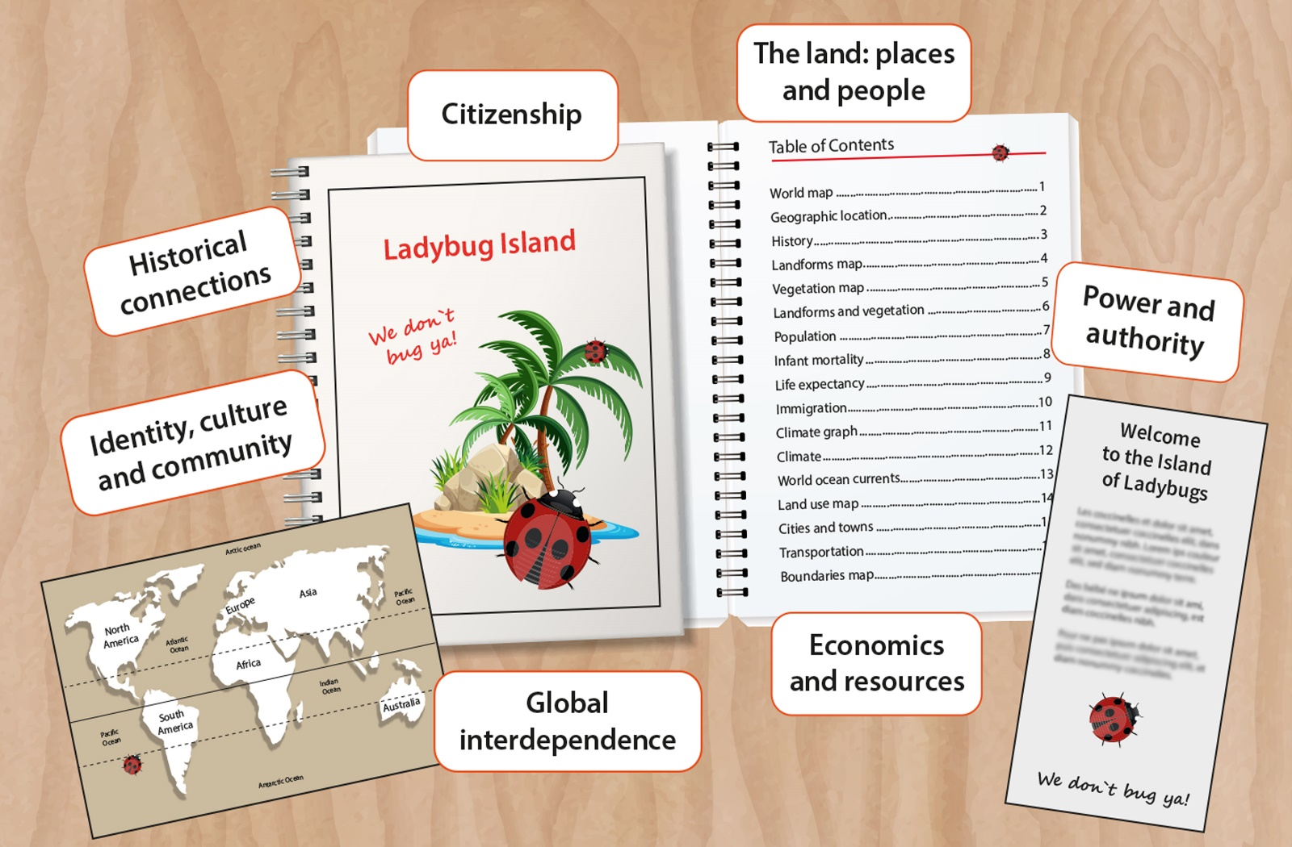

**My Planning**

**My Island to Explore**



**My Planning Booklet  
____________________________  
(name)**

**My Interests**

**Vocabulary Related to My Interest**

Interest:

|  |  |
| --- | --- |
| **Vocabulary** | |
|  |  |
|  |  |
|  |  |
|  |  |
|  |  |
|  |  |
|  |  |
|  |  |
|  |  |
|  |  |
|  |  |
|  |  |
|  |  |
|  |  |
|  |  |
|  |  |
|  |  |

**The Shape of My Island**

**My Island in the World**

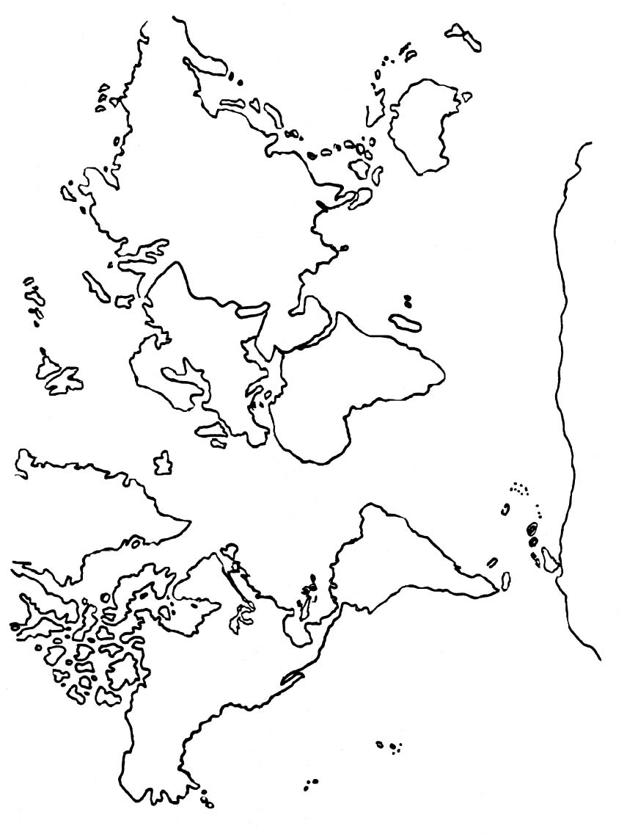**The Physical Geography Story of My Island**

This part consists of creating the Physical Geography story of your island. It's about describing how your island's location influences its physical characteristics.

Here are some things to include:

* Vegetation: what type of vegetation (plants, trees, grasses, etc.) is found there? Vegetation must be adapted to the climate. (For example, if Basketball Island is near the equator, are there rubber trees or other tropical plants?)
* Landforms: are there mountains, valleys, plateaus, plains? (For example, Hoop Mountain, the highest mountain on your island, as part of the Ring of Fire?)
* Climate: what are the average temperatures, precipitation, seasons? Are there winds, currents? Create a climate graph for your island.
* Bodies of Water: what are the main bodies of water on your island (lakes and rivers on the island)?

|  |  |  |
| --- | --- | --- |
| **Physical Characteristics** | **Characteristics of My Island** | **Influence of Location on  These Characteristics** |
| Vegetation |  |  |
| Landforms |  |  |
| Climate |  |  |
| Bodies of Water |  |  |

**The Human Geography Story of My Island**

This part consists of creating the Human Geography portrait of your island. As much as possible, describe your island according to the shape you have chosen for your island or taking into account the main theme. Your portrait will describe how the location of the island influences people's lives.

Here are some things to include:

* History: include a motto, flag, and national anthem for the island
* Population: include a population pyramid/graphic
* Culture
* Cities and Villages
* Immigration and Citizenship
* Life Expectancy/Wellbeing
* Education/Traditional Knowledge
* Careers/Community Roles
* Transportation Systems and Roads
* Land Use

|  |  |
| --- | --- |
| **Elements of Human Geography** | **Human Geography Characteristics of My Island** |
| History |  |
| Culture (traditions, customs, music, celebrations…) |  |
| Cities and Villages |  |
| Immigration and Citizenship |  |

*(continued)*

|  |  |
| --- | --- |
| **Elements of Human Geography** | **Human Geography Characteristics of My Island** |
| Life Expectancy, Wellbeing |  |
| Education, Traditional Knowledge |  |
| Careers, Community Roles |  |
| Transportation Systems/Routes |  |
| Land Use |  |

**Tourist Brochure**

This part of your project should include a Tourist Brochure for your island.

Given the shape of your island and the Human Geography, highlight what tourists could see and do when they visit your island, as well as travel arrangements such as transportation and accommodation and how to prepare for their visit:

* special events • historical sites • food
* points of interest • music/art/theatre • languages
* information technology • markets / shopping
* currency / trade • recreation

|  |  |  |  |
| --- | --- | --- | --- |
| **Special Events** | **Historical Sites** | **Food** | |
|  |  |  | |
| **Points of Interest** | **Music/Art/Theatre** | **Languages** | |
|  |  |  | |
| **Technical Communication** | **Markets/Shopping** | **Recreation** | |
|  |  |  | |
| **Other:** | | |

**My Project Checklist**

The information about my island is complete, clear and relevant.

|  |  |  |
| --- | --- | --- |
| **Physical  geography** | **human  geography** I have included the following  details: | **TOURIST Brochure** My brochure includes specific and relevant details of the following: |
| Vegetation  ○ I have included a complete description of the trees, plants or herbs found there  Landforms ○ I included a complete description of the landforms such as mountains, valleys, plains  Climate ○ I have specified the type of climate and included average temperatures  Bodies of Water ○ I have included bodies of water such as rivers, lakes, etc. | History of the Island ○ Population ○ Culture ○ Cities and Towns ○ Immigration ○ Citizenship ○ Life Expectancy ○ Wellbeing ○ Education ○ Traditional Knowledge ○ Careers ○ Transportation Systems ○ Land Use ○ | Special Events ○ Historical Sites ○ Food ○  Points of Interest ○ Music and Art ○ Languages ○ Information Technology ○ Markets / Shopping ○ Currency / Trade ○ Recreation ○  Travel Itinerary ○ Lodgings ○ |
|  |  |  |

|  |
| --- |
| **QUALITY OF MY WORK** |
| The appearance of my work is attractive ○ Elements are clearly indicated ○ My work is original ○ I have checked my spelling and grammar ○ |
|  |

**Preparation and Checklist of Items for Presentation**

**Introduction:**   
I will share the place where one can find my island in an original way (I can ask a question, give a riddle ...).  
*Example: My island is said to look like ...*

I name my island and present the place where it can be found or the reason why it should be explored.  
*Example: And, yes, strangely it is called and I guarantee you want to explore it because when you are there, it is like being in paradise.*

**Development:**

I'm doing a geographical story of my island.

I present my Tourist Brochure in order to convince my classmates that it is the most beautiful island on the planet.

**Conclusion:**In my conclusion I summarize :  
  
❒ to inform, I summarize the main ideas.  
__________________________________________________________________________________________

__________________________________________________________________________________________  
  
❒ to invite others, I make recommendations.  
_________________________________________________________________________________________

_________________________________________________________________________________________

**My Interests  
(examples)**

Reading

Dance: Salsa, Swing

Construct or make things

Skiing

Spend time with friends

Play card games

**Vocabulary Related to My Interest**

Interest: Dancing

|  |  |
| --- | --- |
| **Vocabulary List** | |
| dancer | masquerade |
| merengue | costume |
| salsa | boléro |
| swing | celebration |
| rhythm | party |
| choreography | song |
| teach | music |
| practice | fireworks |
| workshops | belly dancing |
| gestures | guitar |
| dance floor | dancing |
| contemporary | drums |
| classical | expression |
| cultural | waltz |
| partner | competition |
| spin | prize |
| hip hop | jury |

**Shape of the Island  
(examples of some elements to include)**

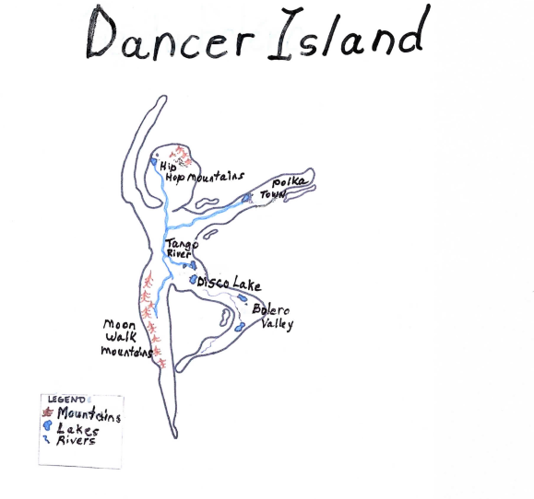

**World Map  
(Remember to add the elements of a map)**

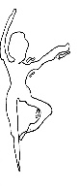

|  |  |  |  |  |  |
| --- | --- | --- | --- | --- | --- |
| **PowerPoint Rubric Individual Work**  **Booklet/Digital Presentation/Brochure** | | | | | |
| **Element** | **4** | **3** | **2** | **1** | **Points** |
| Planning | The planning completely and clearly demonstrates the project. | The planning demonstrates the project somewhat. | The planning demonstrates the project very little | No evidence of planning |  |
| Organization | The sequence of information is very logical. The title and conclusion are included. | There is some logic in the sequence of information. | There is little logic in the sequence of information. | There is no logic in the sequence of information. |  |
| Content | The work covers the subject completely and in depth. The information is clear, appropriate and accurate. | The work includes most essential information. Some information is confusing, incorrect. | The work includes some essential information. The information is confusing, inaccurate or imperfect. | The work includes very little essential information. The information is very confusing, inaccurate or imperfect. |  |
| Multimedia or text design (text, graphics, sound, video, animation) | The choice of media or text design is suited to the presentation and is very attractive to the viewer or reader. | Most of the elements contribute to the subject. Some elements may have too much or not enough text. | A few elements contribute to the subject. Some elements may have too much or too little text. | There are many elements missing. |  |
| Language | Spelling, vocabulary, grammar, the use of punctuation are accurate and correct. | There are minor problems with spelling, vocabulary, grammar, and punctuation. | There are several spelling, vocabulary, grammar and punctuation errors. | There are persistent errors in spelling, vocabulary, grammar and punctuation. |  |
| Appearance | The presentation is very attractive and attractive to the viewer or reader. | The presentation is attractive and attractive to the viewer or reader. | The presentation is somewhat attractive to the viewer or the reader. | Little or no attempt has been made to make the presentation attractive to the viewer or reader. |  |
| TOTAL |  |  |  | | /24 |

|  |  |  |  |  |
| --- | --- | --- | --- | --- |
| **Rubric: Maps**  Student Name/Class ______________________________ Date ________________________ | | | | |
| **Criteria** | **4** | **3** | **2** | **1** |
| Content  Knowledge  (x 2 points) | Student’s work demonstrates mastery of content (geography, maps, physical features) and almost all relevant key vocabulary is used. | Student’s work demonstrates a good understanding of the content and most relevant key vocabulary is used. | Student’s work demonstrates some understanding of the content and some vocabulary is used. | Student’s work demonstrates a lack of understanding of the content and lack of vocabulary. |
| Title | Title is creative and identifies the content/theme of the map, is clearly distinguishable as the title (e.g., larger letters, underlined, etc.), and is located at the top of the map. | Title identifies the content/theme of the map, is distinguishable as the title, and is located at the top of the map. | Title doesn’t identify the content/theme of the map OR is not located at the top of the map. | The map is missing a title. |
| Elements of the map  (x 2 points) | Map includesall required parts (latitude/longitude grid, map key, compass rose, and scale); each can be read easily and is in required location. | Map is missing one required part (latitude/longitude grid, map key, compass rose, or scale) OR part(s) cannot be read easily or are not in required location. | Map is missing two or more required parts (latitude/longitude grid, map key, compass rose, or scale) OR parts cannot be deciphered. | Map is missing more than two required parts (latitude/longitude grid, map key, compass rose, or scale) AND/OR parts cannot be deciphered. |

|  |  |  |  |  |
| --- | --- | --- | --- | --- |
| **Rubric: Maps (continued)**  Student Name/Class______________________________ Date________________________ | | | | |
| **Criteria** | **4** | **3** | **2** | **1** |
| Attractiveness | The map is fully coloured and exceptionally attractive in terms of design, layout, neatness, and overall presentation. | The map is fully coloured including the ocean and attractive in terms of design, layout, neatness, and overall presentation. | The map is acceptably attractive and laid out, although more attention to the design, layout, neatness and overall presentation is required.  Map isn’t fully coloured. | The map is lacking in design, neatness, and/or layout. The map is still in "draft" stage. |
| Originality | Project reflects an exceptional degree of student creativity. | Project reflects strong student creativity. | Project reflects some creativity by the student or theme may be unclear. | Project lacks overall student creativity or does not have a theme. |
| Spelling/  Capitalization | All words on the map and in the key are spelled and capitalized correctly. | Most words on the map and in the key are spelled and capitalized correctly. | Some of the words on the map are spelled and capitalized correctly. | Many words on the map are misspelled or not capitalized correctly. |

|  |  |  |  |  |  |
| --- | --- | --- | --- | --- | --- |
| **Rubric: Oral Presentation** | | | | | |
| **Criteria** | **4** | **3** | **2** | **1** |  |
| Flow of ideas | The ideas presented are well developed and flow in a clear manner. | The ideas presented are generally well developed and flow in a clear manner. | The ideas are presented superficially and do not flow well. | The ideas presented are limited in their development and lack flow. |  |
| Expression | Oral expression is fluent and generally seems authentic. | Oral expression is generally fluent. | Oral expression is understandable and sometimes fluent. | Oral expression is hesitant and is not always understandable. |  |
| Syntax, variety of expressions | Language is varied and idiomatic. | Language is generally correct, varied and idiomatic. | Language is sometimes correct and some idioms are used. | Language is incorrect and / or limited. |  |
| Intonation | Intonation improves communication. | Intonation facilitates communication. | Intonation does not interfere too much with communication. | Intonation interferes with communication. |  |
| Vocabulary | The vocabulary is rich, varied and appropriate. | The vocabulary is varied and appropriate. | The vocabulary is generally varied and appropriate. | The vocabulary is not varied and is unsuitable. |  |
| TOTAL |  |  |  |  | /20 |