Instructions for Using Remote Learning Projects
These materials were developed with the intention of easing the transition between in-class and temporary remote learning. Learning experiences are aligned with curricular outcomes and assessment tools have been included with each project.
Note:
  - The teacher either sends a link to the appropriate project or sends the document itself.
  - The teacher ensures that parents/caregivers receive any required school supplies (bin with pencils, markers, paper, etc.).
  - The teacher reassures parents/caregivers that communication will be maintained between home and school.
  - Parents/caregivers may access additional resources at:
    - My Learning at Home (www.edu.gov.mb.ca/k12/mylearning)
    - My Child in School (www.edu.gov.mb.ca/k12/mychild/index.html)

PROJECT OVERVIEW
Grade: | 3
Main Subject: | Mathematics
Big Idea: | Time
Title: | TIMES OF YOUR LIFE
Strand: | Shape and Space
Duration: | 1–2 weeks
Materials: | paper, crayons/pencil crayons/markers, tape, scissors, clock with a second hand or a stopwatch
Short Description: | Students will examine constructed and natural patterns that exist with tracking the passage of time. Activities in this learning experience build to the creation of a personal timeline of a day in their lives. Most activities can be completed independently but would be greatly enhanced with discussion and sharing sessions held synchronously to develop a deeper understanding of the big ideas about the passage of time.

Learning Outcomes
Mathematics: www.edu.gov.mb.ca/k12/cur/essentials/docs/glance_kto9_math.pdf
3.SS.1, 3.SS.2

Assessment
LANGUAGE ARTS |  |  |  |  | MATHEMATICS |  |  | SCIENCE |  |  | SOCIAL STUDIES
COMP.  Listening &  Viewing | COMP.  Reading | COMM.  Speaking & Represent. | COMM.  Writing | Critical Thinking | Knowledge  and  Understanding | Mental Math &  Estimation | Problem Solving | Knowledge  and  Understanding | Scientific Inquiry Process | Design Process &  Problem Solving | Knowledge  and Understanding | Research  and Communication | Critical Thinking and  Citizenship
 |  |  |  |  | X | X | X

Original concept created by: | Carolyn Sigurdson, Charmaine Mackid, Denise Smith

Learning Experiences and Assessment
Questions:
What activities take a minute, an hour, a day, a week, a month, or a year to complete?
How are seconds, minutes, and hours related? How are days and months related?
In what ways can time be measured?
How do we use patterns in time to predict future events?
Teacher’s instructions
Introduction
Slide 1—In a synchronous session, have students view the pictures (without the title). Ask students what they notice and wonder and to make a prediction about the title and topic of the learning experience. After students have had an opportunity to share their noticings and predictions, share the title and topic of the learning experience.
Slide 2—Assign the question on the slide. You may choose to have students share their ideas or assign as an independent task.
Slides 3 and 4—Share the learning intentions on slides 3 and 4. Feel free to share these in student friendly language if that would be more appropriate for your students.
Calendars (red section)
In this section students will expand on their previous experiences with calendars. Learning activities will develop an understanding of how calendars are designed, how to use them to solve problems, and compare our current calendar with a traditional Indigenous calendar.
Slide 5—Students can independently view the story book reading of Calendar by Myra Cohn Livingston. (www.youtube.com/watch?v=GACaylLi-dI). This picture book is a poem about the months of the year. Each month is shared through artwork. The poem ends with the author sharing why December is their favourite month. Students will answer the question about their favourite month. Their ideas could be shared during a synchronous class meeting. This slide also contains the instructions for slide 6. This can be assigned as an independent activity.
Slide 6—This is a template for creating a calendar for one month. Students are to choose a month for which they will create a calendar. They will put the month and year at the top. They will add the dates (1, 2, 3, …). Students will also add any important events such as celebrations, birthdays, holidays, appointments, etc. A space has been provided on the left where students can insert a photo or a photo of a drawn picture to complete their calendar. Consider how you might have students share their calendars with their class.

Slide 7—Students will use their calendars to solve these problems. Consider having students complete this work independently and then have a synchronous opportunity to share their work. The second and third questions will likely have different answers depending on the months that students chose as their favourite month. This would provide an opportunity to discuss that months have either 28, 30, or 31 days. You might have students make predictions about why they think months have a different number of days.
Slide 8—Students can then watch the video A Kid Explains the Calendar (www.youtube-nocookie.com/embed/-Hg8dsxHzMA?autoplay=1&iv_load_policy=3&loop=1&modestbranding=1&playlist=-Hg8dsxHzMA) and complete the THH template independently. Consider having students share afterwards in a synchronous session. This could be done in breakout rooms.
Slide 9—Here students will be introduced to a traditional calendar that was used by many Indigenous cultures in North America. In 13 Moons on a Turtles Back (https://vimeo.com/409797977), George Couchie explains the importance of Turtle Island and how the Anishinaabe people used the turtle to keep track of time. Students can independently view the video and diagram on this slide.
Slide 10—On this slide, students will need the names of the moons to label their drawing. It would be best to consult with a local elder regarding the appropriate moon names for your location as the names often vary based on location. Consider inviting an elder to your synchronous class to share this information. If this is not possible, then the following resources may be helpful:
- Cree and Dene: See Appendix A—Table 1 has the Moons of the Cree Year and Table 2 has the Moons of the Dene Year (https://education.usask.ca/ccstu/pdfs/night_sky.pdf)
- Ojibwe and Cree: See pages 9-12 for Ojibwe, page 19 for Cree
(https://onlc.ca/wp-content/uploads/2014/06/13-Moon-curriculum2.pdf)
- Ojibwe (https://ojibwe.net/projects/months-moons/)
(Please note that not all languages/cultures of Manitoba are represented in the resources provided here and local dialects may be different from those presented in these resources which are from Saskatchewan and Ontario.)
After students complete their diagrams, have them use it to mark the current date by determining the current moon and how far along we are. Students can then track the date using the Turtle Calendar for a period of time.
Slide 11—As a culminating activity for this section, have students independently consider how our current calendar and the Turtle Calendar are the same and how they are different. Consider having students discuss this in groups after independently completing this activity.
Patterns During the Day (first blue section)
In this section, students will examine patterns in nature that help us determine what time of day it is.
Slide 12—Students can independently complete this task. Students might consider things they observe in the sky such as the sun, moon, and stars as well as length of shadows. This task will prepare students to observe the artwork in the book they will view in the next task.
Slide 13—Students can independently view the book, The Water Princess by Susan Verde (www.youtube-nocookie.com/embed/tIWAjQhClK0?autoplay=1&iv_load_policy=3&loop=1&modestbranding=1&playlist=tIWAjQhClK0). This story is about a young girl who must travel for many hours every day to get water for her family. The illustrator, Peter H. Reynolds, has captured the passage of time through the use of the position of the sun, the color of the sky, and the length of shadows.

Alternately, you might consider viewing this text synchronously, stopping at the following times for discussion:
1:04—The text says, “It is early morning still dark.” Where is the sun? Where is Gie Gie? What is she doing? What time could that be?
2:24—The text says, “…and our journey begins…” Where is the sun now? What time could it be?
2:45—The text says, “Halfway there…” What does halfway there mean? Where is the sun? What time could it be?
3:02—The text says, “Maman, are we there yet?” How much time has passed? How much more time before Gie Gie arrives at the destination?
3:18—The text says, “The sun has gone to bed.” What does this phrase mean?
3:26—When Gie Gie arrives at the river, where is the sun? What time do you think it is?
4:07—What time of day is it when Gie Gie is walking home? Where is the sun?
4:59—The text says, “I hide from the wind.” Where is the sun? What time of day is it?
5:31—The text says, “Sleep...Dream…” Where is the sun? What is in the sky? What time could it be?
End—How long do you think it took Gie Gie to go to get water and return home?
Slide 14—This activity can be completed independently. The activities that students choose for this chart will be used to create pictures for their final project.
Slide 15—This activity can be completed independently. Students will use the information from the previous slide to create four pictures. Pictures will each show an activity that the student participates in and will provide clues such as the sun’s placement to indicate the time of day. Students can share a photo of their pictures placed in order for sharing. It is important that these pictures are kept for the final project.
Measuring Time (yellow section)
This section will give students opportunities to see the relationship between different units of time, develop their sense of time, and discover how time influences their lives.
Slide 16—Use this slide to identify students’ current understanding of how units of time are related. Have students complete it asynchronously and send it to the teacher OR share it at a synchronous time.
Slide 17—Use this slide to identify students’ current sense of time. Have students complete it asynchronously and send it to the teacher OR share about it at a synchronous time.
Slide 18—Students can independently view the storybook A Second is a Hiccup: A Child’s Book of Time by Hazel Hutchins (www.youtube.com/watch?v=gRTI_omv0HQ). It invites them to think about how long specific units of time actually are. It will lead into the task described on Slide 19.
Slide 19—Students follow the instructions to complete slides 20–23. The purpose of this task is to give students a chance to “feel” certain lengths of time. They may notice something like the fact that some activities make time go by fast and some make time go slowly. The goal is to help students develop their sense of time.
Slides 20–23—Students complete these tasks independently, share with the teacher during a synchronous time.
Slide 24—Students can independently view the storybook A Second, a Minute, a Week with Days in It by Brian P. Cleary (www.youtube.com/watch?v=6yc9zs9viHA). It invites them to think about how different units of time are related.
Slide 25—Using the previous storybook as a support, students fill in the boxes with a word or number that applies. They are prompted to pick out patterns they notice (mainly how the words repeat at the start of the next line). Students’ can complete the slide independently or during a synchronous time if support would be needed.
Slides 26–29—Slide 26 explains to students how to document activities they do throughout a day and when and for how long they take. This is preliminary work to the Final Task they will complete next. Slides 27–29 are the pre-created tables students can use to record their information.

Final Project (second blue section)
This section lays out the instructions for the final task students are to complete before some final reflection. Students are to create a timeline that documents their daily life/routines and then apply some of the information gathered to a month-long scenario. This work can be done independently, shared with the teacher then discussed during synchronous times.
Slides 30–32 These slides include instructions and criteria for students to proceed with the Final Project. They can be read and followed by students independently or during a synchronous time. (30) In case students are not familiar with what a timeline is, this slide gives a definition and example. (31) This slide describes how to create the shell of the timeline. (32) This slide includes must do’s and can do’s for the Final Project. These can be changed based on what the teacher expects. They use the information recorded in their table from Slide 27 to fill out the timeline.
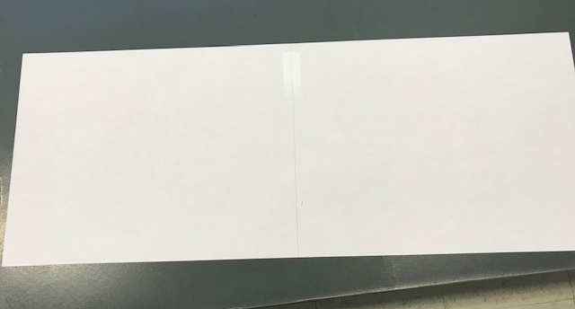
Putting the 2 papers together.
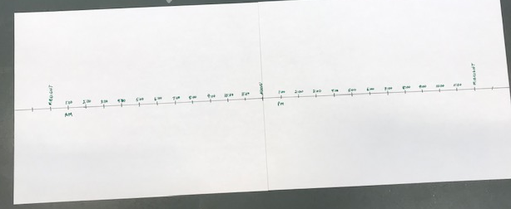
Setting up 1-hour intervals on the timeline. Note there is equal space above and below the timeline.
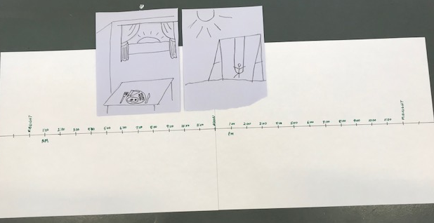
Adding the pictures from slide 27 ABOVE the timeline. This leaves room for the majority of the rest of information students are recording.

Slide 33—Students are asked to pick three of the activities on their timeline (encourage them to pick activities of various lengths) and figure out how much time in their favourite month this would take up. Leave the task open to see how students may go about figuring this out. Slides 34–36 give them space to do so. A photo could be inserted here to show thinking.
Final Reflections
Slide 37—This is an opportunity for students to revisit the question from slide 2 and reflect on whether their thinking has changed since the beginning of this experience. This can be assigned to be completed independently.
Slide 38—This is also an opportunity to reflect on their learning in this experience and to summarize what they have learned about the different ways to note the passage of time. This can also be assigned to be completed independently. Consider how you might have students share their learning with one another as a celebration of learning.
How to Use the Assessment Rubric
1. The rubric is to be used throughout the learning experiences. There is no need for individual criteria or rubrics for each task. Students will use each task to further their understanding of the essential understandings. Students will be demonstrating this through a variety of modalities.
2. As you collect evidence of students’ level of understanding, highlight or check off their progress on the rubric. You should notice your students move across the rows as their understanding develops throughout the experiences. Do not average your check marks or highlights. Students obtain their highest level of understanding. It does not matter where they start.
Step-by-step instructions for students
See PowerPoint Presentation.

APPENDIX (Printable Support Materials Including Assessment)

Grade 3: Times of Your Life.pptx
Grade 3: Times of Your Life Rubric.docx

Times of Your Life Rubric (Grade 3)
 | Limited | Basic | Good | Very Good/Excellent
Basic descriptors to help guide your formative assessments. Full details of the student achievement profiles can be found here:  Mental Math and Estimation  Knowledge and Understanding  Problem Solving | Requires considerable ongoing teacher support. | Requires occasional teacher or peer support. | Accurate, clear, and uses appropriate strategies and procedures. Requires occasional prompting for clarification. | Accurate, clear, flexible, consistent, and efficient. Justifies and explains reasoning clearly and completely using accurate math vocabulary.
Tracking student data throughout these learning experiences allows the teacher to make an informed assessment
about a student’s level of achievement of these outcomes.
Identifies standard and non-standard units of time.
Measures the passage of time.
Chooses appropriate units to measure the passage of time.
Identifies patterns related to time.
Makes connections between units of time.
Describe and apply estimation strategies: Identifies referents for time.
Solves problems involving time.
Suggested Codes for daily record keeping purposes:
- I – Knowledge has been demonstrated individually
- H – Used when knowledge has been demonstrated individually, but with help from the teacher or a peer
- G – Used when knowledge has been demonstrated within a group
- X – Used when a question has been attempted but answered incorrectly
- N – Used when a question has not been attempted
Adapted from: Liljedahl, P. (2021). Building thinking classrooms in mathematics, grades K-12: 14 teaching practices for enhancing learning. Thousand Oaks, CA: Corwin Press Inc.

