Instructions for Using Remote Learning Projects
These materials were developed with the intention of easing the transition between in-class and temporary remote learning. Learning experiences are aligned with curricular outcomes and assessment tools have been included with each project.
Note:
  - The teacher either sends a link to the appropriate project or sends the document itself.
  - The teacher ensures that parents/caregivers receive any required school supplies (bin with pencils, markers, paper, etc.).
  - The teacher reassures parents/caregivers that communication will be maintained between home and school.
  - Parents/caregivers may access additional resources at:
    - My Learning at Home (www.edu.gov.mb.ca/k12/mylearning)
    - My Child in School (www.edu.gov.mb.ca/k12/mychild/index.html)

PROJECT OVERVIEW
Grade: | 8
Main Subject: | English Language Arts
Big Idea: | Wellness
Title: | HABITS AND ROUTINES
Practice: | Power and Agency/Exploration and Design/Sense Making/System
Duration: | 1–2 weeks
Materials: | Paper, writing utensils, technological device, or pdf printouts
Short Description: | This inquiry project infuses mental wellness and literacy. Students engage with various texts to activate their thinking and reflect on their current practices. They are then challenged to add healthy and/or delete unhealthy habits from their daily routines. This can be used as an asynchronous independent learning experience; however, teachers can adapt this to use during their synchronous learning time.

Learning Outcomes
English Language Arts: www.edu.gov.mb.ca/k12/cur/ela/framework/index.html
Power and Agency, Exploration and Design, Sense Making, System
*Learning experiences and support materials may or may not align with the Practices, Elements, and
6-8 Grade Band Descriptors of the English Language Arts Curriculum Framework: A Living Document (September 2020)

Physical Education/Health Education: www.edu.gov.mb.ca/k12/cur/physhlth/curriculum.html
K.4.8.A.2a, K.5.8.A.1, S.5.8.A.1, S.5.8.A.3a

Assessment
LANGUAGE ARTS |  |  |  |  | MATHEMATICS |  |  | SCIENCE |  |  | SOCIAL STUDIES
COMP.  Listening &  Viewing | COMP.  Reading | COMM.  Speaking & Represent. | COMM.  Writing | Critical Thinking | Knowledge  and  Understanding | Mental Math &  Estimation | Problem Solving | Knowledge  and  Understanding | Scientific Inquiry Process | Design Process &  Problem Solving | Knowledge  and Understanding | Research  and Communication | Critical Thinking and  Citizenship
X | X | X | X | X

Original concept created by: | Tara McLauchlan and Jennifer Stark

Learning Experiences and Assessment
Question: How do my habits and routines affect my health and wellness?
Teacher’s instructions:
The original intended audience for this learning experience is students learning in an asynchronous environment. Student instructions are embedded within the PowerPoint slides.
Teachers facilitating this learning experience will decide when to support students synchronously or asynchronously.
If this lesson is being used during synchronous time, please note:
- It is good practice to make your learning intentions clear at the beginning of each class. A morning meeting could provide a space and time for this.
- Time allotments are a suggestion only. Adjust them as needed for the developmental needs of your students. As best you can, “read the room” and consider the stamina of your students in combination with the complexity and depth of the task at hand.
- Scaffolding and modelling are an essential part of remote learning, especially when independent practice is offline during asynchronous time.

APPENDIX (Printable Support Materials Including Assessment)
- Grade 8 Wellness Inquiry: Habits and Routines PowerPoint
- Grade 8 Wellness Inquiry: Habits and Routines Assessment Tool
- 30 Day Habit Tracker Template and Exemplars
- One Pager Explanation and Template

Assessment Tool
Grade 8 Wellness Inquiry: Habits and Routines
The following chart is one way to unpack your body of evidence of student learning. It is important to consider the identified grade band descriptors in relation to the practices and elements as you look through the body of evidence. You are describing the extent to which students enacted the descriptor. Transfer the information into the appropriate report categories.
Evidence of Learning in English language arts  https://app.mapleforem.ca/en/groups/229/wiki/pages/1622#3to5overview |  | Interrelated Dimensions of Learning Growth (IDOL-G) https://app.mapleforem.ca/en/groups/229/wiki/pages/2205 ​
 |  | Independence  Emerging  Expanding  Extending | Breadth  Emerging  Expanding  Extending | Depth  Emerging  Expanding  Extending | Transformation  Emerging  Expanding  Extending
4 ELA Practices & Elements | Grade Band Descriptors Identified
Power and Agency  - Recognize and analyze inequities, viewpoints, and bias in texts and ideas  - Investigate complex moral and ethical issues  - Contemplate the actions that can be taken, consider alternative viewpoints, and contribute other perspectives | Learners are understanding that texts represent and promote particular beliefs, values, and ideas. | Example: Extending In conversation with teacher student confidently discussed the ideas in the various texts
 | Learners are recognizing that one’s identities are influenced by various factors and change over time and contexts.
Exploration and Design  - Research and study topics and ideas  - Interpret and integrate information and ideas from multiple texts and sources  - Manage information and ideas  - Invent, take risks, and reflect to create possibilities | Learners are tapping into and combining experiences with ideas, images, and sounds from various sources to create something new. |  | Example: Extending  Student’s creations show intentional decision making that connects to themselves and a wider community.
Sense Making ​  - Access, use, build, and refine schema  - Select from and use a variety of strategies  - Be aware of and articulate the ways that one engages with text. | Learners are using and integrating background knowledge and sources of information purposefully to make sense of increasingly varied and complex text. |  |  | Example: Extending  Student reflections and conversations about the texts show that they have internalized the ideas and created realistic and achievable goals.
 | Learners are using a variety of thinking processes (e.g., computational, imaginative creative, interpretive, critical) to make sense of and respond to increasingly varied and complex text.
System​  - Recognize, apply, and adapt rules and conventions  - Identify, analyze, and apply understandings of whole-part-whole relationships | Learners are using their understanding of a range of text structures and features to understand and communicate clearly and effectively. |  |  |  | Example: Extending  Student’s creations show independent informed decision making in using appropriate text structures and features. In conversation, the student describes their investigations to transform their texts. They initiated this new learning.
 | Learners are more consistently and strategically applying knowledge of and using various resources for spelling, grammar, punctuation, and capitalization.
Grade 8 Physical Education/Health Education—Healthy Lifestyle
Student Learning Outcomes  www.edu.gov.mb.ca/k12/cur/physhlth/grade_8.html | Grading Scale
 | Incomplete | Complete
K.4.8.A.2a
Develop self-monitoring strategies (e.g., keep a journal, participate with a friend…) and criteria (e.g., believable, achievable, controllable, within timelines…) in setting individual and/or group goals.
K.5.8.A.1
Examine positive and negative health habits of daily living for self and/or others (e.g., daily physical activity, skin care, hygiene, dental hygiene, rest, caring for others, handling/sharing of food/beverages, tobacco use...).
S.5.8.A.1
Apply personal and social management skills (e.g., goal setting, decision making/ problem solving...) in case scenarios related to personal health practices (e.g., sleep habits, cleanliness, nutritional practices, exercise habits...).
S.5.8.A.3a
Develop a personal plan that includes daily health practices (e.g., physical activity participation, healthy food choices, positive thinking...) to maintain a healthy body.

30 Day Habit Tracker

Template and Exemplars

One Pagers

- A one-pager is a way to visually share key ideas and information from what you have learned.
- When you create a one pager, you are trying to use both visual symbols and words to clearly and concisely share your most important take-aways with someone else.
- Create a one pager that reflects your “big ideas” on the topic of habits and routines.
- When creating your one pager, provide examples from the articles, videos, stories and writing prompts you have encountered in these slides

- Use the instructions and blank template on the following pages to create your One Pager.

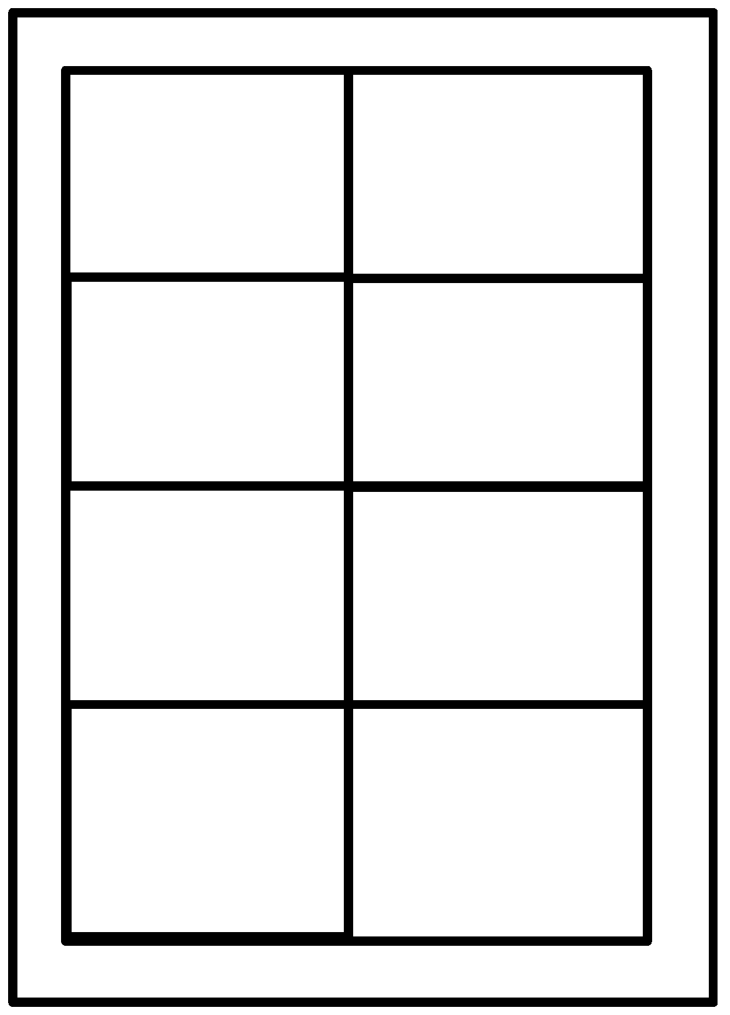
An image, symbol, word, phrase that represents a key idea one of the texts we examined during our discussion of mental health and wellness.
An image, symbol, word, phrase that represents a key idea in a second text we examined during our discussion of mental health and wellness.
An image, symbol, word, phrase that represents a key idea in a third text we examined during our discussion of mental health and wellness.
An image, symbol, word, phrase that represents a key idea in a fourth text we examined during our discussion of mental health and wellness.
An explanation of why you selected this text and how it connects to your image, symbol, word, phrase.
An explanation of why you selected this text and how it connects to your image, symbol, word, phrase.
An explanation of why you selected this text and how it connects to your image, symbol, word, phrase.
An explanation of why you selected this text and how it connects to your image, symbol, word, phrase.
Important words about the theme of wellness.
Important words about the theme of wellness.
Important words about the theme of wellness.
Important words about the theme of wellness.

