|  |
| --- |
| Instructions for Using Remote Learning Projects |
| These materials were developed with the intention of easing the transition between in-class and temporary remote learning. Learning experiences are aligned with curricular outcomes and assessment tools have been included with each project.  **Note:**   * 1. The teacher either sends a link to the appropriate project or sends the document itself.   2. The teacher ensures that parents/caregivers receive any required school supplies (bin with pencils, markers, paper, etc.).   3. The teacher reassures parents/caregivers that communication will be maintained between home and school.   4. Parents/caregivers may access additional resources at:      + My Learning at Home ([www.edu.gov.mb.ca/k12/mylearning](http://www.edu.gov.mb.ca/k12/mylearning))      + My Child in School ([www.edu.gov.mb.ca/k12/mychild/index.html](http://www.edu.gov.mb.ca/k12/mychild/index.html)) |

|  |  |
| --- | --- |
| PROJECT OVERVIEW | |
| Grade: | Kindergarten |
| Main Subject: | Visual Arts |
| Big Idea: | Identify, collect, and assemble natural materials to create a sculpture inspired by Andy Goldsworthy’s artwork. |
| Title: | ANDY GOLDSWORTHY INSPIRED SCULPTURE PROJECT |
| Essential Learning Area: | Art Language and Tools, Creative Expression in Art, Understanding Art in Context, and Valuing Artistic Experience |
| Duration: | 1.5 hours |
| Materials: | Sketch book/paper, pencil, natural materials: twigs, leaves, rocks, seeds, ice, snow, or recyclable materials |
| Short Description: | Through this project, young artists will develop their artistic decision-making skills and be exposed to art language and tools such as texture, pattern, and repetition. Science curriculum content will be integrated throughout, such as aspects of the design process and conducting preliminary research on trees. |

|  |
| --- |
| Learning Outcomes |
| Mathematics: [www.edu.gov.mb.ca/k12/cur/essentials/docs/glance\_kto9\_math.pdf](http://www.edu.gov.mb.ca/k12/cur/essentials/docs/glance_kto9_math.pdf) K.SS.3  Science: [www.edu.gov.mb.ca/k12/cur/science/scicurr.html](http://www.edu.gov.mb.ca/k12/cur/science/scicurr.htm) K-0-3c—GLO: C2, C; K-0-4a—GLO: C1, C2; K-1-01—GLO: C5, D1, D5; K-2-04—GLO: C2, D3  Visual Arts: [www.edu.gov.mb.ca/k12/cur/arts/index.html](https://www.edu.gov.mb.ca/k12/cur/arts/index.html)  A–L1.1, A–C2.5, A–V1.2, A–V4.3, A–U2.1 |

|  |  |  |  |  |  |  |  |  |  |  |  |  |  |
| --- | --- | --- | --- | --- | --- | --- | --- | --- | --- | --- | --- | --- | --- |
| Assessment | | | | | | | | | | | | | |
| LANGUAGE ARTS | | | | | MATHEMATICS | | | SCIENCE | | | SOCIAL STUDIES | | |
| COMP.  Listening &  Viewing | COMP.  Reading | COMM. Speaking & Represent. | COMM. Writing | Critical Thinking | Knowledge  and  Understanding | Mental Math &  Estimation | Problem Solving | Knowledge  and Understanding | Scientific Inquiry Process | Design Process &  Problem Solving | Knowledge  and Understanding | Research  and Communication | Critical Thinking and  Citizenship |
|  |  |  |  |  |  |  |  |  |  |  |  |  |  |

|  |  |
| --- | --- |
| Original concept created by: | Jenn Jacques |

|  |
| --- |
| Learning Experiences and Assessment |
| **Teacher’s instructions:**  Begin this project by presenting images of Andy Goldsworthy’s work to your students (perform a Google images search, use this PowerPoint or click on this YouTube video <https://youtu.be/sngXz55b4bc> as a resource.) If your unique learning environment is conducive to a guided discussion, highlight his use of repetition and balance, and how he organizes objects by colour, size, or material. Include examples of Goldsworthy-inspired sculptures created by students and ones that use household items in place of natural materials (this adaptation ensures that remote learners who are unable to access the outdoors are still able to participate in this project). Students may be unfamiliar with the concept of sculpture. Through exploration of Goldsworthy’s work, they will discover how sculptures build up into the 3-D space as opposed to being a flat, 2-D piece of artwork.  Next, have students watch the instructional video <https://youtu.be/1xOW4Wu61Mg/>. They will then go on a nature walk to gather a collection of materials in a series of containers or bags. Encourage your students to collect materials with adult supervision and be mindful of what they are picking up. Remind them that it is best to collect objects are that are already on the ground.  Students should now create a Design Plan in their Idea Journal—*a sketchbook used to collect sketches, swatches of material, magazine clippings, etc., as part of the idea development process*. The Design Plan is a quick sketch artist’s create to plan out what they are going to make. Once the Design Plan is complete, students can begin building their sculpture. The focus is on experimentation. If it falls, or they don’t have enough supplies to construct the original plan, they are encouraged to adapt and make changes as they work. Once they have completed their sculpture, students are encouraged to submit a photograph of the finished piece and complete a reflection on their sculpture-making process. If the option exists, showcase the photographs of the finished sculptures on the class blog, as a celebration on learning component to the project.  Sample set-up in Seesaw: |

|  |
| --- |
| Template:  The following was created in Seesaw as a template for students to upload their photographs and display their finished artwork.    Sample of student work using the template:    Assessment:  Teachers may modify the *Visual Arts Assessment: Andy Goldsworthy Inspired Sculpture Project* rubric to reflect the criteria they would like to focus on and the assessment language used by their school.  Review the template with students prior to sculpture building so they are informed about what they are being evaluated on. Model how to complete a thoughtful assessment. For example, “Class now we are going to circle the emoji face that matches how successful we were making our finished sculptures look like our Design Plans. Does it look just like your Design Plan? Circle the first happy face or “Very Good.” Does it look a lot like your Design Plan but you made a few changes here and there? Circle the second happy face or “Good.” Does it only look a little bit like your Design Plan? Circle the straight-line face. Did you make a drawing of a cat instead of your sculpture Design Plan? Circle the sad face. That just means you could try that again one day!”  For the Art Critique section, read each question and give the students suggestions about how to respond to it (see examples or leader sentences on the paper). Critiques are an important part of the artmaking process and Kindergarten students benefit from learning this skill early on and it is transferable to other Inquiry based projects. Art compliments encourage students to think about what they did well in a project. It is also important to be able to choose an aspect of your work that was successful. As students gain more experience with this process, the rubric and critique questions can become more complex.  Use the *Artmaking Reflection: Andy Goldsworthy Inspired Sculptures* if it is the students’ first experience reflecting on their artwork. Add a picture of the student at work, their Design Plan or ideally, a picture of them with their finished sculpture. Like with the other template, read the questions to the students and offer suggestions on possible responses. It is not necessary to provide this piece in advance of them working on their sculptures. |

|  |
| --- |
| **Step-by-step instructions for students:**  Andy Goldsworthy is an incredible artist that works with materials from nature. He likes to spend hours outside working with leaves, rocks, ice, or twigs. Today you are going to make some of your own Andy Goldsworthy-inspired sculptures!  1. Think about the information your teacher just shared with you about Andy Goldsworthy.  2. Click on this link to view some pictures of sculptures made by other students. [www.bing.com/images/search?q=andy+goldworthy+student+sculptures&form=HDRSC3&first=1&tsc=ImageBasicHover&cw=1440&ch=727](https://www.bing.com/images/search?q=andy+goldworthy+student+sculptures&form=HDRSC3&first=1&tsc=ImageBasicHover&cw=1440&ch=727)  3. Click on the link to watch a video that explains how to make your own sculpture. <https://youtu.be/1xOW4Wu61Mg/>  4. In your Idea Journal, create a quick sketch Design Plan of what you would like to build.  5. Get 3 baskets or bags and fill them with seeds, pinecones, small rocks, twigs, leaves, or dandelions. (Note: You can use blocks, pencil crayons, or noodles if you can’t go collecting outside.) Be sure to collect materials with adult supervision and be mindful of what you are picking up. Collect things that are already on the ground.  6. Practise using the different materials you collected to build some sculptures just like Andy Goldsworthy. Do not worry if it falls over, or you have to change your Design Plan, that is part of the fun!  7. When you are finished, take a picture of your Design Plan and your finished sculpture and submit your work.  8. Complete the sculpture building reflection questions below.  Reflection:  Congratulations on completing your sculpture! Now you are going to complete a reflection on your experience. A reflection is when we think about our work and how we would like to improve it next time!  1. Ask your adult helper to read the reflection questions to you.  2. Think about what you want to say and then record your responses. If you don’t have a microphone or video camera, you can ask your adult helper to write down your answers on a whiteboard or paper.  3. When you are all done, submit your voice recording, video, or written responses for review. |

|  |
| --- |
| APPENDIX (Printable Support Materials Including Assessment) |
| Kindergarten: PowerPoint Presentation  Kindergarten: Design Plan BLM  Kindergarten: Samples of Student Work  Kindergarten: Reflection Questions  Kindergarten: Visual Arts Assessment: Andy Goldsworthy Inspired Sculpture Project  Kindergarten: Artmaking Reflection: Andy Goldsworthy Inspired Sculptures |

Name: \_\_\_\_\_\_\_\_\_\_\_\_\_\_\_\_\_\_\_\_\_\_\_\_\_\_\_\_\_\_\_

Design Plan

Andy Goldsworthy Inspired Sculpture Project

Use the space provided to make a quick sketch of the sculpture you would like to build.

**Samples of Student Work—Design Plan and Finished Art Work**

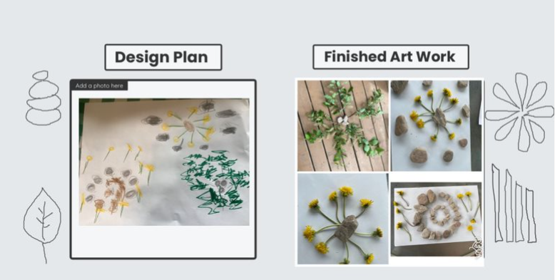Student #1

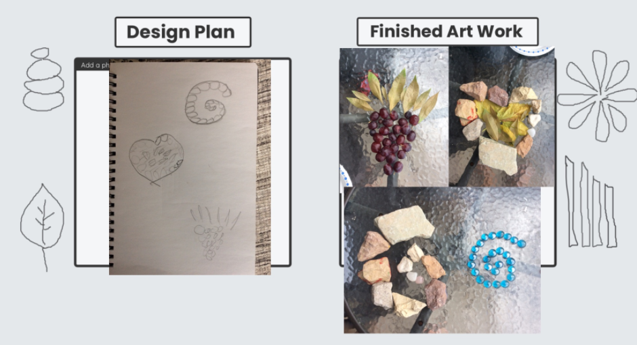Student #2

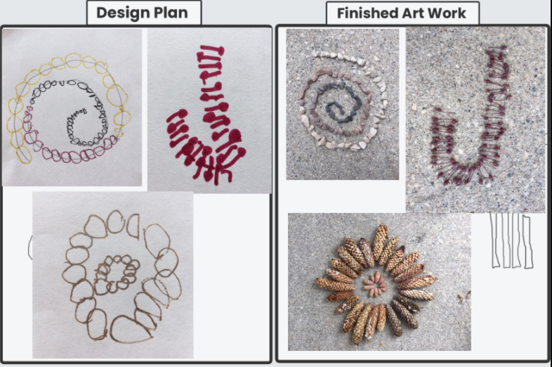Student #3

Student #4 Student #5

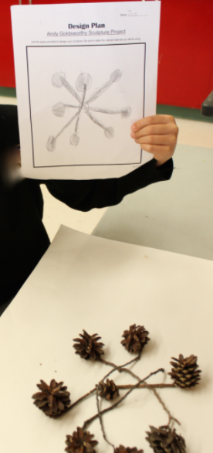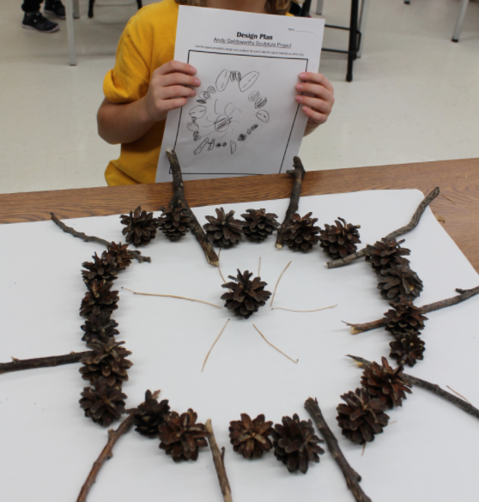

Student #6 Student #7

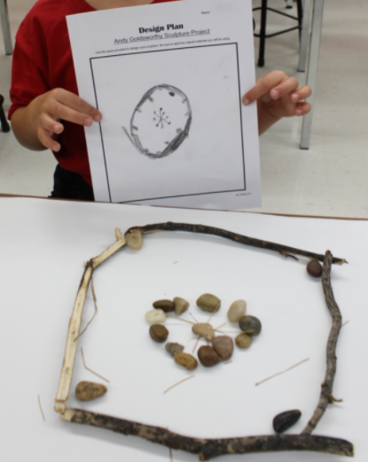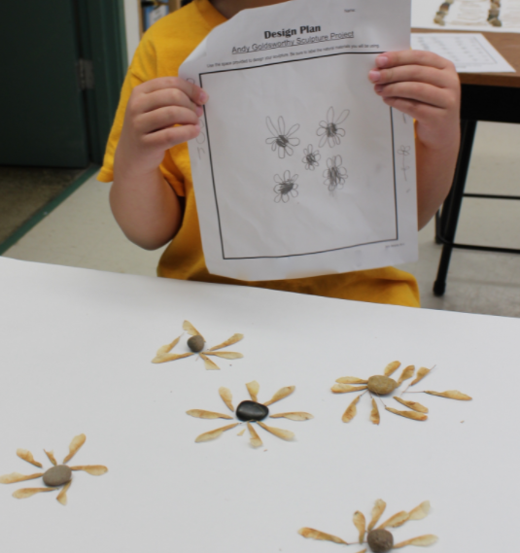

Andy Goldsworthy Inspired Sculpture Project

REFLECTION

1. What was the hardest part about building your sculpture?

2. What is your favourite part of your sculpture? Why?

3. What would you do differently if you could build your sculpture again?

Name: \_\_\_\_\_\_\_\_\_\_\_\_\_\_\_\_\_\_\_\_\_\_\_\_\_\_\_\_\_\_\_\_\_\_\_\_

Visual Arts Assessment

Andy Goldsworthy Inspired Sculpture Project

**Art Problem:** *Use natural materials to build a sculpture inspired by the work of Andy Goldsworthy.*

|  |  |  |  |  |
| --- | --- | --- | --- | --- |
| **Assessment Criteria** | **Very Good** | **Good** | **Satisfactory** | **Partial** |
| **Resolution of Artistic Problem**  My sculpture looks like my Design Plan | **smiley face2** | **smiley face2** | **yellow-neutral-face-300x300** | **sad_smiley_face_thumb[1]** |
| **Craftsmanship and Attention to Detail**  I took my time and placed each object carefully | **smiley face2** | **smiley face2** | **yellow-neutral-face-300x300** | **sad_smiley_face_thumb[1]** |

**ART CRITIQUE**

1. What was your favourite part in this project? *Drawing your design, collecting natural materials or building your sculpture!*

\_\_\_\_\_\_\_\_\_\_\_\_\_\_\_\_\_\_\_\_\_\_\_\_\_\_\_\_\_\_\_\_\_\_\_\_\_\_\_\_\_\_\_\_\_\_\_\_\_\_\_\_\_\_\_\_\_\_\_\_\_\_\_\_\_\_\_\_\_\_\_\_\_\_\_\_\_\_\_\_\_\_\_\_\_\_\_\_\_\_\_\_

\_\_\_\_\_\_\_\_\_\_\_\_\_\_\_\_\_\_\_\_\_\_\_\_\_\_\_\_\_\_\_\_\_\_\_\_\_\_\_\_\_\_\_\_\_\_\_\_\_\_\_\_\_\_\_\_\_\_\_\_\_\_\_\_\_\_\_\_\_\_\_\_\_\_\_\_\_\_\_\_\_\_\_\_\_\_\_\_\_\_\_\_

2. What was the hardest part about making your sculpture? *Deciding what to make,* *finding enough materials to make what I wanted, making things balance*

\_\_\_\_\_\_\_\_\_\_\_\_\_\_\_\_\_\_\_\_\_\_\_\_\_\_\_\_\_\_\_\_\_\_\_\_\_\_\_\_\_\_\_\_\_\_\_\_\_\_\_\_\_\_\_\_\_\_\_\_\_\_\_\_\_\_\_\_\_\_\_\_\_\_\_\_\_\_\_\_\_\_\_\_\_\_\_\_\_\_\_\_

\_\_\_\_\_\_\_\_\_\_\_\_\_\_\_\_\_\_\_\_\_\_\_\_\_\_\_\_\_\_\_\_\_\_\_\_\_\_\_\_\_\_\_\_\_\_\_\_\_\_\_\_\_\_\_\_\_\_\_\_\_\_\_\_\_\_\_\_\_\_\_\_\_\_\_\_\_\_\_\_\_\_\_\_\_\_\_\_\_\_\_\_

3. Give yourself an art compliment. *The best part about my sculpture is*…

\_\_\_\_\_\_\_\_\_\_\_\_\_\_\_\_\_\_\_\_\_\_\_\_\_\_\_\_\_\_\_\_\_\_\_\_\_\_\_\_\_\_\_\_\_\_\_\_\_\_\_\_\_\_\_\_\_\_\_\_\_\_\_\_\_\_\_\_\_\_\_\_\_\_\_\_\_\_\_\_\_\_\_\_\_\_\_\_\_\_\_\_

\_\_\_\_\_\_\_\_\_\_\_\_\_\_\_\_\_\_\_\_\_\_\_\_\_\_\_\_\_\_\_\_\_\_\_\_\_\_\_\_\_\_\_\_\_\_\_\_\_\_\_\_\_\_\_\_\_\_\_\_\_\_\_\_\_\_\_\_\_\_\_\_\_\_\_\_\_\_\_\_\_\_\_\_\_\_\_\_\_\_\_\_

----------------------------------------------------------------------------------------------------------

TEACHER COMMENTS:\_\_\_\_\_\_\_\_\_\_\_\_\_\_\_\_\_\_\_\_\_\_\_\_\_\_\_\_\_\_\_\_\_\_\_\_\_\_\_\_\_\_\_\_\_\_\_\_\_\_\_\_\_\_\_\_\_\_\_\_\_\_\_\_\_\_\_\_\_\_\_\_\_\_\_

\_\_\_\_\_\_\_\_\_\_\_\_\_\_\_\_\_\_\_\_\_\_\_\_\_\_\_\_\_\_\_\_\_\_\_\_\_\_\_\_\_\_\_\_\_\_\_\_\_\_\_\_\_\_\_\_\_\_\_\_\_\_\_\_\_\_\_\_\_\_\_\_\_\_\_\_\_\_\_\_\_\_\_\_\_\_\_\_\_\_\_\_\_\_\_

\_\_\_\_\_\_\_\_\_\_\_\_\_\_\_\_\_\_\_\_\_\_\_\_\_\_\_\_\_\_\_\_\_\_\_\_\_\_\_\_\_\_\_\_\_\_\_\_\_\_\_\_\_\_\_\_\_\_\_\_\_\_\_\_\_\_\_\_\_\_\_\_\_\_\_\_\_\_\_\_\_\_\_\_\_\_\_\_\_\_\_\_\_\_\_

Name: \_\_\_\_\_\_\_\_\_\_\_\_\_\_\_\_\_\_\_\_\_\_\_\_\_\_\_\_\_\_\_

Artmaking Reflection

Andy Goldsworthy Inspired Sculptures

I like my sculpture because \_\_\_\_\_\_\_\_\_\_\_\_\_\_\_\_\_\_\_\_\_\_\_\_\_\_\_\_\_\_\_\_\_\_\_\_\_\_\_\_\_

\_\_\_\_\_\_\_\_\_\_\_\_\_\_\_\_\_\_\_\_\_\_\_\_\_\_\_\_\_\_\_\_\_\_\_\_\_\_\_\_\_\_\_\_\_\_\_\_\_\_\_\_\_\_\_\_\_\_\_\_\_\_\_

One thing I remember about Andy Goldsworthy is \_\_\_\_\_\_\_\_\_\_\_\_\_\_\_\_\_\_\_\_\_\_\_

\_\_\_\_\_\_\_\_\_\_\_\_\_\_\_\_\_\_\_\_\_\_\_\_\_\_\_\_\_\_\_\_\_\_\_\_\_\_\_\_\_\_\_\_\_\_\_\_\_\_\_\_\_\_\_\_\_\_\_\_\_\_\_

Next time I make an Andy Goldsworthy sculpture, I’d like to try \_\_\_\_\_\_\_\_\_\_\_\_\_

\_\_\_\_\_\_\_\_\_\_\_\_\_\_\_\_\_\_\_\_\_\_\_\_\_\_\_\_\_\_\_\_\_\_\_\_\_\_\_\_\_\_\_\_\_\_\_\_\_\_\_\_\_\_\_\_\_\_\_\_\_\_\_