|  |
| --- |
| Instructions for Using Remote Learning Projects |
| These materials were developed with the intention of easing the transition between in-class and temporary remote learning. Learning experiences are aligned with curricular outcomes and assessment tools have been included with each project.  **Note:**   * 1. The teacher either sends a link to the appropriate project or sends the document itself.   2. The teacher ensures that parents/caregivers receive any required school supplies (bin with pencils, markers, paper, etc.).   3. The teacher reassures parents/caregivers that communication will be maintained between home and school.   4. Parents/caregivers may access additional resources at:      + My Learning at Home ([www.edu.gov.mb.ca/k12/mylearning](http://www.edu.gov.mb.ca/k12/mylearning))      + My Child in School ([www.edu.gov.mb.ca/k12/mychild/index.html](http://www.edu.gov.mb.ca/k12/mychild/index.html)) |

|  |  |
| --- | --- |
| PROJECT OVERVIEW | |
| Grade: | 3 |
| Main Subject: | Social Studies |
| Big Idea: | Family |
| Title: | WHAT IS FAMILY? |
| Cluster: | Communities of the World |
| Duration: | 1–2 weeks (depending assignment schedule of tasks) |
| Materials: | Pencils, art supplies, computer/tablet/or phone with Internet access |
| Short Description: | This independent study provides students the opportunity to explore the concept of family through integrated, authentic learning experiences. Extensive use of hands-on activities will keep students engaged, while providing breaks from technology time. Students will demonstrate their learning in a variety of ways. In addition to the tasks provided in this project plan, it is expected that students be provided direct, synchronous instruction of fundamental concepts in literacy and numeracy (such as the components of a balanced reading and writing program, as well as number talks, and open-ended numeracy tasks). |

|  |
| --- |
| Learning Outcomes |
| Social Studies: [www.edu.gov.mb.ca/k12/cur/socstud/docs.html](https://www.edu.gov.mb.ca/k12/cur/socstud/docs.html)  KI-012, KI-013, KI-007  Science: [www.edu.gov.mb.ca/k12/cur/science/scicurr.htm](https://www.edu.gov.mb.ca/k12/cur/science/scicurr.htm)  3-4-12, 3-1-15, 3-1-16  Mathematics: [www.edu.gov.mb.ca/k12/cur/essentials/docs/glance_kto9_math.pdf](https://www.edu.gov.mb.ca/k12/cur/essentials/docs/glance_kto9_math.pdf)  3.N.2, 3.N.3, 3.N.5, 3.N.13, 3.PR.1, 3.PR.2  English Language Arts: [www.edu.gov.mb.ca/k12/cur/ela/index.html](https://www.edu.gov.mb.ca/k12/cur/ela/index.html) Language as sense making, Language as system, Language as power and agency, Language as exploration and design  Physical Education/Health Education: [www.edu.gov.mb.ca/k12/cur/physhlth/curriculum.html](https://www.edu.gov.mb.ca/k12/cur/physhlth/curriculum.html) K.1.3.B.2  Art: [www.edu.gov.mb.ca/k12/cur/arts/visual/index.html](https://www.edu.gov.mb.ca/k12/cur/arts/visual/index.html)  3-4 A-U1.3  Music: www.edu.gov.mb.ca/k12/cur/arts/music/index.html 3-4 M-U1.3 |

|  |  |  |  |  |  |  |  |  |  |  |  |  |  |
| --- | --- | --- | --- | --- | --- | --- | --- | --- | --- | --- | --- | --- | --- |
| Assessment | | | | | | | | | | | | | |
| LANGUAGE ARTS | | | | | MATHEMATICS | | | SCIENCE | | | SOCIAL STUDIES | | |
| COMP.  Listening &  Viewing | COMP.  Reading | COMM. Speaking & Represent. | COMM. Writing | Critical Thinking | Knowledge  and  Understanding | Mental Math &  Estimation | Problem Solving | Knowledge  and Understanding | Scientific Inquiry Process | Design Process &  Problem Solving | Knowledge  and Understanding | Research  and Communication | Critical Thinking and  Citizenship |
| x | x | x | x | x | x | x | x | x | x | x | x | x | x |

For further information on assessment, see Appendix K.

|  |  |
| --- | --- |
| Original concept created by: | Holly Sorenson |

|  |
| --- |
| Learning Experiences and Assessment |
| Question: What is family? |
| Teacher’s instructions:  To launch this project, have a synchronous meeting with your students to discuss the topic of family. Ask your students what they believe it means to be a family, what families are made up of, how different families are the same and how they differ. Share a provocation, such as images of a variety of families, to engage the students, provide context, and enrich the conversation. Here are some links to find images of families:  [www.huffingtonpost.ca/entry/29-gorgeous-photos-show-what-families-around-the-world-have-in-common_n_56aba5f8e4b077d4fe8dde68](https://www.huffingtonpost.ca/entry/29-gorgeous-photos-show-what-families-around-the-world-have-in-common_n_56aba5f8e4b077d4fe8dde68)  <https://allaboutfamilies.weebly.com/types-of-families.html>  [www.boredpanda.com/the-universal-family-portrait-project-michele-crowe/?utm_source=google&utm_medium=organic&utm_campaign=organic](https://www.boredpanda.com/the-universal-family-portrait-project-michele-crowe/?utm_source=google&utm_medium=organic&utm_campaign=organic)  Assign the following tasks to your students over the course of 1 to 2 weeks, in a timeframe that is appropriate to you and your students. Assigning a smaller number of tasks, over a short period of time is recommended over assigning an extensive list of tasks at one time. This will allow you to monitor and provide formative assessment and feedback to students, as required, throughout the learning process, as well as avoiding overloading students. As learning tasks are assigned, provide students with instructions, as well as any templates or support material they need to complete the task (see appendix).  English Language Arts   * Discuss the question “What makes a family?” with your family. Share your ideas and listen to others’ ideas. Write a summary of your discussion (Appendix A). * Throughout the week, find and read five books (online or books at home) that have a family theme, or read the recommended list provided (Appendix B). Discuss with an adult what the messages are about family that were found in the books. * Choose one person in your family to interview. Write a list of five questions you will ask them to get to know them better. Record their answers and make a list of what you learned about them that you did not know before (Appendix C).   Mathematics   * While making an audio recording, estimate the sum of the ages of the two oldest people in your family (explain how you made that estimate), then calculate the actual sum (explain what strategies you used to mentally calculate the sum). * With an adult, find and make a favourite family recipe that uses fractions. Talk about the measurements of different ingredients and how they relate to whole parts (a whole cup, teaspoon, or tablespoon). * Find and describe five examples of increasing patterns in your family home (for example, lining up the shoes of family members in increasing order by size) (Appendix D). * Make a list of 10 activities that can or cannot be accomplished in minutes, hours, days, months, and years (for example, “I can brush my teeth in the time it takes to sing the alphabet three times.” (Appendix E).   Physical Education/Health Education   * Have a family member stand facing you, arm distance apart, and palm to palm. On the “go” signal, push against each other, attempting to push one another off balance (be gentle and aware of your space—safety first!). Experiment with a wide versus narrow base of support, and stiff versus bent knees. * Have family members face one another and lock wrists. Place a club or pin on the floor between you. On the “go” signal, push and pull one another (safely) trying to cause the other to knock down the club.   Science   * Read the recommended stories, and watch the video links about families from other countries. Draw and label the objects you see people from other countries make that use materials from the earth (for example, sod houses) (Appendix F). * List and describe things your family members do that is related to plants (for example, My mom plants flowers in the garden., My dad trims the trees in the yard., etc.) (Appendix G). * Fill in the T-chart to show how families use plants for food and for medicine (Appendix H).   Social Studies   * Watch the video provided of a family from another country. Fill in the Venn diagram to show what is different and the same about your family and the family in the video (Appendix I).   Art:   * Walk through your home while observing the artwork and décor. Answer the following questions: How does the artwork and décor represent the values and interests of your family? What are the personal stories behind the artwork and décor? What would you like to add to the décor of your family home? * Create a work of art (for example, a sculpture, painting) that represents your family. Take a picture to share.   Music   * Watch videos provided of musical families from around the world. Talk to your family about their own musical interests, experiences, and backgrounds. Have they played musical instruments? Were they in a band? What songs did your grandparents sing to your parents when they were children? Record your learning (Appendix J).   Step-by-step instructions for students:  Instructions for students, as well as any necessary support materials, will be provided by the teacher as individual tasks are assigned. |

|  |
| --- |
| APPENDIX (Printable Support Materials Including Assessment) |
| Appendix A: What Makes a Family.docx Appendix B: Recommended Book List.docx Appendix C: Getting to Know You Better!.docx Appendix D: Find and Describe 5 Examples of Increasing Patterns in Your Family.docx Appendix E: Make a List of 10 Daily Activities.docx Appendix F: Recommended Stories and Videos.docx Appendix G: List and Describe Things Your Family Members Do Related to Plants.docx Appendix H: T-Chart: How Families Use Plants for Food and Medicine.docx Appendix I: Venn Diagram.docx Appendix J: Musical Families.docx Appendix K: Assessment Rubrics |

What Makes a Family?

Appendix A

* Discuss this question with your family.
* Share your ideas and listen to others’ ideas.
* Write a summary of your discussion

Summary:

* What were the main ideas shared during the conversation?
* What were my opinions and ideas?
* What were the opinions and ideas of my family members?

|  |
| --- |
| Word bank:  mom, dad, sister, brother, grandmother, grandfather, believe, think, share, opinion, idea, talk, disagree, agree, important, different, |
| Sentence starters:  My family believes… My ____ believes…  We talked about… I think that…  Some important points were… We agreed that… |

Recommended Book List

Appendix B

The following is a sampling of books about family that are available through the Winnipeg Public Library:

*Family* by Isabell Monk

*One Family* by Shannon George

*Tractor Mac Family Reunion* by Billy Steers

*Passover Family* by Monique Polak

*My Family* by Lorraine Adams

*Meet the Family* by Alexandra West

*Best Family Ever* by Karen Kingsbury

*‘Ohana Means Family* by Ilima Loomis

*The Family Tree* by David McPhail

*My Family History* by Jane O’Connor

*The Family Book* by Todd Parr

*All In the Family* by Stan Berenstain

*My Family Is Special* by Maggie Testa

*Life with My Family* by Renee Hooker

*Love Makes a Family* by Sophie Beer

*Travels with My Family* by Marie-Louise Gay

*My Family Is Forever* by Nancy Carlson

Many more titles are available through the Winnipeg Public Library. Please contact the library for more support.

For stories online, click on the following links:

[www.youtube.com/watch?v=ni_at59TzMA](https://www.youtube.com/watch?v=ni_at59TzMA) (*The World’s Family*)

[www.youtube.com/watch?v=p2eX6truzs8](https://www.youtube.com/watch?v=p2eX6truzs8) (*We Are Family*)

[www.youtube.com/watch?v=WcvCUBK9s6U](https://www.youtube.com/watch?v=WcvCUBK9s6U) (*A Family Is a Family Is a Family*)

[www.youtube.com/watch?v=_XwL5KOeWoQ](https://www.youtube.com/watch?v=_XwL5KOeWoQ) (*My Family, Your Family, Our Families*)

[www.youtube.com/watch?v=yND_GbTcO8w](https://www.youtube.com/watch?v=yND_GbTcO8w) (*Families, Families, Families*)

[www.youtube.com/watch?v=gMpecJKW0jM](https://www.youtube.com/watch?v=gMpecJKW0jM) (*The Family Book*)

[www.youtube.com/watch?v=N37z7Ve8Rik](https://www.youtube.com/watch?v=N37z7Ve8Rik) (*All Kinds of Families*)

[www.youtube.com/watch?v=WgoQSXfg5co](https://www.youtube.com/watch?v=WgoQSXfg5co) (*This Is My Family*)

[hwww.youtube.com/watch?v=-nzegt5mdAw](https://www.youtube.com/watch?v=-nzegt5mdAw) (*Just Right Family*)

Appendix C

Getting to Know You Better!

The person I will interview is _____________________________.

Here are the questions I will ask them to get to know them better:

1.

2.

3.

4.

5.

Here are their answers:

1.

2.

3.

4.

5.

What I learned:

Appendix D

Find and describe 5 examples of increasing patterns in your family home (for example, lining up family members shoes in increasing order by size)

Increasing pattern #1:

The pattern is

Description:

Increasing pattern #2:

The pattern is

Description:

Increasing pattern #3:

The pattern is

Description:

Increasing pattern #4:

The pattern is

Description:

Increasing pattern #5:

The pattern is

Description:

Appendix E

Make a list of 10 daily activities your family does that can or cannot be accomplished in minutes, hours, days, months, and years. For example, “My dad can brush his teeth in the time it takes to sing the alphabet twice.”

1.

2.

3.

4.

5.

6.

7.

8.

9.

10.

Appendix F

Read the recommended stories, and watch the video links about families from other countries. Draw and label the objects you see people from other countries make that use materials from the earth (for example sod houses)

[www.youtube.com/watch?v=ngLoJxssEao](https://www.youtube.com/watch?v=ngLoJxssEao) (*From Sheep to Cloth*)

[www.youtube.com/watch?v=fVmnlOtbadk](https://www.youtube.com/watch?v=fVmnlOtbadk) (*Traditional Crafts Made from Natural Materials*)

[www.youtube.com/watch?v=k2leKfPyBbU](https://www.youtube.com/watch?v=k2leKfPyBbU) (*Birch Bark Canoe*)

[www.youtube.com/watch?v=K3DJ9nNblVQ](https://www.youtube.com/watch?v=K3DJ9nNblVQ) (*Mud Construction*)

[www.youtube.com/watch?v=9ecr22Fws7U](https://www.youtube.com/watch?v=9ecr22Fws7U) (*Eco-Friendly Houses with Mud*)

Click on the following link:

[www.youtube.com/watch?v=hMrw9r_lsfA&list=PLqAhKot_pSl3gmyI57_mr8UKmP483jbIE&index=2](https://www.youtube.com/watch?v=hMrw9r_lsfA&list=PLqAhKot_pSl3gmyI57_mr8UKmP483jbIE&index=2)

Using the menu on the right, choose a minimum of 6 videos to view from the list of 45 options. Almost all videos are less than 2 minutes in length, and explore different aspects of life in countries from around the world.

Here are my labeled drawings of objects people make and use around the world that use materials from the earth:

Appendix G

List and describe things your family members do that is related to plants (for example, My mom plants flowers in the garden., My dad trims the trees in the yard., etc.).

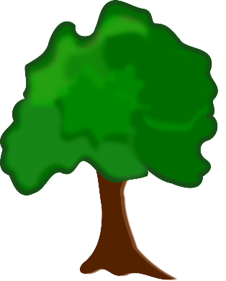

https://pixabay.com/vectors/clip-art-flora-nature-plant-tree-1300584/

How Families Use Plant Parts for Food and Medicine

Appendix H

Follow the links to learn about ways families use plant parts for food and medicine. Then fill out the t-chart.

<https://ouroneacrefarm.com/2015/04/17/12-native-plants-for-food-and-medicine/>

[www.first-learn.com/uses-of-plants.html](https://www.first-learn.com/uses-of-plants.html)

<https://kids.britannica.com/students/article/plant/276449>

|  |  |
| --- | --- |
| Food | Medicine |
| *Example:* People use the sap from maple tress to make maple syrup. | *Example:* The Cherokee used common violets to soothe headaches. |

Appendix I

<https://kidsinothercountries.org/>

Follow the link to the website. Choose one child’s video to watch. When you are done, fill in the Venn diagram below. Write your name in one label, and the child whose video you watched in the other. Write down all the things that are different about your lives in the correct circle, with things you have in common in the middle, where the circles overlap.

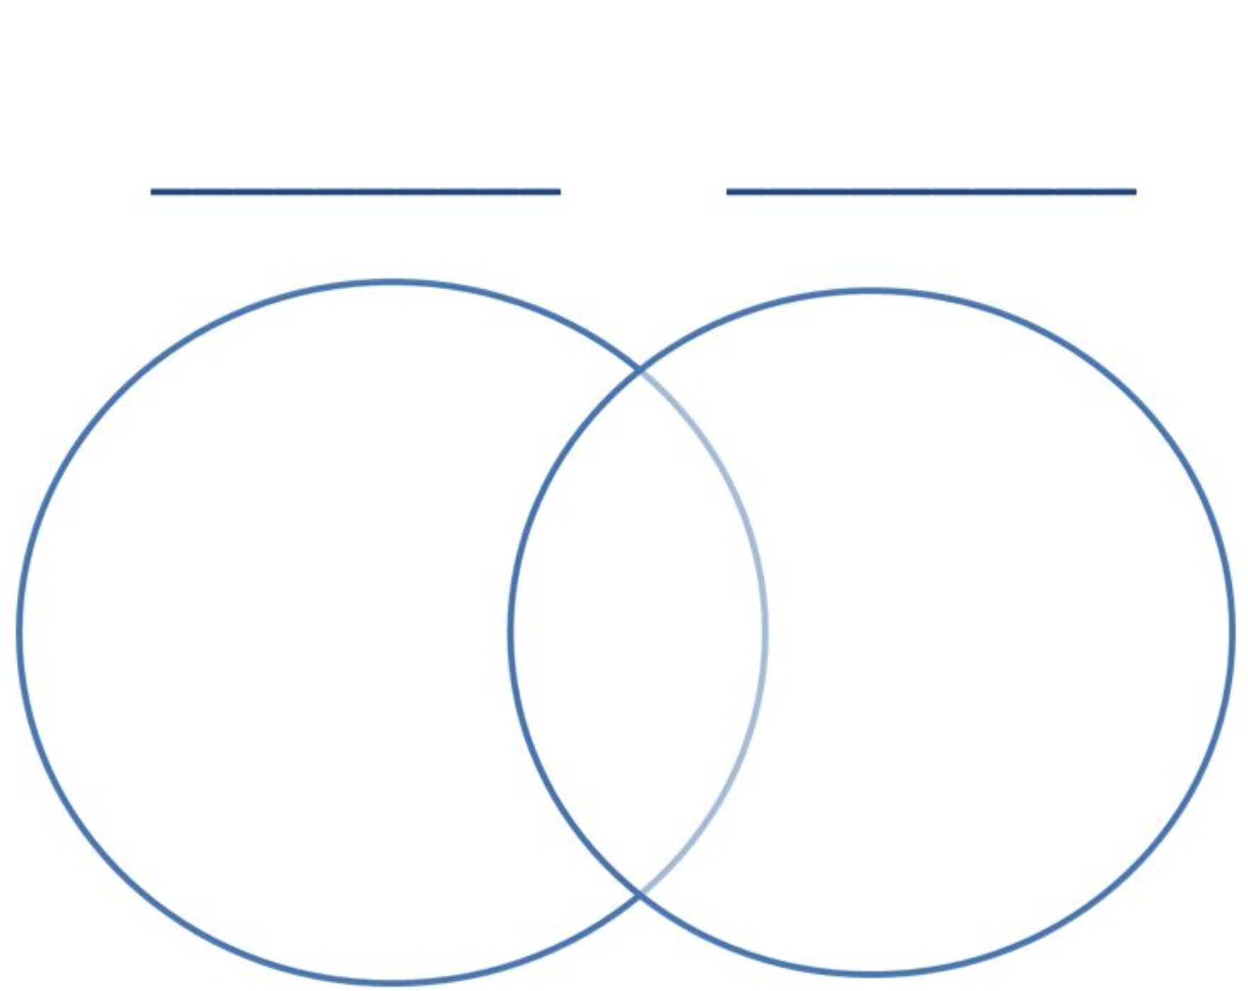

Ex. I live in Canada.

Other child’s name

Your name

Ex. Lives in _______. ________.

Appendix J

Musical Families

Watch the videos provided of musicians, musical instruments, and cultural families enjoying music from around the world. Talk to your family about their own musical interests, experiences, and backgrounds. Have they played musical instruments? Were they in a band? What songs did your grandparents sing to your parents when they were children? Record your learning.

[www.youtube.com/watch?v=s-mTjA9gxHU](https://www.youtube.com/watch?v=s-mTjA9gxHU) (*CTV: Carm Colvin*)

[www.youtube.com/watch?v=Ta9xdVxJOng](https://www.youtube.com/watch?v=Ta9xdVxJOng) (*WSO: One Voice*)

[www.youtube.com/watch?v=m7IHRWphGHA](https://www.youtube.com/watch?v=m7IHRWphGHA) (*Metis Music Manitoba*)

[www.youtube.com/watch?v=iNv6XvRJQS4](https://www.youtube.com/watch?v=iNv6XvRJQS4) (*A Musical Journey*)

[www.youtube.com/watch?v=fVMgB6OVO0o](https://www.youtube.com/watch?v=fVMgB6OVO0o) (*Native American Instruments*)

Here is what I learned about my family’s musical experience, interests, and memories:



https://pixy.org/471919/

Appendix K

Assessment Rubrics

For learning outcomes in mathematics, science, social studies and physical education, please refer to the achievement grade profiles provided by Manitoba Education at the following link:  
[www.edu.gov.mb.ca/k12/assess/report_cards/grading/profiles.html](https://www.edu.gov.mb.ca/k12/assess/report_cards/grading/profiles.html)

|  |  |
| --- | --- |
| **Grade Scale** | **Academic Achievement of Provincial Expectations** |
| 4 | Very good to excellent understanding and application of concepts and skills |
| 3 | Good understanding and application of concepts and skills |
| 2 | Basic understanding and application of concepts and skills |
| 1 | Limited understanding and application of concepts and skills; see teacher comments |

Please refer to the achievement scale for Manitoba provincial report cards (above) to complete the following table, which can be used to record marks and observations/notes for the learning outcomes targeted in this family project:

|  |  |  |  |  |  |
| --- | --- | --- | --- | --- | --- |
| **Learning outcome** | **1** | **2** | **3** | **4** | **Notes** |
| **Science:** | | | | | |
| Investigate how humans from various cultures use earth materials to make objects. |  |  |  |  |  |
| Identify and describe hobbies and jobs involving plants. |  |  |  |  |  |
| Identify how humans from various cultures use plant parts for food and medicine |  |  |  |  |  |
| **Social Studies:** | | | | | |
| Recognize the diversity of cultures and communities in the world. |  |  |  |  |  |
| Compare daily life in their own communities to life in communities studied. |  |  |  |  |  |

|  |  |  |  |  |  |
| --- | --- | --- | --- | --- | --- |
| **Learning outcome** | **1** | **2** | **3** | **4** | **Notes** |
| **Mathematics:** | | | | | |
| Quantities can be represented concretely, pictorially, and symbolically. |  |  |  |  |  |
| There are different but equivalent representations of numbers. |  |  |  |  |  |
| Benchmark numbers are useful for comparing, relating, and estimating numbers. |  |  |  |  |  |
| Our number system is based on patterns (place value). |  |  |  |  |  |
| The position of a digit in a number determines the quantity it represents. |  |  |  |  |  |
| Classifying numbers provides information about their characteristics. |  |  |  |  |  |
| Patterns can be represented in a variety of ways. |  |  |  |  |  |
| Relationships can be described and generalizations made for mathematical situations that have numbers or objects that repeat in predictable ways. |  |  |  |  |  |
| Data can be arranged to highlight patterns and relationships. |  |  |  |  |  |
| It is necessary to understand the attributes of the object before anything can be measured. |  |  |  |  |  |
| **English Language Arts:** | | | | | |
| General ELA Goal: Build a sense of self, identity, community, and the world |  |  |  |  |  |
| Lens: Personal and Philosophical and/or Social, Cultural and Historical |  |  |  |  |  |
| Focus on the Practice of Power and Agency (consider alternative viewpoints and perspectives) |  |  |  |  |  |

|  |  |  |  |  |  |
| --- | --- | --- | --- | --- | --- |
| **Learning outcome** | **1** | **2** | **3** | **4** | **Notes** |
| **Physical Education/ Health Education:** | | | | | |
| Recognize concepts relating to force (i.e., body alignment, application of force, addition of forces) in pulling, pushing, and carrying activities (e.g., carrying a mat together, rope pulling...) |  |  |  |  |  |
| **Art:** | | | | | |
| Describe works of art and design experienced first-hand in own community and the places and venues (e.g., galleries, places of worship, public buildings, parks) where these experiences occurred |  |  |  |  |  |
| **Music:** | | | | | |
| Demonstrate awareness of musicians from own community, Manitoba, Canada, and various global contexts |  |  |  |  |  |

ELA grade band descriptors identified in the family project:

|  |  |  |
| --- | --- | --- |
| **Practices and Elements** | **Grade Band Descriptor Identified** | **Evidence of Learning** |
| Power and Agency | * Learners are recognizing families’ and peers’ unique identities and similar and different ways of seeing the world. |  |
| Language as Sense Making | * Learners are enhancing meaning through dialogue, reflection, and revision. * Learners are building stamina for engagement, perseverance, and interactions with texts. |  |
| Language as System | * Learners’ automaticity with printed text is becoming secure. |  |
| Language as Exploration and Design | * Learners are using strategies, resources, and sources to explore ideas and deepen and extend thinking. |  |